Table of Contents
UNITED STATES
SECURITIES AND EXCHANGE COMMISSION
Washington, D.C. 20549
SCHEDULE 14A
Proxy Statement Pursuant to Section 14(a) of the Securities
Exchange Act of 1934

 |  | Filed by the Registrant |  |  |  | Filed by a party other than the Registrant

Check the appropriate box:
Preliminary Proxy Statement
CONFIDENTIAL, FOR USE OF THE COMMISSION ONLY (AS PERMITTED BY RULE
14A-6(e)(2))
Definitive Proxy Statement
Definitive Additional Materials
Soliciting Material under
§240.14a-12
CSW INDUSTRIALS, INC.


(Name of Registrant as Specified in its Charter)
(Name of Person(s) Filing Proxy Statement, if other than the Registrant)

Payment of Filing Fee (Check the appropriate
box
):
No fee required.
Fee paid previously with preliminary materials.
Fee computed on table in exhibit required by Item 25(b) per Exchange Act Rules
14a-6(i)(1)
and
0-11.

Table of Contents
Notice of 2026 Annual Meeting of Shareholders
August 27, 2026
12:30 p.m., Central Time
Virtual Meeting
www.virtualshareholdermeeting.com/CSW2026

This Notice, the accompanying Proxy Statement, our Annual Report on Form 10-K for the year ended March 31, 2026, and the form of proxy card or the Notice of Internet Availability of Proxy Materials, are first being mailed on or about July 16, 2026 to shareholders of record of the common stock of CSW Industrials, Inc. (the “Company”) as of the close of business on July 8, 2026.  At the Annual Meeting, shareholders will vote on the following matters:  • the election of seven director nominees to serve a one-year term expiring at the 2027 annual meeting of shareholders;  • the approval, on an advisory basis, of the Company’s executive compensation, or the “Say on Pay” vote;  • the ratification of Grant Thornton LLP’s appointment to serve as the Company’s independent registered public accounting firm for fiscal year 2027; and  • the transaction of any other business properly presented at the Annual Meeting.  The accompanying Proxy Statement contains other important information that you should read and consider before you vote. For additional related information, please refer to the “Important Notice Regarding the Availability of Proxy Materials for the Shareholder Meeting to be held on August 27, 2026” in the accompanying Proxy Statement.  Your vote is important. Even if you plan to attend the Annual Meeting, please vote your shares promptly! Thank you in advance for voting and for your support of the Company. |  | VOTE IN ONE OF FOUR WAYS:
 |  | Internet  Visit the website shown on the Notice of Internet Availability of Proxy Materials or proxy card |  | 
 |  | By Telephone  Call the telephone number shown on your proxy card |  | 
 |  | By Mail  Complete, sign, date and return your proxy card in the envelope provided |  | 
 |  | At The Meeting  Visit www.virtualshareholdermeeting.com/CSW2026 and follow the instructions. |  | 
 |  | If your shares are held by a bank, broker or other holder of record, please refer to their instructions to see which voting methods are available to you.
 |  | IMPORTANT NOTICE REGARDING THE AVAILABILITY OF PROXY MATERIALS FOR THE SHAREHOLDER MEETING TO BE HELD AUGUST 27, 2026: This Proxy Statement and the Annual Report to Shareholders are available at www.proxyvote.com.
By Order of the Board of Directors,

 |  |   Joseph B. Armes  Chairman, CEO and President |  |  |  | 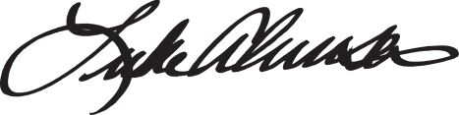  Luke E. Alverson  Senior Vice President,  General Counsel and Secretary
July 16, 2026

 |  |  |  |  |  |  |  | | 2026 Proxy Statement |  | i

Table of Contents
Table of Contents

Our Company |  |  | 1
Proxy Statement Summary |  |  | 4
Proposal 1: Election of Directors |  |  | 9
Required Vote and Recommendation |  |  | 9
Director Nominees for Election |  |  | 10
Corporate Governance |  |  | 17
Governance Highlights |  |  | 17
Board and Committee Structure |  |  | 17
Director Engagement |  |  | 19
Board Oversight of Risk Management |  |  | 21
Corporate Sustainability, Culture & Compliance |  |  | 22
Other Governance Policies and Practices |  |  | 24
Director Compensation |  |  | 26
Executive Officers |  |  | 28
Proposal 2: Advisory Vote on Executive Compensation |  |  | 30
Required Vote and Recommendation |  |  | 31
Executive Compensation |  |  | 32
Compensation & Talent Development Committee Report |  |  | 32
Compensation Discussion and Analysis |  |  | 33
Summary Compensation Table |  |  | 59
2026 Grants of Plan-Based Awards |  |  | 60
Outstanding Equity Awards at Year-End 2026 |  |  | 61
2026 Option Exercises and Stock Vested |  |  | 62
2026 Pension Benefits |  |  | 62
Potential Payments upon Termination or Change-In-Control |  |  | 63
CEO Pay Ratio |  |  | 66
Pay Versus Performance Disclosure |  |  | 67

Equity Compensation Plan Information |  |  | 69
Section 16(a) Beneficial Ownership Reporting Compliance |  |  | 69
Proposal 3: Ratification of Grant Thornton LLP’s Appointment to Serve as our Independent Registered Public Accounting Firm for Fiscal 2027 |  |  | 70
Required Vote and Recommendation |  |  | 70
Report of The Audit Committee |  |  | 71
Other Audit Information |  |  | 72
Relationship with Independent Registered Public Accounting Firm |  |  | 72
Audit and Non-Audit Fees and Services |  |  | 72
Audit Committee Approval Policy |  |  | 72
Beneficial Ownership of Common Stock |  |  | 73
Management |  |  | 73
Certain Other Beneficial Owners |  |  | 74
General Voting and Meeting Information |  |  | 75
Solicitation |  |  | 75
Voting |  |  | 75
Other Information About this Solicitation |  |  | 78
Cost of Proxy Solicitation |  |  | 78
Shareholders Sharing an Address |  |  | 78
Shareholder Proposals and Nominations |  |  | 78
Exhibit A |  |  | A-1
GAAP to Non-GAAP Reconciliations |  |  | A-1

Table of Contents

Our Company

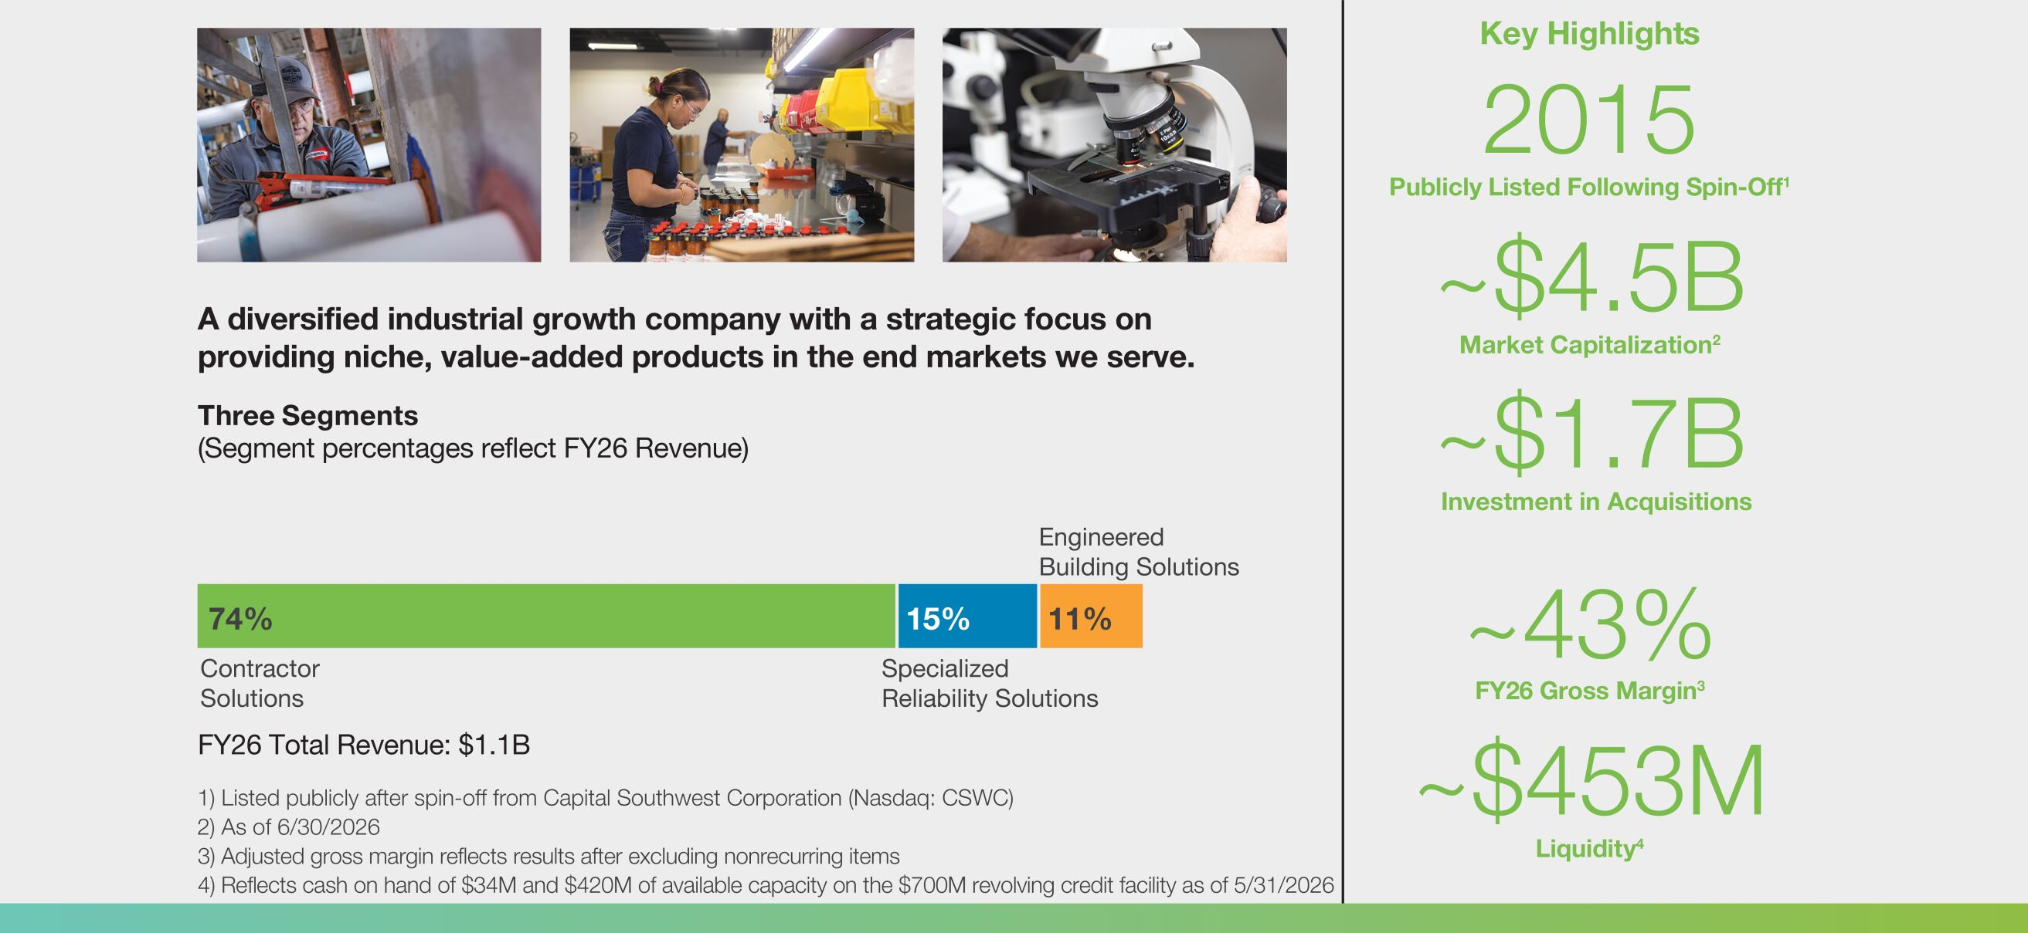
Investment Thesis

 |  | Growth  exceeding  end markets served |  | • Total revenue CAGR of 15.0% from FY16 through FY26  • Organic revenue CAGR of 8.3% from FY16 through FY26  • Total adjusted EBITDA CAGR of 16.7% from FY16 through FY26
 |  | Robust  margin  profile |  | • 43.9% adjusted Gross Profit Margin annual average FY16 through FY26  • 22.9% adjusted EBITDA Margin annual average FY16 through FY26
 |  | Strong financial position |  | • $420M available on our $700M revolving credit facility, and $34M cash on hand  • $270M FY26 adjusted EBITDA, and 24.9% adjusted EBITDA margin as a percent of revenue
 |  | Experienced leadership team |  | • Dedicated to enhancing shareholder value  • Committed to exemplifying CSW’s culture and values
 |  | Driving  long-term shareholder  value |  | • ~$1.7B cumulative investment in acquisitions completed from FY16 to date  • ~$370M cash returned to shareholders since 3Q18, in the form of dividends and share repurchases

 |  |  |  |  |  |  |  | | 2026 Proxy Statement |  | 1

Table of Contents
Our Company
Fiscal 2026 Financial Highlights

Fiscal 2026 Financial Highlights

Fiscal 2026 was a year of significant change for our organization – with intentionality, we are a meaningfully larger and more diversified company than we were last year. Driven by our disciplined capital allocation philosophy, and facilitated by our strong balance sheet, we invested in multiple high-quality growth opportunities, deploying over $1.0 billion of acquisition capital in consummating five highly synergistic, cash-flow accretive acquisitions. This included MARS Parts and Aspen Manufacturing within our Contractor Solutions segment.
Throughout the year, we remained true to our stated approach of driving sustainable growth and long-term shareholder value via a strategy that combines organic and inorganic growth, which once again enabled us to deliver record results in fiscal 2026. These results were achieved against a backdrop of
challenged end markets driven by multiple factors, including rapidly changing foreign policy, the imposition of new and increased tariffs, and increased macroeconomic volatility, ultimately surpassing the impressive results of the prior year. We also returned almost $150 million of capital to shareholders through share repurchases and dividends, demonstrating our continued commitment to long-term value creation and utilizing all capital allocation avenues available to us.
Perhaps most importantly, we achieved all of this while remaining true to our distinctive employee-centric culture. We remain steadfast in our commitment to fostering a culture of respect where we focus on recruiting and retaining great talent, offering rewarding careers, and recognizing team members who excel while providing the opportunity for a safe, secure, and dignified retirement.

Financial and Operational Performance

 |  | We achieved the following financial results in fiscal 2026 (comparisons to fiscal 2025):
 |  | Revenues  $1.1b  +23.2% |  | Adjusted  EBITDA*  $270m  +18.3% |  |  |  | 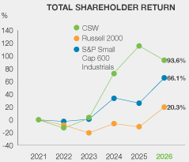
 |  | Adjusted  EPS*  $10.38  +6.9% |  | Operating Cash Flow  $150m  -11.1%
* EBITDA is comprised of earnings (net income) before interest, taxes, depreciation and amortization. Please see GAAP and Non-GAAP Reconciliations in Exhibit A.

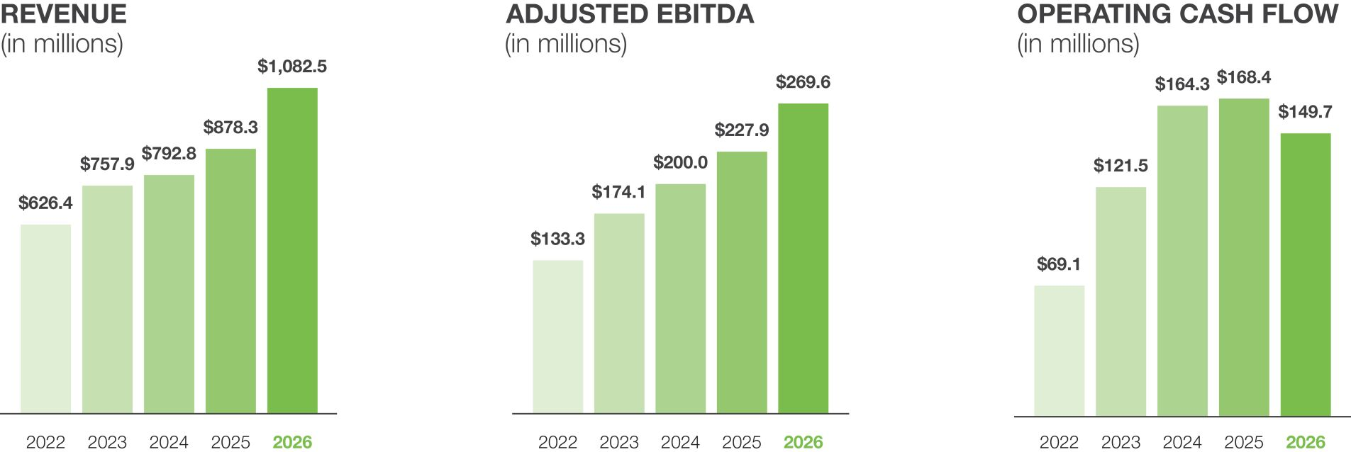

 | 2 |  |  |  |  | | 2026 Proxy Statement

Table of Contents
Our Company
Governance Highlights

Governance Highlights
Our Board of Directors (the “Board”) is committed to sound governance practices, including the following:

Director Independence |  | • Six of our seven director nominees are independent  • Our Chief Executive Officer (“CEO”) is our only management director
Board Composition |  | • All Board members are elected annually  • The Board annually assesses and evaluates its performance and the performance of its committees  • The Nominating & Corporate Governance Committee leads the full Board in considering Board member competencies in light of Company strategy  • Our Corporate Governance Guidelines maintain an age-based retirement limit for directors at age 73  • Our directors have a diverse mix of backgrounds, qualifications, skills, and experiences that we believe contribute to a well-rounded Board that is positioned to effectively oversee our strategy  • 43% of our director nominees are female and/or diverse
Board Committees |  | • We have three committees — Audit; Compensation & Talent Development; and Nominating & Corporate Governance  • All committees are composed entirely of independent directors
Leadership Structure |  | • Our Board has a Lead Independent Director who works closely with our Chairman, CEO and President in fulfilling responsibilities and duties  • Our Lead Independent Director chairs executive sessions of the independent directors, among other duties
Environmental, Social  & Governance Oversight |  | • Our Nominating & Corporate Governance Committee oversees our Environmental, Social & Governance (“ESG”) Program
Risk Oversight |  | • Our Board is responsible for enterprise risk oversight and has committees designated to oversee specific key risks  • Our Audit Committee oversees administration of the Company’s Enterprise Risk Management (“ERM”) Program for the assessment and mitigation of key risks
Open Communication |  | • We encourage open communication and strong working relationships among the Lead Independent Director, Chairman, and other directors  • Our directors have direct and unrestricted access to management and other employees
Stock Ownership |  | • Our directors and executive officers are subject to robust stock ownership requirements

 |  |  |  |  |  |  |  | | 2026 Proxy Statement |  | 3

Table of Contents

Proxy Statement Summary
This summary highlights selected information that is discussed in more detail elsewhere in this Proxy Statement. This summary does not contain all the information that you should consider, and you should read the entire Proxy Statement and the Annual Report on Form 10-K for the year ended March 31, 2026 carefully before voting.
References in this Proxy Statement to “we,” “us,” “our,” “the Company,” and “CSW” refer to CSW Industrials, Inc. and its consolidated subsidiaries.
Information About the Annual Meeting (page 75)
Time and Place

 |  |  |  |  |  | 
 |  | Time and Date  12:30 p.m., Central Time  Thursday, August 27, 2026 |  | Location  Via live webcast at  www.virtualshareholdermeeting.com/CSW2026 |  | Record Date  July 8, 2026
How to Vote

 |  |  |  |  |  |  |  | 
 |  | Via the Internet  Visit the website  shown on the Notice of  Internet Availability of Proxy  Materials or proxy card |  | By Telephone  Call the telephone number  shown on your proxy card |  | By Mail  Complete, sign, date, and  return your proxy card in  the envelope provided |  | At the Meeting  Visit  www.virtualshareholdermeeting.com/  CSW2026
Voting Matters and Board Recommendations

Proposal |  | Board Recommendation |  | Page
1. Election of Directors |  | FOR |  |  | 9
2. Advisory Vote on Executive Compensation |  | FOR |  |  | 30
3. Ratification of Independent Public Accounting Firm |  | FOR |  |  | 70
We may also transact any other business that may properly come before the Annual Meeting. As of the date of this Proxy Statement, we are not aware of any other business to be presented for consideration other than the matters described in this Proxy Statement.

 | 4 |  |  |  |  | | 2026 Proxy Statement

Table of Contents
Proxy Statement Summary
Shareholder Engagement

Shareholder Engagement
We are actively engaged with our investors. Our senior leaders participate in numerous industry and analyst conferences throughout the year, and we have dedicated resources to engage with all shareholders through a variety of mediums. This focus on engagement was again demonstrated in the context of executive compensation matters, which is discussed further within the “Compensation Discussion and Analysis” section of this Proxy Statement. The table below summarizes our engagement efforts in fiscal 2026.

In fiscal 2026, we met with  investors representing |  |  |  | How we engage  with investors |  | Topics regularly discussed  with investors
 |  | 66%  of our outstanding shares |  | We engage with analysts and shareholders through investor and analyst conferences, non-deal road shows, quarterly earnings calls, our investor relations website, and individual visits, meetings, and calls  We regularly report our investors’ views, comments, and concerns to our Board of Directors, and all of our Board committees consider these perspectives in conducting committee business |  | • Capital allocation  • Strategy and risk management  • Macro trends and long-term outlook  • Financial performance  • Segment performance  • Corporate governance  • Senior leadership team  • Employee engagement  • Margin leverage; pricing  • Executive compensation  • Environmental and sustainability matters
 |  | 72%  of our actively held shares
 |  | 85%  of our top 20 active investors
Board of Directors Highlights (page 10)
Seven of our current eight Board members are nominated for re-election at the Annual Meeting, as Mr. J. Kent Sweezey is retiring from the Board at the conclusion of the Annual Meeting. As shown below, our seven director nominees strengthen our Board with their varied professional backgrounds and experiences.

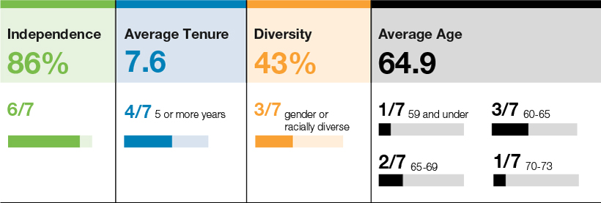

 |  |  |  |  |  |  |  | | 2026 Proxy Statement |  | 5

Table of Contents
Proxy Statement Summary
Board of Directors Highlights

Current Directors
Mr. Sweezey, who joined our Board in 2016, is retiring effective at the conclusion of the 2026 Annual Meeting. We thank Mr. Sweezey for his leadership and ten years of distinguished service to the Company.

 |  |  |  |  |  |  |  |  |  |  |  | Committee Memberships
 |  | Name |  | Age |  | Director  Since |  | Occupation |  | Independent |  | Audit |  | Comp &  Talent Dev |  | Nom &  Gov
 |  | Joseph B. Armes |  | 64 |  | 2015 |  | Chairman, CEO and President, CSW Industrials, Inc.
 |  | Darron K. Ash |  | 61 |  | 2024 |  | CEO, Sammons Enterprises, Inc. |  | ● |  | ● |  | ●
 |  | Michael R. Gambrell |  | 72 |  | 2015 |  | Former EVP, The Dow Chemical Company |  | ● |  |  |  |  |  | 
 |  | Bobby Griffin |  | 59 |  | 2021 |  | Chief Diversity Officer, Rockwell Automation, Inc. |  | ● |  |  |  | ● |  | ●
 |  | Terry L. Johnston |  | 68 |  | 2017 |  | Former EVP and COO, Commercial Segment, Lennox International |  | ● |  | ● |  |  |  | ●
 |  | Linda A. Livingstone, Ph.D.  (Lead Independent Director) |  | 66 |  | 2015 |  | President, Baylor University |  | ● |  |  |  | ● |  | ●
 |  | Anne B. Motsenbocker |  | 64 |  | 2022 |  | Former Managing Director, J.P. Morgan Chase |  | ●
 |  | J. Kent Sweezey(1) |  | 73 |  | 2016 |  | Founding Partner, Turnbridge Capital, LLC |  | ● |  | ●
Denotes Committee Chair

(1) | Not nominated for reelection at the 2026 Annual Meeting due to planned retirement pursuant to the age limitation provision in our Corporate Governance Guidelines.

 | 6 |  |  |  |  | | 2026 Proxy Statement

Table of Contents
Proxy Statement Summary
Executive Compensation Highlights

Executive Compensation Highlights (page 33)
Executive Compensation Program Objectives and Elements
Our executive compensation program is designed for one purpose: to support and enable execution of CSW’s growth strategy. To accomplish this purpose, we have adopted the following key executive compensation objectives:

 |  |  |  |  |  |  |  |  |  |  |  | 
Align Long-Term  Executive and  Shareholder  Interests |  |  |  | Reward Current  Performance |  |  |  | Drive Future  Performance |  |  |  | Attract and Retain  Key Leaders
Our executive compensation program is composed of the following foundational elements to accomplish our objectives:

Pay Element |  | Form |  |  |  | Compensation Objective Addressed
Base Salary |  | Cash |  |  |  |  |  | Reward Current Performance
 |  |  |  |  |  |  |  | Attract and Retain
Annual Incentive |  | Performance Cash Opportunity |  |  |  |  |  | Shareholder Alignment
 |  |  |  |  |  |  |  | Reward Current Performance
 |  |  |  |  |  |  |  | Attract and Retain
Long-Term  Equity Incentive |  | Performance Shares |  |  |  |  |  | Shareholder Alignment
 |  | 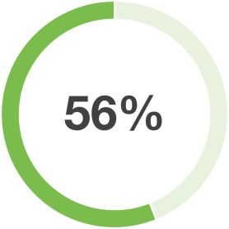 |  | NEO average  target grant value |  |  |  | Drive Future Performance
 |  |  |  |  |  |  |  | Attract and Retain
 |  | Restricted Stock |  |  |  |  |  | Shareholder Alignment
 |  | 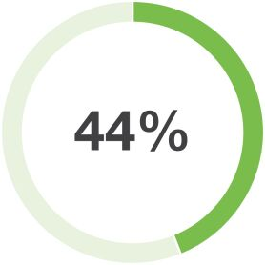 |  | NEO average  target grant value |  |  |  | Drive Future Performance
 |  |  |  |  |  |  |  | Attract and Retain

 |  |  |  |  |  |  |  | | 2026 Proxy Statement |  | 7

Table of Contents
Proxy Statement Summary
Executive Compensation Highlights

Fiscal 2026 Executive Target Compensation Mix

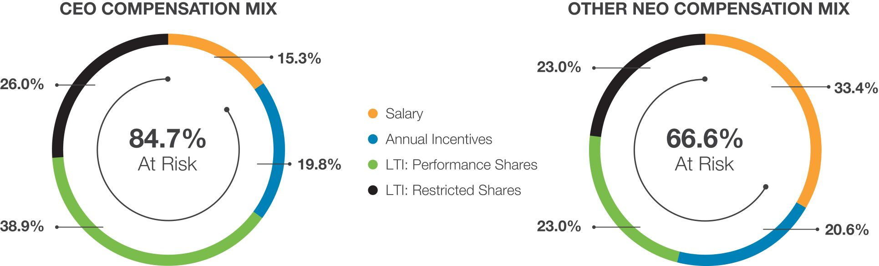
The Compensation Committee maintains a thoughtful approach to our executive compensation program design and governance practices in furtherance of our objectives. The following table summarizes these practices.

What We Do |  |  |  |  |  | What We Don’t Do
 |  | Promote a strong pay for performance plan design |  |  |  |  |  | No hedging, pledging, or short sales of stock permitted
 |  | Regularly benchmark executive compensation against peers of comparable size, complexity, and industry |  |  |  |  |  | No change in control excise tax gross ups
 |  | Maintain meaningful stock ownership guidelines for our directors and executive officers |  |  |  |  |  | No option repricing without shareholder approval
 |  | Have double trigger requirements on cash payments following a change in control |  |  |  |  |  | No perquisites offered, other than those generally provided to all employees
 |  | Conduct an annual compensation risk review |  |  |  |  |  | No dividends paid and no voting rights on unvested performance-based equity awards
 |  | Provide reasonable and standardized benefits upon severance or change in control |  |  |  |  |  | No duplication of metrics in annual and long-term incentive plans
 |  | Engage independent compensation consultants |  |  |  |  |  | No supplemental executive retirement plans
 |  | Maintain an incentive compensation “clawback” policy

 | 8 |  |  |  |  | | 2026 Proxy Statement

Table of Contents

Proposal 1:
Election of Directors
The Company’s Board currently consists of eight directors. J. Kent Sweezey will retire from the Board effective at the conclusion of the 2026 Annual Meeting, as he has reached the mandatory retirement age of 73 under our Corporate Governance Guidelines. Mr. Sweezey joined our Board in 2016 and has served as our Compensation & Talent Development Committee Chair since 2021. Mr. Sweezey has contributed meaningfully to making the Company what it is today, and we thank Mr. Sweezey for his ten years of distinguished service and the leadership he has provided to the Company during his tenure.
The Board has nominated Joseph B. Armes, Darron K. Ash, Michael R. Gambrell, Bobby Griffin, Terry L. Johnston, Linda A. Livingstone, and Anne B. Motsenbocker, whose terms of office are expiring at this 2026 Annual Meeting, to serve a one-year term that will expire at the 2027 annual meeting of shareholders. Immediately following the vote for election of directors at the 2026 Annual Meeting, the number of directors on the Board will be reduced from eight to seven.
All director nominees were elected by shareholders at the 2025 annual meeting. Biographical information regarding the director nominees is provided on the following pages.
Required Vote and Recommendation
Our Certificate of Incorporation provides provide that, in an uncontested election, each director nominee shall be elected by a majority of the votes cast in person or represented by proxy. This means that the number of shares cast “for” a director nominee’s election must exceed the number of votes “withheld” from that director nominee. If this were a contested election, the directors would be elected by a plurality of the votes cast, meaning the director nominees receiving the largest number of “for” votes would be elected. For more information, see “General Voting and Meeting Information—Voting—Counting of Votes.”
Our Corporate Governance Guidelines provide that in an uncontested election, any incumbent director who does not receive the affirmative vote of a majority of the votes cast must tender his or her resignation promptly after such election. The remaining independent directors of the Board, giving due consideration to the best interests of CSW and our shareholders, will then evaluate the relevant facts and circumstances and make a decision, within 30 days after election results are certified, on whether to accept the tendered resignation. The Board will promptly disclose publicly its decision and, if applicable, the reasons for rejecting the tendered resignation. The Board may fill any vacancy resulting from a director’s accepted resignation.
The individuals named as proxies on the enclosed proxy card will vote your proxy “FOR” the election of these director nominees unless you instruct otherwise or you withhold authority to vote for any one or more of the director nominees. If any director is unable to stand for re-election, the Board may reduce the number of directors or choose a substitute director nominee. The director nominees have indicated their willingness to serve as directors, and we have no reason to believe the director nominees will not be able to stand for re-election.

 |  | THE BOARD RECOMMENDS A VOTE FOR THE ELECTION OF ALL DIRECTOR NOMINEES.

 |  |  |  |  |  |  |  | | 2026 Proxy Statement |  | 9

Table of Contents
Proposal One: Election of Directors
Director Nominees for Election

Director Nominees for Election

 |  |  |  | 86%  Independence |  |  |  | 43%  Diversity |  |  |  | 7.6  Average  Tenure |  |  |  | 64.9  Average  Age
 |  | 6/7 |  |  |  | 3/7 gender or racially  diverse |  |  |  | 4/7 five or more years |  |  |  | 1/7 59 and under  3/7 60-64  2/7 65-69  1/7 70-73
What We Look for in Director Candidates
Before considering director nominee candidates, the Nominating & Corporate Governance Committee (“N&CG Committee”) assesses whether the Board’s current size and composition are appropriate and whether any vacancies on the Board are expected due to retirement, age limits, or other factors. If additional directors are needed or vacancies are anticipated or otherwise arise, the N&CG Committee utilizes a variety of methods for identifying and evaluating possible director nominees.
The Company’s Corporate Governance Guidelines establish the criteria for Board membership. As a starting point, the N&CG Committee assesses a director candidate’s judgment, skill, diversity, integrity, experience with businesses and other organizations of comparable size, and the interplay of the candidate’s experience with the experience of current Board members. In evaluating these characteristics, and including diversity, the Board considers individual qualities and attributes, such as educational background, professional skills, business experience, and cultural viewpoint, as well as more categorical diversity metrics, such as race and ethnicity, gender, and age. The Board considers whether this evaluation process is effective in promoting diversity during its annual self-evaluation process.
How We Identify Director Candidates
The Board considers various potential director candidates who come to the Board’s attention through professional search firms, current Board members, shareholders, or other sources. A shareholder who wants to recommend a candidate for election to the Board should submit a written notice, as required by the Company’s Bylaws, including the candidate’s name and qualifications to our Corporate Secretary, who will refer the recommendation to the N&CG Committee. The N&CG Committee facilitates the director candidate evaluation process and may require any shareholder-recommended candidate to furnish such other information as may reasonably be required to determine the candidate’s eligibility or to assist in evaluating the candidate. The N&CG Committee also may require the submission of a fully completed and signed questionnaire for directors and executive officers on the Company’s standard form and a written consent by the shareholder-recommended candidate to serve as a director, if so elected.
All identified candidates, including shareholder-recommended candidates, are evaluated by the N&CG Committee and the full Board using generally the same methods and criteria, although those methods and criteria may vary from time to time depending on the N&CG Committee’s and the full Board’s assessment of the Company’s needs and current situation.

 | 10 |  |  |  |  | | 2026 Proxy Statement

Table of Contents
Proposal One: Election of Directors
Director Nominees for Election

Director Nominee Skill Sets

 |  |  |  |  |  |  |  |  |  |  |  |  |  |  |  | 
 |  | Executive Leadership |  | 
 |  | Finance/Accounting |  |  |  | 
 |  | Industry/End Market Knowledge
 |  | Corporate Development & Strategy
 |  | Risk Management
 |  | Cybersecurity and Information
 |  | Global Business
 |  | Sales & Marketing
 |  | Corporate Governance
 |  | Human Capital Management
 |  | = Experience
 |  | = Expertise

 |  |  |  |  |  |  |  | | 2026 Proxy Statement |  | 11

Table of Contents
Proposal One: Election of Directors
Director Nominees for Election

Director Nominee Biographies

 |  |  |  | Joseph B. Armes  Chairman, CEO and President, CSW Industrials  Professional Highlights  Mr. Armes has served as Chief Executive Officer and Chairman of the Board of the Company since September 2015, and as President of the Company since February 2018. Prior to the Company’s spin-off in September 2015 from Capital Southwest Corporation, Mr. Armes served as the Chief Executive Officer and President of Capital Southwest Corporation from June 2013 to September 2015, and as Chairman of the Board from January 2014 through August 2017.  Key Skills and Qualifications  We believe Mr. Armes is well qualified to serve as a director due to his position as the Company’s Chief Executive Officer, which provides the Board with knowledge of the Company’s day-to-day operations. Mr. Armes also has broad executive and board leadership experience, finance and accounting expertise, compliance and governance expertise, and corporate development experience, all of which support the Company’s strategic growth plans.  Other Public Company Directorships  •  Switchback Energy Acquisition Corp. (2019-2021)  •  RSP Permian, Inc. (2013-2018)  •  Capital Southwest Corporation (2013-2017)
Age: 64

Director Since:
September 2015

CSW Board Committee(s):
•
None

 |  |  |  | Darron K. Ash  CEO, Sammons Enterprises, Inc.  Professional Highlights  Mr. Ash has served as Chief Executive Officer of Sammons Enterprises, Inc., a diverse global holding company, since January 2023. Mr. Ash joined Sammons Enterprises in June 2006 as its Chief Financial Officer, and in June 2015 was appointed to the Executive Committee of Sammons Enterprises’ board of directors, on which he continues to serve. From June 2015 to February 2024, Mr. Ash served as Chairman and Chief Executive Officer of Sammons Industrial, which is the parent company of Sammons Enterprises’ industrial investments and operating companies. Mr. Ash began his career in public accounting, and prior to joining Sammons Enterprises, he served in financial leadership roles in the private equity, consumer products manufacturing, professional services, and real estate sectors.  Key Skills and Qualifications  We believe Mr. Ash is well qualified to serve as a director due to his executive and board leadership experience and his deep financial and operational expertise. Mr. Ash’s experience and expertise leading complex, global organizations, as well as his corporate development experience and investment acumen, provides the Board with unique insight into the Company’s growth opportunities and positions him well to support the Company’s growth strategy and manufacturing optimization focus.
Age: 61

Director Since:
June 2024

INDEPENDENT

CSW Board Committee(s):
•
Audit
•
Compensation & Talent Development

 | 12 |  |  |  |  | | 2026 Proxy Statement

Table of Contents
Proposal One: Election of Directors
Director Nominees for Election

 |  |  |  | Michael R. Gambrell  Former EVP, The Dow Chemical Company  Professional Highlights  Mr. Gambrell had a 37-year career at The Dow Chemical Company, a publicly traded chemicals company (now Dow, Inc.), most recently serving as an Executive Vice President and an advisor to the Chairman and CEO of Dow. During his time at Dow, Mr. Gambrell served on the company’s Executive Leadership Committee, Strategy Board, Sustainability Team, and Geographic Leadership Council, and he was an ex officio member of the Board’s Environment, Health and Safety Committee. In 2012, Mr. Gambrell founded GamCo, LLC, a privately-held company providing advisory services to public, private equity, and start-up companies as well as non-profit organizations. He served as Chairman of the Campbell Institute from 2012 to 2015, and as a director and member of the Executive Committee and Strategic Planning Committee of the National Safety Council from 2011 to 2015.  Key Skills and Qualifications  We believe Mr. Gambrell is well qualified to serve as a director due to his executive and board leadership experience and his extensive knowledge of the chemicals industry, which provide a global perspective and deep understanding of the Company’s products, customers, end markets, competitive landscape, and operational challenges and opportunities. In addition, Mr. Gambrell has extensive corporate development experience and integration expertise, as well as knowledge and experience in addressing health, safety and environmental issues, which provides the Board unique insight into the Company’s strategic growth plans.  Other Public Company Directorships  •  TRW Automotive Inc. (2007-2015)
Age: 72

Director Since:
September 2015

INDEPENDENT

CSW Board Committee(s):
•
Nominating & Corporate Governance (Chair)

 |  |  |  | Bobby Griffin  Chief Diversity Officer  Rockwell Automation, Inc.  Professional Highlights  Mr. Griffin has served as Chief Diversity Officer of Rockwell Automation, Inc. since February 2021. Prior to that role and beginning in 2017, Mr. Griffin served as Vice President of Diversity and Inclusion at CBRE Group, Inc., and prior to that served as Global Director of Diversity and Inclusion at Flowserve Corporation. Additionally, Mr. Griffin held various human resources and business partner leadership positions in Fortune 100 companies, including Coca-Cola Enterprises and Merck & Co.  Key Skills and Qualifications  We believe Mr. Griffin is well qualified to serve as a director due to his notable expertise in corporate culture, organizational health, diversity & inclusion, talent management, leadership development, and compensation and benefits, which provides the Board a valuable perspective on the Company’s core values and employee-centric culture. His experience also provides strategic insight into the Company’s leadership development, human capital management, and organizational design opportunities in support of the Company’s strategic growth plans.
Age: 59

Director Since:
December 2021

INDEPENDENT

CSW Board Committee(s):
•
Compensation & Talent Development
•
Nominating & Corporate Governance

 |  |  |  |  |  |  |  | | 2026 Proxy Statement |  | 13

Table of Contents
Proposal One: Election of Directors
Director Nominees for Election

 |  |  |  | Terry L. Johnston  Former EVP & COO, Commercial Segment,  Lennox International  Professional Highlights  Mr. Johnston was Executive Vice President and Chief Operating Officer of the Commercial Segment of Lennox International Inc., a leading international provider of heating and cooling systems and technologies for residential and commercial applications, from 2013 until October 2019. Before assuming that position, Mr. Johnston held roles of increasing responsibility with Lennox International from the time he joined the company in 2001. Prior to his time with Lennox International, Mr. Johnston spent 20 years with General Electric Company, serving primarily in marketing and commercial leadership roles.  Key Skills and Qualifications  We believe Mr. Johnston is well qualified to serve as a director due to his executive leadership experience and extensive knowledge of the Company’s served industrial markets. In addition, Mr. Johnston has extensive global experience, strategic planning experience, and operational and commercial expertise, which provides the Board with a global perspective and positions him well to support the Company’s growth strategy and manufacturing optimization focus.
Age: 68

Director Since:
January 2017

INDEPENDENT

CSW Board Committee(s):
•
Audit
•
Nominating & Corporate Governance

 |  |  |  | Linda A. Livingstone, Ph.D.  President, Baylor University  Professional Highlights  Dr. Livingstone is President of Baylor University, a position she has held since June 2017. From August 2014 through May 2017, she served as Dean of The George Washington University School of Business, and she previously served as Dean of the Graziadio School of Business and Management at Pepperdine University for twelve years. Dr. Livingstone began her academic career at Baylor University, where she served for eleven years as an Assistant and then Associate Professor of Management, which included serving for four years as Associate Dean for Graduate Programs. Dr. Livingstone currently serves on the Big 12 Conference board of directors and the Baylor College of Medicine board of trustees. She also serves on the board of the International Association of Baptist Colleges & Universities, and has previously served on the board of directors for the American Council on Education. Dr. Livingstone has served as the Company’s Lead Independent Director since August 2025.  Key Skills and Qualifications  We believe Dr. Livingstone is well qualified to serve as a director due to her extensive executive leadership experience, as well as experience as an administrator and educator in the field of business administration, all of which provide the Board a valuable perspective on organizational development, corporate governance, information security, executive compensation, and leadership development matters.
Age: 66

Director Since:
September 2015

INDEPENDENT

CSW Board Committee(s):
•
Compensation & Talent Development
•
Nominating & Corporate Governance

 | 14 |  |  |  |  | | 2026 Proxy Statement

Table of Contents
Proposal One: Election of Directors
Director Nominees for Election

 |  |  |  | Anne B. Motsenbocker  Former Managing Director, J.P. Morgan Chase  Professional Highlights  Ms. Motsenbocker is a former Managing Director of J.P. Morgan Chase, a global financial services company. She retired from J.P. Morgan Chase in February 2021 after a 36-year career with the firm, serving most recently as Managing Director and functional CEO of the Southwest Region of the Commercial Bank. Prior to that position, she held roles of increasing responsibility at J.P. Morgan Chase, including National Head of Multinational Corporations, President of Dallas Region Middle Market Bank, and Head of the Dallas Region of the Private Bank. From 2016 to 2022, Ms. Motsenbocker was a director of Children’s Health System of Texas, where she served as the chair of the HR and Compensation Committee and as a member of the Audit Committee. She also serves on the boards of the National Kidney Foundation, United Way Foundation of Metropolitan Dallas, NACD North Texas Chapter, and Economic Mobility Center.  Key Skills and Qualifications  We believe Ms. Motsenbocker is well qualified to serve as a director due to her executive and board leadership experience and her strategic and financial acumen. Ms. Motsenbocker’s extensive experience in advising companies in the development and implementation of capital strategies, managing risk, achieving operational excellence, and growing organically and inorganically positions her well to support the Company’s strategic growth plans.  Other Public Company Directorships  •  Fortress Private Lending Fund (August 2025-Present)  •  U.S. Physical Therapy, Inc. (2022-Present)
Age: 64

Director Since:
June 2022

INDEPENDENT

CSW Board Committee(s):
•
Audit (Chair)

 |  |  |  |  |  |  |  | | 2026 Proxy Statement |  | 15

Table of Contents
Proposal One: Election of Directors
Director Nominees for Election

Director Independence
Our Corporate Governance Guidelines require that a majority of our directors satisfy applicable independence requirements set forth in New York Stock Exchange (the “NYSE”) listing rules and under applicable law. Only those directors who have no material relationship with the Company (except in their role as a director) are deemed independent. The Board has determined that, other than Mr. Armes, who is the Company’s Chairman, CEO and President, each member of the Board meets the independence standards set forth in the applicable rules of the Securities and Exchange Commission (the “SEC”) and the NYSE.

 | 16 |  |  |  |  | | 2026 Proxy Statement

Table of Contents

Corporate Governance
Governance Highlights
Our Board of Directors is committed to sound governance practices, including the following:

Director Independence |  | • Six of our seven director nominees are independent  • Our CEO is our only management director
Board Composition |  | • All Board members are elected annually  • The Board annually assesses and evaluates its performance and the performance of its committees  • The Nominating & Corporate Governance Committee leads the Board in considering board member competencies in light of Company strategy  • Our Corporate Governance Guidelines maintain an age-based retirement limit for directors at age 73  • Our directors have a diverse mix of backgrounds, qualifications, skills, and experiences that we believe contribute to a well-rounded Board that is positioned to effectively oversee our strategy  • 43% of our director nominees are female and/or diverse
Board Committees |  | • We have three committees – Audit; Compensation & Talent Development; and Nominating & Corporate Governance  • All committees are composed entirely of independent directors
Leadership Structure |  | • Our Board has a Lead Independent Director who works closely with our Chairman, CEO and President in fulfilling responsibilities and duties  • Our Lead Independent Director chairs executive sessions of the independent directors, among other duties
Environmental,  Social & Governance  Oversight |  | • Our Nominating & Corporate Governance Committee oversees our Environmental, Social & Governance (“ESG”) Program
Risk Oversight |  | • Our Board is responsible for enterprise risk oversight and has committees designated to oversee specific key risks  • Our Audit Committee oversees administration of the Company’s Enterprise Risk Management (“ERM”) Program for the assessment and mitigation of key risks
Open Communication |  | • We encourage open communication and strong working relationships among the Lead Independent Director, Chairman, and other directors  • Our directors have direct and unrestricted access to management and other employees
Stock Ownership |  | • Our directors and executive officers are subject to robust stock ownership requirements
Board and Committee Structure
Board Leadership Structure

The Board’s current leadership structure is characterized by:

• | An engaged, qualified, and independent Board;

• | A combined Chairman of the Board and CEO;

• | An independent, highly experienced Lead Independent Director with well-defined responsibilities that support and facilitate the Board’s oversight responsibilities; and

• | A strong committee structure consisting entirely of independent directors with well-defined authority and risk oversight responsibilities.

 |  |  |  |  |  |  |  | | 2026 Proxy Statement |  | 17

Table of Contents
Corporate Governance
Board and Committee Structure

Dr. Linda Livingstone has served as the Board’s Lead Independent Director since August 2025. The Lead Independent Director serves an important leadership and oversight role by providing input on the Board’s annual schedule and collaborating with the Chairman and CEO on the agendas for all Board meetings. Additionally, the Lead Independent Director provides support and advice to the Chairman and CEO, reinforcing the CEO’s reporting relationship and accountability to the Board.
The Board believes it is important to retain flexibility to allocate the responsibilities of the positions of Chairman of the Board and CEO in a manner that it believes is in the best interests of the Company and its shareholders. The Board does not have a policy mandating that the CEO should or should not also serve as Chairman. Rather, the Board considers this issue as part of the CEO succession planning process, and the decision is based on its evaluation of current circumstances and the needs of the Company at the time it is considering candidates for the CEO role. Based on Mr. Armes’ significant knowledge of the Company, the Board has concluded that combining the roles of Chairman and CEO, along with the presence of a strong Lead Independent Director, is in the best interests of the Company and its shareholders at this time to promote the pursuit of the Company’s business objectives and strategic growth plans.

Lead Independent Director Responsibilities
• Provide leadership to the independent directors  • Provide support and advice to the Chairman and CEO  • Preside over executive sessions of the independent directors  • Chair meetings of the Board in the absence of the Chairman of the Board |  | • Collaborate with the Chairman and CEO on Board meeting agendas  • Oversee director recruiting  • Collaborate with the N&CG Committee on the Board’s self-evaluation processes
Board Committees
The Board maintains an Audit Committee, a Compensation & Talent Development Committee (“Compensation Committee”), and an N&CG Committee. Only independent directors are eligible to serve on these standing Board committees. Each committee is governed by a written charter, all of which are available on the Company’s website at www.csw.com under “Investors — Corporate Governance.”
The Board has determined that all members of all committees meet the independence standards of the SEC and the NYSE, including the heightened independence requirements for certain committee members.
Audit Committee

Members and Other Information |  | Primary Oversight Responsibilities
Committee Chair:  Anne B. Motsenbocker  Other Members:  Darron K. Ash  Terry L. Johnston  J. Kent Sweezey |  | • Engage and oversee, including the qualifications, independence and performance of, the Company’s independent registered public accounting firm  • Approve all audit engagement fees and terms, including all non-audit services, provided by the Company’s independent registered public accounting firm  • Oversee the adequacy and integrity of the Company’s financial statements, financial reporting, and disclosures  • Oversee internal controls matters, which includes information security and cybersecurity risk  • Oversee and monitor the performance of the Company’s internal audit function  • Oversee the Company’s ethics and compliance program  • Oversee management’s administration of the Enterprise Risk Management program  • Oversee the Company’s compliance with legal and regulatory requirements relating to financial reporting
5 Meetings in Fiscal 2026

 | 18 |  |  |  |  | | 2026 Proxy Statement

Table of Contents
Corporate Governance
Board and Committee Structure

The Board has determined that Ms. Motsenbocker and Mr. Ash qualify as audit committee financial experts under SEC rules. The Board has also determined that all members of the Audit Committee are financially literate within the meaning of the NYSE’s listing standards.
Compensation & Talent Development Committee

Members and Other Information |  | Primary Oversight Responsibilities
Committee Chair:  J. Kent Sweezey  Other Members:  Darron K. Ash  Bobby Griffin  Linda A. Livingstone  5 Meetings in Fiscal 2026 |  | • Establish the Company’s executive compensation philosophy and compensation programs  • Oversee risk management related to the Company’s executive compensation programs  • Administer the Company’s equity and incentive compensation plan  • Review executive performance, management succession plans, and talent development  • Administer the Company’s clawback policies  • Recommend to the Board changes in non-employee director compensation
Nominating & Corporate Governance Committee

Members and Other Information |  | Primary Oversight Responsibilities
Committee Chair:  Michael R. Gambrell  Other Members:  Bobby Griffin  Terry L. Johnston  Linda A. Livingstone  4 Meetings in Fiscal 2026 |  | • Establish and implement procedures to review the qualifications for membership on our Board of Directors, including nominees recommended by shareholders  • Identify and recommend to the Board qualified candidates to become Board members  • Develop and review succession planning for the Board and its leadership positions  • Manage risks associated with board independence and potential conflicts of interest  • Establish corporate governance principles and policies, including overseeing the Company’s Corporate Governance Guidelines  • Oversee the Company’s ESG program and related initiatives  • Oversee the Board and committee self-evaluation process
The Board has a responsibility to oversee the CEO and other members of senior management in the competent and ethical operation of the Company and to ensure that our shareholders’ best interests are being served. To meet this responsibility, the Board has established Corporate Governance Guidelines designed to promote effective oversight of the Company’s business affairs. The Board monitors and updates these Guidelines periodically as it deems appropriate.
As discussed in this section of the Proxy Statement, the Corporate Governance Guidelines cover a range of matters, including:

• | the director selection process;

• | the composition of the Board and its committees;

• | the review and evaluation of the CEO;

• | succession planning and management development;

• | director compensation;

• | the review of individual directors and the Board’s performance; and

• | director independence requirements, age-based service limits, and other restrictions for directors.

The Corporate Governance Guidelines are available on the Company’s website at www.csw.com under “Investors — Corporate Governance.”
Director Engagement
Executive Sessions
Executive sessions of independent directors are generally held at each regularly-scheduled Board meeting without the presence of non-independent directors or members of management. Any independent director may request that additional executive sessions be scheduled. Our Lead Independent Director presides at the executive sessions.

 |  |  |  |  |  |  |  | | 2026 Proxy Statement |  | 19

Table of Contents
Corporate Governance
Director Engagement

Director Attendance at Meetings
Board members are expected to devote the time necessary to appropriately discharge their responsibilities and to rigorously prepare for and, to the extent possible, attend and participate in all Board meetings and meetings of Board committees on which they serve. In fiscal 2026, the Board held seven (7) meetings, and each director attended at least 75% of the meetings of the Board and committees on which he or she served during the period for which he or she was a director.
The Company encourages all directors to attend its annual meeting of shareholders, though we do not have a specific policy with respect to director attendance. All of the Company’s then-current directors attended the 2025 annual meeting of shareholders.
Director Education and Orientation Program
The Company provides an orientation program and continuing education process for Board members to enable them to better understand our Company and to remain current on developments related to their Board and committee service. Educational opportunities include seminars, management and third-party expert presentations, meetings with key management, and visits to Company facilities.

New Director Orientation |  | When a new director joins the Board, the Company provides an interactive, customized orientation and onboarding program. After completing the program, new directors should understand the Company’s strategy, reportable segments and product brands, organizational structure, leadership team, and Company resources available to them to help them be successful in their new role. This helps new directors quickly engage with other Board members and executive leadership and best fulfill their responsibilities and fiduciary duties as directors.
Continuing Education |  | The Company provides regular updates on continuing education opportunities and will reimburse board members for the cost of any programs attended.
Outside of the Boardroom |  | Throughout a Board member’s service, our directors have discussions with each other and key leaders of the Company outside of regularly scheduled Board and committee meetings to foster a deeper understanding of the Company’s business and build relationships through sharing of perspectives and ideas.
Board Self-Evaluation
Our Board has conducted an annual self-evaluation since CSW’s inception. The self-evaluation is designed to assess whether the Board and its committees are functioning effectively. The Board’s committees also conduct annual self-evaluations for the same purpose. These evaluations focus on the performance of the Board or the committee, as applicable, as a unit, rather than the performance of any individual director. The N&CG Committee, in collaboration with the Lead Independent Director, oversees our annual Board self-evaluation process, which is illustrated below. The Board believes this annual self-evaluation process supports its effectiveness and continuous improvement efforts.

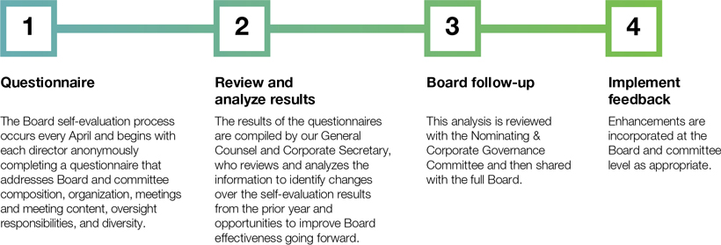

 | 20 |  |  |  |  | | 2026 Proxy Statement

Table of Contents
Corporate Governance
Board Oversight of Risk Management

Board Oversight of Risk Management
The Company’s CEO and other members of senior management are responsible for the ongoing assessment and management of the risks the Company faces. These enterprise risks are formally assessed annually by management as part of the Company’s robust Enterprise Risk Management program. At least annually, the Board—both as a whole and through its committees—oversees the Company’s risk profile and management’s policies and processes for assessing and managing risk. Responsibilities for risk management are allocated generally as set forth below.

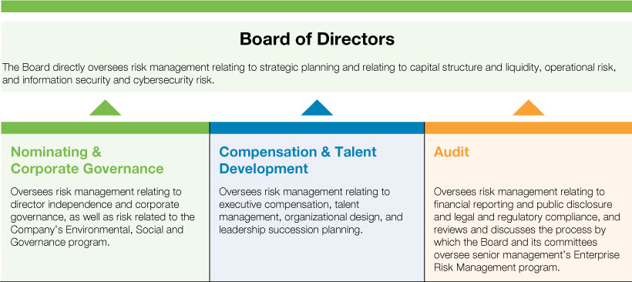
The Board is regularly informed through committee reports of each committee’s activities in overseeing risk management within their respective areas of oversight responsibility.
Our Enterprise Risk Management (“ERM”) program, which is overseen by our Audit Committee, supports our risk management and strategic planning efforts. Since our inception, our ERM program has begun with an annual risk assessment survey. Near the end of each calendar year, approximately 35 key leaders across our organization and all Board members receive a focused questionnaire that they use to provide feedback on a universe of nearly 50 enterprise risks covering six distinct risk categories: Strategic; Financial; Legal & Compliance; Operational; IT & Systems; and Talent Management. The following graphic illustrates this process:

 |  | Enterprise Risk Assessment  • Each risk is evaluated for likelihood, impact, and control effectiveness, and risk tolerance data is collected  • Prioritized risks listing assembled using analyzed respondent data  • “Dashboards” developed for each prioritized risk,  identifying risk owner, key risk indicators, and risk prevention and mitigation actions  • The Company’s “risk culture” is evaluated for continual improvement |  | 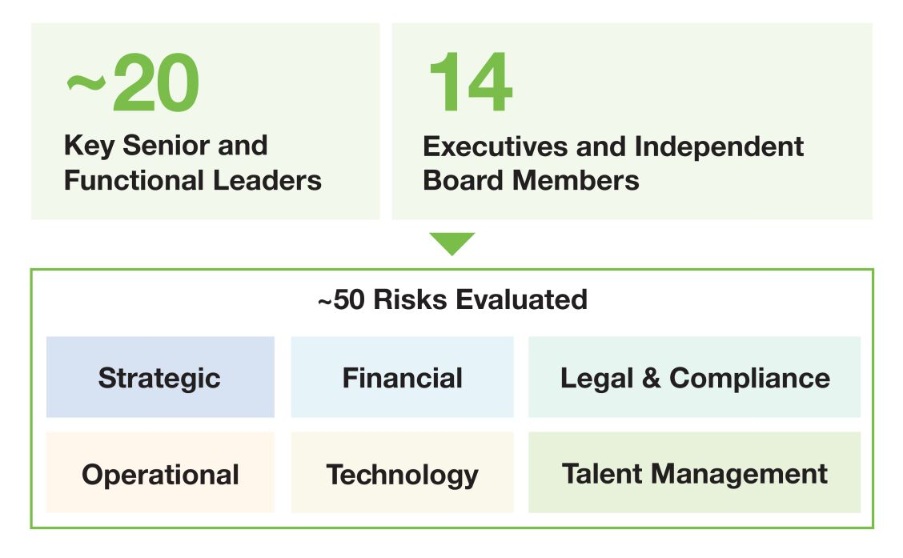

 |  |  |  |  |  |  |  | | 2026 Proxy Statement |  | 21

Table of Contents
Corporate Governance
Board Oversight of Risk Management

Spotlight on Cybersecurity

Cybersecurity is a critical component of the Company’s ERM program. The Company has established an information security framework to help safeguard the confidentiality, integrity, and access of its information assets and to ensure regulatory, contractual, and operational compliance. The Board oversees cybersecurity risk, and the Audit Committee oversees information security compliance as part of its broader compliance oversight mandate. Together they ensure that the Board has a comprehensive view of the Company’s cybersecurity risk profile and risk mitigation framework.

The Board receives cybersecurity updates from senior management, including our head of Information Technology, at least twice per year, and the Audit Committee receives quarterly reports on any notable incidents or control issues that may have occurred during the quarter. The Company has experienced, and expects to continue experiencing, cyber threats and incidents; however, to date, no incidents have been material to the Company, and expenses incurred in response to incidents have been immaterial in any given fiscal year.

Corporate Sustainability, Culture & Compliance
Environmental, Social and Governance Matters

CSW’s Environmental, Social, and Governance (“ESG”) strategy is based on our belief that long-term shareholder value, sustainable growth, and social responsibility are interrelated. Corporate responsibility lies at the heart of our culture and speaks directly to our ACT. RISE. core values: Accountability, Citizenship, Teamwork, Respect, Integrity, Stewardship, and Excellence. Driven by our executive leadership team, sustainability influences how we operate our business, take care of our people, and serve our customers. Our ESG initiatives are aligned with and inform the long-term strategies of our operating companies and corporate center. Additionally, ESG-related enterprise risks and opportunities are identified and addressed through our strategic processes, helping further align our initiatives and strategy. |  | Corporate sustainability lies at the heart of our culture and speaks directly to our ACT. RISE. core values
Our Board’s proactive engagement and oversight on ESG matters is demonstrated in the following ways:

 | • | Our N&CG Committee has primary oversight responsibility for our ESG program.

 | • | Our Board and its committees engage at least quarterly with our executive team members having responsibility to present and discuss various ESG topics. In the past year, management has presented to the Board and its committees on initiatives such as business continuity, environmental compliance, employee health and safety, gender pay equity, employee engagement, and employee welfare programs.

 | • | Our Audit Committee and Board have direct engagement with ESG risk areas through our robust ERM program.
Commitment to Environmental Stewardship
We are committed to being good stewards of the environment. We demonstrate our commitment by actively working to reduce the environmental impact of our operations and by providing environmentally responsible products and services to our customers. Our products help our customers protect and reduce emissions from industrial systems and mission-critical equipment; improve the energy efficiency and resource consumption of HVAC/R, plumbing, and electrical systems; and make commercial and residential buildings safer for occupants and their surrounding communities. Additionally, certain manufacturing facilities within our operating companies are ISO 9001 and 14001 certified.
Our environment-focused initiatives have included and continue to include:

• | Reducing overall energy consumption as a percentage of sales and increasing the amount of consumed electricity that is generated from renewable sources, such as solar and wind

• | Reducing overall water consumption as a percentage of sales

 | 22 |  |  |  |  | | 2026 Proxy Statement

Table of Contents
Corporate Governance
Corporate Sustainability, Culture & Compliance

• | Reducing solid, liquid and air discharges, including continuing and increasing our efforts to improve air quality by reducing VOC emissions

• | Reducing the amount of scrap and non-recyclable waste generated by our operations by increasing the use of rework and recycled metal and materials

• | Increasing ISO 9001 and 14001 certifications at manufacturing facilities

• | Expanding LEED certifications for product categories

• | Increasing usage of CSW-produced environmentally-friendly lubricants in manufactured mechanical products

• | Increasing usage of environmentally-friendly cleaners and chemicals in manufacturing processes

• | Reducing hazardous waste generation as a percentage of finished goods
We provide additional details regarding our energy usage, resource consumption, and greenhouse gas emissions on our Corporate Sustainability webpage within our corporate website at www.csw.com.
Commitment to Our Employees and Communities
At CSW, how we succeed matters. We live out our commitment to doing the right things the right way by first taking care of the health, safety, and wellbeing of our employees—our most valuable asset. We view this duty holistically and address it on multiple fronts, including through competitive total rewards compensation, providing comprehensive benefits and retirement plans, offering employer-subsidized healthcare coverage and defined contribution benefit plans with profit sharing, requiring health and safety training and programs, and offering training and development, including job skills and compliance training, leadership training, and advancement opportunities.
In fiscal 2026, we demonstrated our commitment to our employees in numerous ways, which included:

 | • | Continued to promote equal employment opportunities in all our operations, which begins with our employee recruiting process and continues through our employees’ relationship with the Company.

 | • | Continued to provide Company-subsidized medical, dental, vision, life, short-term and long-term disability insurance plans, as well as paid supplemental life and accident insurance plans.

 | • | Assessed employee engagement through targeted surveys, providing feedback on subjects including safety, communications, performance management, development opportunities, respect and recognition and management support, with 82% of our employees participating in our fiscal 2026 survey conducted through Great Place to Work®. In March 2026, we received the Great Place to Work® CertificationTM for the fourth consecutive year.

 | • | Continued to provide developmental opportunities to help our employees build the skills necessary to reach their career goals, including on-the-job training, online learning, professional memberships, and leadership and management training.

 | • | Achieved a Company-wide voluntary retention rate of 85%, well in excess of manufacturing industry averages.

 | • | Held our fifth annual Safety Awareness Month with supplemental training.
Demonstrating our commitment to creating and maintaining a safe, healthy working environment, we delivered a Total Recordable Incident Rate (“TRIR”) of 1.1 at the end of calendar 2025, which was a slight improvement compared to calendar 2024, even as we integrated newly acquired businesses and brought their safety programs up to our high standards. We delivered a Lost Time Incident Rate (“LTIR”) of 0.18, consistent with our historically positive LTIR performance levels. Through the first three months of calendar 2026 (the end of our fiscal year), our TRIR was 1.0 and our LTIR was 0.09, demonstrating our consistent, sharp focus on safety performance and improving the safety performance of acquired companies.

 |  |  |  |  |  |  |  | | 2026 Proxy Statement |  | 23

Table of Contents
Corporate Governance
Corporate Sustainability, Culture & Compliance

In fiscal 2026, we maintained our comprehensive and competitive retirement and benefit programs. Since our inception, we have provided a 100% match of employee contributions to our 401(k) plan up to 6% of compensation, as well as an additional 7% to 11% of eligible compensation each year through profit sharing benefit programs, including our Employee Stock Ownership Plan (“ESOP”), which strongly aligns our employees’ interests with those of our shareholders. This equates to 13% to 17% of each employee’s annual eligible compensation that we invest to help provide a safe, secure, and dignified retirement.
Commitment to Sound Governance Practices
Sound governance practices are foundational to any high performing organization. We believe the principles and policies described throughout this Proxy Statement clearly demonstrate our commitment to thoughtful, value-focused governance that helps us effectively manage our enterprise risks and ultimately preserve and create shareholder value.
Shareholder Communications with the Board
Shareholders and other interested parties may communicate with the Board directly by writing to: Lead Independent Director, c/o CSW Industrials’ Corporate Secretary, CSW Industrials, Inc., 5420 Lyndon B. Johnson Freeway, Suite 500, Dallas, Texas 75240. All such communications will be delivered to our Lead Independent Director.
Other Governance Policies and Practices
Integrity and Ethics
Our ACT. RISE. core values form the foundation for our decentralized, entrepreneurial culture, and our Code of Business Conduct represents our shared commitment to living out these core values with the highest level of ethical conduct. Our Board and all our employees across the globe, including our executive officers, are required to abide by our Code of Business Conduct to ensure that our business is conducted in a consistently legal and ethical manner. Our Code of Business Conduct covers many topics, including conflicts of interest, anticorruption, financial reporting, confidentiality, insider trading, antitrust and competition law, cybersecurity and information security, appropriate use of social media, and respect in the workplace. All employees receive online and in-person training on all topics addressed in our Code of Business Conduct every year, and they are required to certify that they will comply with our Code of Business Conduct.
Employees are required to report any conduct that they believe in good faith violates our Code of Business Conduct. Through our Ethics Hotline, the Audit Committee has adopted procedures to receive and address complaints related to accounting policy, internal controls, auditing matters or fraud, and to enable the confidential and anonymous submission by employees or others of concerns relating to questionable accounting or auditing matters. Information on how to submit any such communications through our Ethics Hotline is on the Company’s website at www.csw.com under “Investors — Corporate Governance,” and also is available through cswindustrials.ethicspoint.com. Our Senior Vice President and General Counsel, who serves as our chief compliance officer, reports directly to the Audit Committee on compliance matters, and periodically updates the Audit Committee on compliance with the Company’s Code of Business Conduct, including the overall effectiveness of the Company’s compliance program.
Our integrity and compliance program also includes, among other elements, a Business Partner Code of Conduct that extends to our operating companies’ global supply chains. The Business Partner Code of Conduct reinforces our expectation that suppliers and other business partners will live up to our high standards of integrity and compliance, including our policies regarding Conflict Minerals, Human Rights, and Environmental, Health and Safety. Business partners are monitored according to these standards, and if found to be deficient, are issued a corrective action plan or are replaced.

 | 24 |  |  |  |  | | 2026 Proxy Statement

Table of Contents
Corporate Governance
Other Governance Policies and Practices

Certain Relationships and Related Transactions
The Company has adopted a written policy for approval of transactions between the Company and its directors, director nominees, executive officers, greater-than-5% beneficial owners, and their respective immediate family members, where the amount involved in the transaction exceeds or is expected to exceed $120,000 in a single calendar year.
The policy provides that the N&CG Committee reviews transactions subject to the policy and determines whether to approve or ratify those transactions. In doing so, the N&CG Committee takes into account, among other factors it deems appropriate, whether a transaction is on terms that are no less favorable to the Company than terms generally available to an unaffiliated third party under the same or similar circumstances and the extent of the related person’s interest in the transaction. In addition, the Board has delegated authority to the Chairman of the N&CG Committee to pre-approve or ratify transactions where the aggregate amount involved is expected to be less than $1 million. A summary of any new transactions pre-approved by the Chairman is provided to the full N&CG Committee for its review in connection with each regularly scheduled N&CG Committee meeting.
The N&CG Committee has considered and adopted standing pre-approvals under the policy for limited transactions with related persons. Pre-approved transactions include:

 | • | business transactions with other companies in which a related person’s only relationship is as an employee, director or less-than-10% beneficial owner if the amount of business falls below the thresholds in the NYSE’s listing standards and the Company’s director independence standards; and

 | • | charitable contributions, grants, or endowments to a charitable organization where a related person is an employee if the aggregate amount involved does not exceed the greater of $1 million or 2% of the organization’s total annual receipts.
The N&CG Committee was not requested to and did not approve any transactions required to be reported under applicable SEC rules in fiscal 2026.
Age and Term Limits
Our Corporate Governance Guidelines provide that no individual may be nominated to stand for election or re-election to the Board if they reach the age of 73 before the date of election. We do not have term limits, as our Board believes such limits work against retaining the valued contributions of directors who have developed increasing insight into the Company and its operations over time.
Limits on Other Board Service
Board members are expected to ensure that their other commitments do not materially interfere with their service as a director. To that end, our Corporate Governance Guidelines require that directors may not serve on more than three other public company boards, and Audit Committee members may not serve on more than two other public company audit committees. Additionally, directors must advise the Chairman of the Board and the Chair of the N&CG Committee before accepting an invitation to serve on the board of directors or similar body of another company.
Compensation Committee Interlocks and Insider Participation
During fiscal 2026, the members of the Compensation Committee included Mr. Sweezey (current Chair), Mr. Ash, Mr. Griffin, and Dr. Livingstone. None of the Board members who served on the Compensation Committee during fiscal 2026 were formerly an officer of the Company or were at any time during fiscal 2026 an officer or employee of the Company. None of our executive officers serve as a member of the board of directors or a compensation committee of any entity that has one or more executive officers serving as a member of our Board or Compensation Committee.

 |  |  |  |  |  |  |  | | 2026 Proxy Statement |  | 25

Table of Contents
Corporate Governance
Director Compensation

Director Compensation
2026 Director Compensation Elements
The following table shows the fiscal 2026 non-employee director compensation elements, which were reviewed and adjusted in fiscal 2026 based on competitive benchmarking and market analysis, in consultation with the Compensation Committee’s independent compensation consultant:

Annual Director Compensation Element |  | Amount ($)
Cash Retainer |  |  | 90,000
Equity Compensation (annual value) |  |  | 130,000
Lead Independent Director Retainer |  |  | 30,000
Audit Committee Chair Retainer |  |  | 20,000
Compensation & Talent Development Committee Chair Retainer |  |  | 15,000
Nominating & Corporate Governance Committee Chair Retainer |  |  | 10,000
Non-Chair Committee Member Retainers:
Audit |  |  | 10,000
Compensation & Talent Development |  |  | 8,000
Nominating & Corporate Governance |  |  | 8,000
The equity portion of non-employee director compensation is provided in the form of restricted stock of the Company. The Company typically makes annual non-employee director equity grants upon the directors’ reelection each year (grant values are prorated if a director joins the Board mid-year). The restricted stock, which fully vests on the earliest of the director’s reelection as a director, one year from the date of grant, the termination of the director’s service due to death or disability, or a change in control, has full voting rights and is eligible to receive dividends (if any) from the date of grant.
Directors are also eligible to receive special additional compensation when performing services that are determined by the Board to be well above and beyond the normal director service requirements. The Board has not set a compensatory rate for these services, and no fees were paid for this purpose in fiscal 2026.

 | 26 |  |  |  |  | | 2026 Proxy Statement

Table of Contents
Corporate Governance
Director Compensation

2026 Director Compensation Table
The following table sets forth information with respect to our non-employee director compensation for the fiscal year ended March 31, 2026. Compensation information for Mr. Armes is set forth below under “Executive Compensation—Summary Compensation Table.” Mr. Armes did not receive any additional compensation for his service as a director.

Name |  | Fees Earned  or Paid in  Cash  ($) |  |  |  | Stock  Awards  ($)(1)(2) |  |  |  | Total  ($)
Darron K. Ash |  |  | 108,000 |  |  |  | 135,199 |  |  |  | 243,199
Michael R. Gambrell |  |  | 100,000 |  |  |  | 135,199 |  |  |  | 235,199
Bobby Griffin |  |  | 106,000 |  |  |  | 135,199 |  |  |  | 241,199
Terry L. Johnston |  |  | 108,000 |  |  |  | 135,199 |  |  |  | 243,199
Linda A. Livingstone |  |  | 123,772 |  |  |  | 135,199 |  |  |  | 258,971
Anne B. Motsenbocker |  |  | 110,000 |  |  |  | 135,199 |  |  |  | 245,199
Robert M. Swartz(3) |  |  | 53,342 |  |  |  | — |  |  |  | 53,342
J. Kent Sweezey |  |  | 115,000 |  |  |  | 135,199 |  |  |  | 250,199

(1) | Eligible non-employee directors received an annual equity grant of 495 shares of restricted stock on August 28, 2025. The amounts shown in this column reflect the grant date fair value of the awards computed in accordance with Financial Accounting Standards Board Accounting Standards Codification 718, “Compensation—Stock Compensation,” and are calculated using a price per share of $273.13, the closing market price of the Company’s common stock as quoted by the NYSE on the date of grant. The price per share used for calculating the actual shares granted was based on a volume weighted average price for the 20 trading days prior to the date of grant. Equity grant valuations are discussed in Note 5 to the Company’s audited consolidated financial statements for the year ended March 31, 2026, in the Annual Report on Form 10-K filed with the SEC on May 26, 2026 (“Annual Report”).

(2) | The current non-employee directors each had 495 shares of restricted stock outstanding at March 31, 2026. The non-employee directors did not have any stock option awards outstanding at March 31, 2026.

(3) | Mr. Swartz retired from Board effective August 28, 2025.
Stock Ownership Guidelines
Under the Company’s Stock Ownership and Retention Guidelines, all non-employee directors are expected to own shares of Company common stock with a value equal to at least five times the annual cash retainer (currently equal to $450,000) by their fifth anniversary of board service. As of March 31, 2026, all non-employee directors were in compliance with Company ownership guidelines.

 |  |  |  |  |  |  |  | | 2026 Proxy Statement |  | 27

Table of Contents

Executive Officers
The following sets forth information about the Company’s executive officers. Information for Mr. Armes, who is both Chairman of the Board and an executive officer of the Company, is presented above under “Director Nominees for Election—Director Nominee Biographies.”

 |  | Name |  | Age |  | Year Joined CSW |  | Position With the Company |  | In Position Since
 |  | Joseph B. Armes |  | 64 |  | 2015 |  | Chairman, CEO and President |  | 2015
 |  | James E. Perry |  | 55 |  | 2020 |  | Executive VP, CFO |  | 2020
 |  | Donal J. Sullivan |  | 63 |  | 2015 |  | Executive VP, Chief Strategy Officer |  | 2024
 |  | Jeff A. Underwood |  | 44 |  | 2018 |  | Executive VP & GM, Contractor Solutions |  | 2026
 |  | Luke E. Alverson |  | 48 |  | 2016 |  | Senior VP, General Counsel and Secretary |  | 2016
 |  | Danielle R. Garde |  | 55 |  | 2022 |  | Senior VP, Chief People Officer |  | 2022
 |  | Fang Wang |  | 49 |  | 2018 |  | VP, Chief Accounting Officer |  | 2025
James E. Perry has served as Executive Vice President and Chief Financial Officer since June 2020. From 2004 through May 2020, Mr. Perry served in senior financial leadership roles with Trinity Industries, a publicly held, diversified industrial company, including serving as Chief Financial Officer from May 2010 to February 2019. From 2001 to 2004, Mr. Perry served in senior financial leadership roles at RMH Teleservices, a telemarketing and customer service company, including serving as Chief Financial Officer. Mr. Perry began his career at JP Morgan Chase & Co. in the investment banking division, and he also served in a consulting group within Ernst & Young LLP.
Donal J. Sullivan has served as Chief Strategy Officer since April 2024 and as Executive Vice President since May 2020. Previously, Mr. Sullivan served as General Manager, Contractor Solutions from May 2020 through March 2024, and as Senior Vice President & General Manager, Industrial Products from January 2016 through May 2020. From May 2015 to January 2016, Mr. Sullivan was the Chief Operating Officer for RectorSeal, the Company’s operating subsidiary now within the Contractor Solutions segment. From October 2010 to April 2015, he served as Division President of Goodman Global, a member of the Daikin

 | 28 |  |  |  |  | | 2026 Proxy Statement

Table of Contents
Executive Officers

Group, a leading global HVAC manufacturer. Prior to 2005, Mr. Sullivan held a variety of management positions at Carrier Corporation, a leading heating, air-conditioning, and refrigeration solutions company, including sales, product management, and general management.
Jeff A. Underwood has served as Executive Vice President & General Manager, Contractor Solutions since May 2026, serving previously as Senior Vice President & General Manager, Contractor Solutions since April 2024. From May 2021 through March 2024, he served as Senior Vice President, Sales & Marketing, for RectorSeal, the Company’s operating subsidiary within the Contractor Solutions segment, and from September 2018 through April 2021, he served as Vice President of Sales for RectorSeal. Prior to joining the Company, Mr. Underwood held roles of increasing responsibility at Goodman Manufacturing, a leading manufacturer of HVAC products and systems and an independent subsidiary of Daikin Group, where he served most recently as Vice President of Marketing. Prior to his time with Goodman Manufacturing, Mr. Underwood was a manager at Bain & Company, a business consulting firm.
Luke E. Alverson has served as Senior Vice President, General Counsel and Secretary since February 2016. From May 2008 to February 2016, he held roles of increasing responsibility with Flowserve Corporation, a leading global manufacturer of fluid motion control products and provider of related services, serving most recently as Vice President, Corporate Legal Services, and Assistant Secretary. Prior to 2008, Mr. Alverson was associated with the law firms of Vinson & Elkins, LLP in Dallas, Texas, and Hallett & Perrin, P.C., in Dallas, Texas.
Danielle R. Garde has served as Senior Vice President and Chief People Officer since October 2022. From June 2020 to October 2022, she was the Chief Human Resources Officer at Play Power, Inc., a privately held producer of recreation equipment. From March 2014 to February 2020, Ms. Garde held roles of increasing responsibility with KidKraft, Inc., a privately held producer of children’s toys and furniture, last serving as Vice President, Human Resources. Prior to this, from 2007 to 2014, she served in several senior leadership roles at Danone North America, a food and beverage company, last serving as Senior Director, North America Operations. Additionally, she developed deep human resources acumen between 1993 and 2007 in numerous organizational development roles at J.P. Morgan, Unilever Cosmetics International, American Express, and Deloitte.
Fang Wang has served as Vice President and Chief Accounting Officer since August 2025 and previously served as the Company’s Vice President and Corporate Controller from November 2020 and Assistant Corporate Controller from December 2018. From September 2016 to November 2018, Ms. Wang served as Director of Accounting and Reporting at Service King, a privately held collision-repair company. Prior to 2016, Ms. Wang spent 10 years with KPMG, a global accounting firm, where she held roles of increasing responsibility with a focus on publicly traded companies in the consumer and industrial products industry.

 |  |  |  |  |  |  |  | | 2026 Proxy Statement |  | 29

Table of Contents

Proposal 2:
Advisory Vote on Executive Compensation
The Board is providing shareholders the opportunity to cast an advisory vote on the compensation of our Named Executive Officers pursuant to Section 14A of the Securities Exchange Act of 1934. This proposal, commonly known as a “Say on Pay” proposal, gives our shareholders the opportunity to endorse or not endorse our executive compensation programs and policies and the compensation paid to our Named Executive Officers. We currently hold annual “Say on Pay” votes, and our next “Say on Pay” vote will be submitted to shareholders at the 2027 annual meeting.
The Board values the opinions of the Company’s shareholders as expressed through their votes and other communications. This Say on Pay vote is advisory, meaning that it is not binding on the Compensation Committee or the Board. This vote will not affect any compensation already paid or awarded to any Named Executive Officer, nor will it change any decisions the Board has made. Nonetheless, the Compensation Committee and the Board will review and carefully consider the outcome of this advisory vote when making future decisions regarding our executive compensation programs and policies.
We design our executive compensation programs to implement our core objectives of aligning the long-term interests of our executives with those of our shareholders, rewarding current performance, driving future performance, and attracting and retaining key leaders. Shareholders are encouraged to read the Compensation Discussion and Analysis (“CD&A”) section of this Proxy Statement, including the “Executive Summary.” In the CD&A, we describe our compensation programs, including the underlying philosophy and strategy, the individual elements of compensation, and how our compensation plans are administered. We also describe how the Compensation Committee continues to evolve our executive compensation program based on shareholder feedback.
We believe shareholders should consider the following information when voting on this proposal:

 | • | Shareholder Responsiveness. The Board and the Compensation Committee take the results of each Say on Pay vote seriously, and we regularly engage with shareholders to solicit feedback on our executive compensation program. The Board and the Compensation Committee take Say on Pay voting results into account and respond directly to shareholder feedback in establishing the Company’s compensation practices, as they did so again in fiscal 2025. For additional information, see “The 2025 Say on Pay Vote and Shareholder Engagement” within the CD&A on page 34.

 | • | Annual Incentive Plan Performance. Concerning our Annual Incentive Plan, consolidated EBITDA performance as measured under our plan increased 13.5% over fiscal 2025 and resulted in a payout of 95% of target for that metric, and operating cash flow (“OCF”) performance as measured under our plan increased 22.5% over fiscal 2025 and resulted in a payout of 159% of target for that metric. Combined, this resulted in a weighted average financial performance metric payout of 107.8% of target for the consolidated CSW financial metrics.

 | • | At Risk Pay. On average, the Named Executive Officers had 70.2% (or 84.7% in the case of the CEO) of their target pay “at risk,” or dependent upon both Company and individual performance.

 | • | Benchmarking. Compensation program elements and Named Executive Officer compensation amounts are benchmarked against practices among the broader market and a thoughtfully selected group of peer industrial companies. Individual compensation levels are benchmarked using market median as a reference point.

 | • | Performance Matrix Maximums. Maximum payout levels for the annual cash incentive award are capped at 200% of target, with formulaic positive or negative adjustment for financial and individual performance, and the performance share award payouts are capped at 200% of target. These caps moderate total compensation amounts and reduce the incentive to engage in unnecessarily risky behavior.

 | • | Threshold Performance Requirements. The annual cash incentive award and the performance share award have threshold performance requirements, ensuring that

 | 30 |  |  |  |  | | 2026 Proxy Statement

Table of Contents
Proposal 2: Advisory Vote on Executive Compensation
Required Vote and Recommendation

incentive compensation is reduced or eliminated altogether if minimum performance levels are not achieved.

 | • | Ownership Guidelines. Our officers are subject to stock ownership guidelines, which further encourage a long-term focus on sustainable performance and align our officers’ interests with those of our shareholders.

 | • | No Hedging or Pledging. Our officers are prohibited from pledging Company stock or engaging in transactions designed to hedge the value of the Company’s stock.

 | • | No Perquisites. The Company does not provide perquisites or special benefits to executive officers, other than those generally provided to all employees.

The Board believes the Company’s executive compensation program uses appropriate structures and sound pay practices promoting our core objectives. Accordingly, the Board recommends that you vote in favor of the following resolution:
“RESOLVED, that the CSW Industrials, Inc. shareholders approve, on an advisory basis, the compensation of the Company’s Named Executive Officers as described in the section of this Proxy Statement entitled ‘Executive Compensation.’”
Required Vote and Recommendation
Approval of this proposal requires the affirmative vote of a majority of the votes cast in person or represented by proxy. The individuals named as proxies on the enclosed proxy card will vote your proxy “FOR” this proposal unless you instruct otherwise or you withhold authority to vote. For more information, see “General Voting and Meeting Information—Voting—Counting of Votes.”
The advisory vote on executive compensation is non-binding, meaning that our Board will not be obligated to take any compensation actions, or to adjust our executive compensation programs or policies, as a result of the vote. However, our Compensation Committee considers the results of the vote in evaluating our executive compensation program.

THE BOARD RECOMMENDS A VOTE FOR THE APPROVAL OF THIS ADVISORY VOTE ON EXECUTIVE COMPENSATION.

 |  |  |  |  |  |  |  | | 2026 Proxy Statement |  | 31

Table of Contents

Executive Compensation
Compensation & Talent Development Committee Report
The Compensation Committee is currently comprised of four independent directors: J. Kent Sweezey (Chair), Darron K. Ash, Bobby Griffin, and Linda A. Livingstone.
The Compensation Committee has reviewed and discussed with management the following Compensation Discussion and Analysis. Based on this review and discussion, the Compensation Committee recommended to the Board that this Compensation Discussion and Analysis be included in this Proxy Statement and incorporated by reference in the Company’s Annual Report on Form 10-K filed with the SEC for the fiscal year ended March 31, 2026.
J. Kent Sweezey, Chair
Darron K. Ash
Bobby Griffin
Linda A. Livingstone

 | 32 |  |  |  |  | | 2026 Proxy Statement

Table of Contents
Executive Compensation
Compensation Discussion and Analysis

Compensation Discussion and Analysis
Table of Contents

Introduction |  |  | 33
The 2025 Say on Pay Vote and Shareholder Engagement |  |  | 34
Executive Summary |  |  | 34
The Compensation Decision Making Process |  |  | 39
Executive Compensation Program |  |  | 43
Principles |  |  | 43
Base Salary |  |  | 44
Annual Incentive Program |  |  | 45
Long-Term Equity Incentives |  |  | 51
Additional Executive Compensation Information |  |  | 55
Summary Compensation Table |  |  | 59
2026 Grants of Plan-Based Awards |  |  | 60
Outstanding Equity Awards at Year-End 2026 |  |  | 61
2026 Option Exercises and Stock Vested |  |  | 62
2026 Pension Benefits |  |  | 62
Potential Payments upon Termination or Change-In-Control |  |  | 63
CEO Pay Ratio |  |  | 66
Pay Versus Performance Disclosure |  |  | 67
Introduction
This Compensation Discussion and Analysis (“CD&A”) contains an overview and analysis of our executive compensation program and policies and the material compensation decisions our Compensation & Talent Development Committee (“Compensation Committee”) has made for the executive officers named in the “Summary Compensation Table” on page 59. We refer to this group of executive officers collectively as our Named Executive Officers (“NEOs”). For fiscal 2026, our NEOs were:

Joseph B. Armes |  | Chairman, Chief Executive Officer (“CEO”) and President (principal executive officer)
James E. Perry |  | Executive Vice President and Chief Financial Officer (“CFO”) (principal financial officer)
Jeff A. Underwood |  | Executive Vice President & General Manager, Contractor Solutions
Luke E. Alverson |  | Senior Vice President, General Counsel & Secretary
Danielle R. Garde |  | Senior Vice President & Chief People Officer

 |  |  |  |  |  |  |  | | 2026 Proxy Statement |  | 33

Table of Contents
Executive Compensation
Compensation Discussion and Analysis

The 2025 Say on Pay Vote and Shareholder Engagement

The Company has a demonstrated track record of seeking and considering shareholder feedback in designing and implementing our executive compensation program, and our current program is a product of that interactive process. The Compensation Committee, along with the entire Board, takes the outcome of every Say on Pay vote seriously. The 2025 Say on Pay vote was no exception, where we received 96.3% support for our annual Say on Pay proposal.  While the Say on Pay vote is non-binding, the Compensation Committee believes this high level of approval indicated that our shareholders strongly support our executive compensation program and policies and the material compensation decisions made for executive officers. As it always does, the Compensation Committee will consider the results of this year’s Say on Pay vote, as well as continuing feedback from our shareholders, when evaluating future executive compensation decisions. |  | 96.3%  Say on Pay  approval  in 2025
Executive Summary
Fiscal 2026 Financial Results and Other Achievements
Fiscal 2026 was a year of significant change for our organization – with intentionality, we are a meaningfully larger and more diversified company than we were last year. Driven by our disciplined capital allocation philosophy, and facilitated by our strong balance sheet, we invested in multiple high-quality growth opportunities, deploying over $1.0 billion of acquisition capital in consummating five highly synergistic, cash-flow accretive acquisitions. This included MARS Parts, our largest acquisition to date, and Aspen Manufacturing within our Contractor Solutions segment.
Throughout the year, we remained true to our stated approach to driving sustainable growth and long-term shareholder value via a strategy that combines organic and inorganic growth, which once again enabled us to deliver record results in fiscal 2026. These results were achieved against a backdrop of challenged end markets driven by multiple factors, including rapidly changing foreign policy, the imposition of new and increased tariffs, and increased macroeconomic volatility, ultimately surpassing the impressive results of the prior year. We also returned almost $150 million of capital to shareholders through share repurchases and dividends, demonstrating our continued commitment to long-term value creation and utilizing all capital allocation avenues available to us.
Perhaps most importantly, we achieved all of this while remaining true to our distinctive employee-centric culture. We remain steadfast in our commitment to fostering a culture of respect where we focus on recruiting and retaining great talent, offering rewarding careers, and recognizing team members who excel while providing the opportunity for a safe, secure, and dignified retirement.The following highlights our consolidated financial results achieved in fiscal 2026 (comparisons to fiscal 2025).

Revenues  $1.1b  +23.2% |  | Adjusted EBITDA*  $270m  +18.3% |  | Adjusted EPS*  $10.38  +6.9% |  | Operating Cash Flow  $150m  -11.1%

* | Reconciliation to GAAP amounts appear on Exhibit A.
Compensation Objectives
The Compensation Committee has designed our executive compensation program for one purpose: to support and enable execution of CSW’s growth strategy. To accomplish this purpose, we have adopted the following key executive compensation objectives:

Align Long-Term  Executive and  Shareholder  Interests |  |  |  | Reward Current  Performance |  |  |  | Drive Future  Performance |  |  |  | Attract and Retain  Key Leaders

 | 34 |  |  |  |  | | 2026 Proxy Statement

Table of Contents
Executive Compensation
Compensation Discussion and Analysis

Overview of the Executive Compensation Program
We utilize the following compensation elements to achieve each of our key executive compensation objectives:

Pay Element |  | Form |  |  |  | Compensation Objective  Addressed |  |  |  | Description & Rationale
Base Salary |  | Cash |  |  |  |  |  | Reward Current Performance |  | Fixed cash compensation aligned with responsibilities of the position and market benchmarks
 |  |  |  |  |  |  |  | Attract and Retain
Annual Incentive |  | Performance Cash Opportunity |  |  |  |  |  | Shareholder Alignment |  | Annual cash incentive tied to achievement of short-term performance metrics aligned with the Company’s strategy  Payout ranges from 0% to 200% of target
 |  |  |  |  |  |  |  | Reward Current Performance
 |  |  |  |  |  |  |  | Attract and Retain
Long-Term Equity Incentive |  | Performance Shares |  | NEO average  target grant value |  |  |  | Shareholder Alignment |  | Cliff vest at end of a three-year period at 0% to 200% of award value based on TSR performance against the Russell 2000 Index  No voting rights and not eligible to receive dividends (if any) until vesting
 |  |  |  |  |  |  |  | Drive Future Performance
 |  |  |  |  |  |  |  | Attract and Retain
 |  | Restricted Stock |  | NEO average  target grant value |  |  |  | Shareholder Alignment |  | Vests ratably over a three-year period  Has voting rights and is eligible to receive dividends (if any) from date of grant
 |  |  |  |  |  |  |  | Drive Future Performance
 |  |  |  |  |  |  |  | Attract and Retain
Other |  | Health, Welfare and Retirement  Programs |  |  |  |  |  | Attract and Retain |  | Executives participate in the same benefit programs as other employees, including:  • Employee Stock Ownership Plan, through which approximately 3% of our Company is owned by our employees, aligning our collective interests  • Qualified 401(k) Plan
 |  | Severance Benefits |  |  |  |  |  | Shareholder Alignment |  | Standardized benefits in the event of termination without cause by the Company or for good reason by the executive
 |  |  |  |  |  |  |  | Attract and Retain
 |  | Change-in-Control Benefits |  |  |  |  |  | Shareholder Alignment |  | Standardized “double trigger” severance benefits for executive officers in the event of termination following a change in control
 |  |  |  |  |  |  |  | Attract and Retain
 |  | Other Benefits |  |  |  |  |  |  |  | No perquisites offered, other than those generally provided to all employees

 |  |  |  |  |  |  |  | | 2026 Proxy Statement |  | 35

Table of Contents
Executive Compensation
Compensation Discussion and Analysis

As discussed in further detail below, one of our compensation program principles states that a majority of an executive’s total compensation should be performance-based and “at risk,” or dependent upon the Company’s and the individual’s performance. As shown below, for fiscal 2026, our CEO had 84.7% of his target pay “at risk,” and our other NEOs had on average 66.6% of their target pay “at risk.”

Pay for Performance Alignment
The following charts illustrate the relationship between our Company performance and CEO pay.

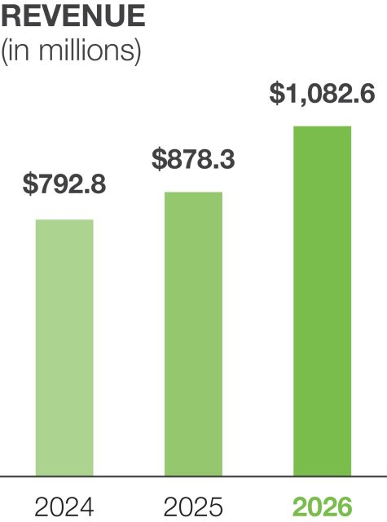 |  | 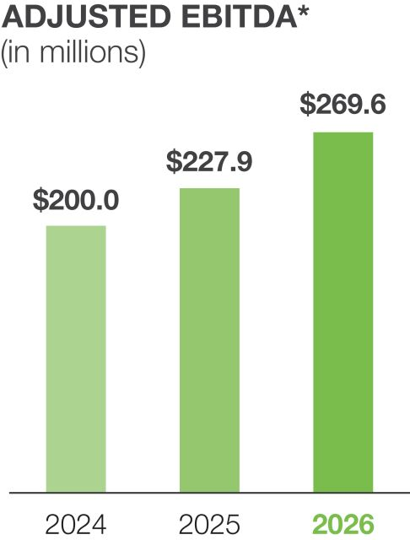 |  | 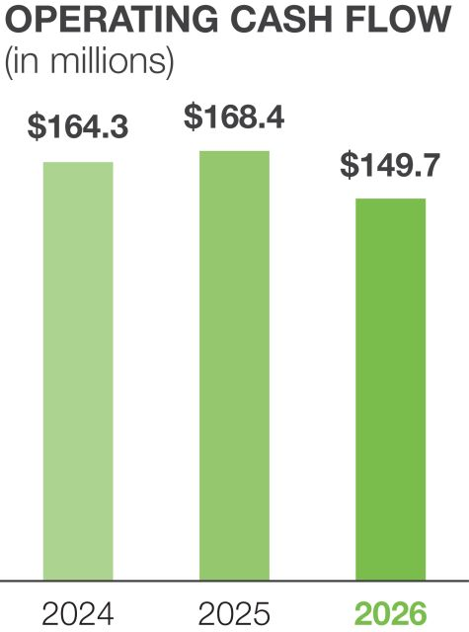

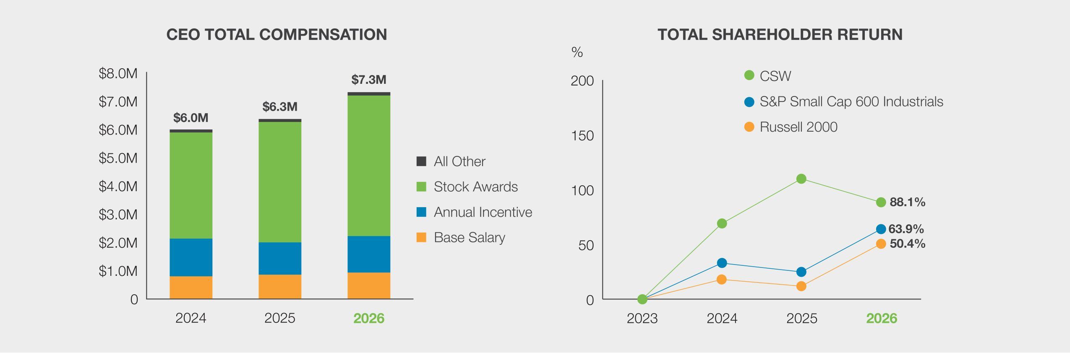
* Reconciliation to GAAP amounts appear in Exhibit A.

 | 36 |  |  |  |  | | 2026 Proxy Statement

Table of Contents
Executive Compensation
Compensation Discussion and Analysis

As discussed in more detail under “Executive Compensation Program—Annual Incentive Program,” our Annual Incentive Program (“AIP”) allows our NEOs, as well as almost all other Company employees, to receive a cash incentive payment based upon achievement of pre-established financial and individual goals. Based on our fiscal 2026 results, the Company achieved approximately 95% of our annual EBITDA goal and achieved approximately 109% of our annual Operating Cash Flow goal.
As discussed in more detail under “Executive Compensation Program—Long-Term Equity Incentives,” our NEOs, as well as other Company employees, are eligible to receive equity awards under our Long-Term Incentive Program (“LTIP”) that include performance shares, which vest based upon the Company’s financial performance against pre-established goals. For our fiscal 2024 awards (having an April 1, 2023 to March 31, 2026 performance period), our NEOs at the time received performance shares that vested based on the Company’s total shareholder return (“TSR”) compared to the TSRs of the Russell 2000 Index’s members. When measured as prescribed in our performance share awards, the Company achieved a TSR of 92.8% for this performance period, which ranked 425th among the members of the Russell 2000 Index, or the 78.1st percentile. This performance vested these performance shares at 190.7% of target, under our established performance vesting grid. This result is consistent with our emphasis on long-term shareholder value creation and the achievement of benchmarked performance goals, which are described in more detail throughout this CD&A. The chart below illustrates the actual relative TSR performance for the fiscal 2024 performance share awards, as well as the projected relative TSR performance for the fiscal 2025 and 2026 performance share awards, all compared to the Russell 2000 Index’s members at March 31, 2026.

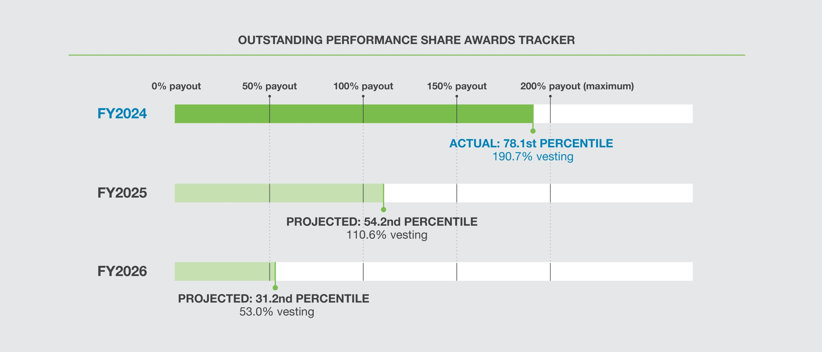

 |  |  |  |  |  |  |  | | 2026 Proxy Statement |  | 37

Table of Contents
Executive Compensation
Compensation Discussion and Analysis

Executive Compensation Program Changes for Fiscal 2026
The Compensation Committee is committed to continuously evaluating our executive compensation program, with a focus on the best interests of our shareholders and the Company and sound compensation practices, consistent with our compensation program purpose and objectives. The Compensation Committee evaluated all elements of our compensation program for fiscal 2026, in consultation with management and WTW, its independent compensation consultant. As a result of this evaluation, the Compensation Committee approved incremental updates to certain elements of the AIP and the LTIP.
Annual Incentive Plan Changes
Metric Target Setting Process. In fiscal 2025, the Compensation Committee returned to annual target setting for our AIP performance metrics following a period of four years during which we used a less-than-annual target setting process for AIP metrics, as we navigated COVID-related challenges and related market disruptions, the integration of material acquisitions, and an unprecedented inflationary environment and significant volatility in actual and forecasted input costs, including freight. As we concluded fiscal 2025 and entered fiscal 2026, rapid changes in domestic and international trade policy and the threat and/or implementation of increased and retaliatory tariffs created significant macroeconomic turmoil and uncertainty regarding market demand, input costs, and freight. Due to this, forecasting annual performance targets for our AIP metrics became very difficult, which magnified risks within the AIP program in a manner similar to what we experienced in the fiscal 2021-2024 time frame.
To address these risks, for fiscal 2026, the Compensation Committee, with the support of WTW and management, returned to a semi-annual target-setting process for our AIP metrics, the same as used during the fiscal 2022-2024 time frame. As was demonstrated during prior years, the semi-annual AIP target-setting process provides an artful solution to target setting challenges that exist in the face of unique market conditions and their associated challenges, which were again present in fiscal 2026. Utilizing more frequent than annual target setting intervals has a limiting effect on AIP payouts—it mitigates the risk of inflated payouts that can result from targets being set too conservatively in the face of significant uncertainty, and, due to having multiple measurement periods, it makes achieving “maximum” payout levels for the full year more difficult. Conversely, it provides the Compensation Committee and management the ability to address rapidly changing market conditions, reducing the potential for out-of-cycle adjustments to established AIP metric targets.
The Compensation Committee continued to adhere to our compensation objectives and principles in fiscal 2026, including ensuring that performance targets for all financial metrics used in our AIP are set at objective, challenging levels that require significant effort and achievement by our NEOs for a target payout to occur.
Payout Matrix Update. For fiscal 2026, the Compensation Committee approved an expansion of the lower end of the payout matrix for the AIP’s EBITDA and OCF financial metrics. As shown in the table below, the existing “threshold” (or 50% payout) remained at 85% of target for the EBITDA metric and at 80% of target for the OCF metric; however, a new “lower threshold” (or 30% payout) was added at 70% of target for the EBITDA metric and at 60% of target for the OCF metric. This change was made to better align the AIP’s payout matrix with practices among our Compensation Peer Group and the broader market regarding short-term incentive programs.

EBITDA Payout Matrix
Lower  Threshold  (30% Payout) |  | Interim  Threshold  (50%  Payout) |  | Target  (100%  Payout) |  | Maximum  (200%  Payout)
70% of Target |  | 85% of Target |  | 100% of Target |  | 115% of Target

Operating Cash Flow Payout Matrix
Lower  Threshold  (30% Payout) |  | Interim  Threshold  (50%  Payout) |  | Target  (100%  Payout) |  | Maximum  (200%  Payout)
60% of Target |  | 80% of Target |  | 100% of Target |  | 120% of Target

Consistent with the philosophy and approach used in prior years, the Compensation Committee continued to evaluate performance levels for our AIP payout matrix to ensure an appropriate level of rigor was maintained, and that maximum performance remained a realistic probability to motivate overperformance for shareholders’ benefit.

 | 38 |  |  |  |  | | 2026 Proxy Statement

Table of Contents
Executive Compensation
Compensation Discussion and Analysis

Executive Compensation Practices
In support of our compensation program objectives, the Compensation Committee maintains a thoughtful approach to our executive compensation program design and governance practices. The below table summarizes these practices.

What We Do |  |  |  |  |  | What We Don’t Do
 |  | Promote a strong pay for performance plan design |  |  |  |  |  | No hedging, pledging, or short sales of stock permitted
 |  | Regularly benchmark executive compensation against peers of comparable size, complexity, and industry |  |  |  |  |  | No change in control excise tax gross ups
 |  | Maintain meaningful stock ownership guidelines for our directors and executive officers |  |  |  |  |  | No option repricing without shareholder approval
 |  | Have double trigger requirements on cash payments following a change in control |  |  |  |  |  | No perquisites offered, other than those generally provided to all employees
 |  | Conduct an annual compensation risk review |  |  |  |  |  | No dividends paid and no voting rights on unvested performance-based equity awards
 |  | Provide reasonable and standardized benefits upon severance or change in control |  |  |  |  |  | No duplication of metrics in annual and long-term incentive plans
 |  | Engage an independent compensation consultant |  |  |  |  |  | No supplemental executive retirement plans
 |  | Maintain an incentive compensation clawback policy
The Compensation Decision Making Process
How Compensation Decisions Are Made for Our NEOs

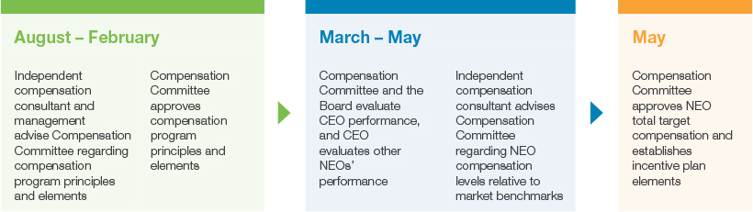

 |  |  |  |  |  |  |  | | 2026 Proxy Statement |  | 39

Table of Contents
Executive Compensation
Compensation Discussion and Analysis

Roles and Responsibilities

Compensation  Committee |  | CEO and Management |  | Independent  Compensation  Consultant
•  Oversees the Company’s compensation and benefit programs, including the AIP and LTIP  •  Administers the executive compensation program  •  Evaluates NEO performance and sets target compensation levels for all NEOs  •  Approves incentive plan performance metrics and targets  •  Oversees the assessment of compensation program risks  •  Oversees management’s leadership development and succession planning programs  •  Engages the independent compensation consultant  •  Oversees stock ownership guidelines and clawback policy  •  Recommends changes in director compensation for Board approval  •  Composed entirely of independent, non-employee directors, per NYSE requirements |  | •  CEO evaluates other NEO performance and makes recommendations to the Compensation Committee on compensation levels in light of performance and market benchmarks  •  Other members of the executive team, as appropriate, advise the Compensation Committee on compensation program elements, market practices, and compliance matters  •  No member of management participates in discussions concerning his or her compensation |  | •  Engaged by, and reports to, the Compensation Committee  •  Assists and advises the Compensation Committee on aspects of compensation program objectives, principles, and design  •  Advises the Compensation Committee on selection of competitive market benchmarking data, including the Compensation Peer Group (as defined below)  •  Analyzes competitive market data in the context of the Company’s compensation program and provides recommendations to the Compensation Committee  •  Provides compensation program risk assessment  •  Provides no other services to the Company
Review of Executive Compensation Program Effectiveness
As shown above, the Compensation Committee annually conducts a comprehensive review of all components of our executive compensation program. This review is facilitated by management with the assistance of the independent compensation consultant and is influenced by feedback from our shareholders. The Compensation Committee continually evaluates whether our executive compensation program is aligned with and supports the Company’s strategic objectives, and it considers evolving market practices in the general industry, external regulatory requirements, shareholder feedback, the competitive market for executives, and our compensation program objectives and principles. In conducting its review, the Compensation Committee assesses all information related to each executive officer’s compensation, including base salary, target short-term and long-term incentives, and retirement, health and welfare benefits.

 | 40 |  |  |  |  | | 2026 Proxy Statement

Table of Contents
Executive Compensation
Compensation Discussion and Analysis

Market Competitiveness and External Benchmarking
The Compensation Committee regularly reviews relevant market compensation survey data to evaluate the market competitiveness of our executive compensation program. This specifically furthers our “Attract and Retain Key Leaders” compensation program objective and enables the achievement of our other objectives. The Compensation Committee uses survey data provided by its independent compensation consultant, which consists of compensation data for comparable executive positions within a group of peer companies (the “Compensation Peer Group”). The data also includes data from comparably sized companies within the broader market, as candidates for executive roles, as well as market opportunities for our current executives, are not limited to companies in our industry sectors.
The process for selecting the members of the Compensation Peer Group is shown below.

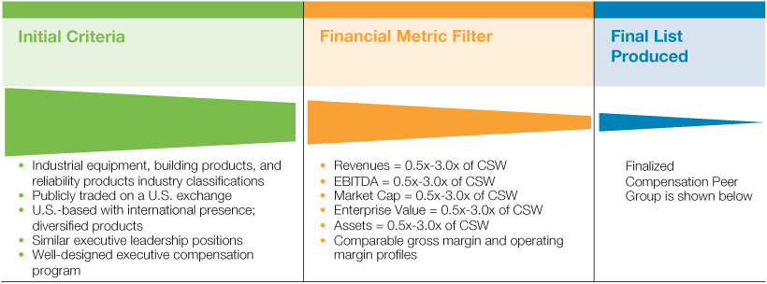
The Compensation Peer Group used to evaluate executive compensation in fiscal 2026 was as follows:

AAON, Inc.  Armstrong World Industries, Inc.  AZZ Inc.  Barnes Group Inc.  Columbus McKinnon Corp.  EnPro Industries, Inc.  ESCO Technologies Inc.  Franklin Electric Co., Inc. |  | Gibraltar Industries, Inc.  Helios Technologies, Inc.  Innospec Inc.  Kadant Inc.  Mueller Water Products, Inc.  SPX Technologies, Inc.  Standex International Corp.
Compared to fiscal 2025, only incremental updates were made to the Compensation Peer Group. One former peer company, PGT Innovations, Inc., was acquired in calendar 2024 and removed from the group. This position was replaced with a qualifying industrial equipment company, AZZ Inc., maintaining the group’s industry representation and the size of the data set for statistical purposes. The Compensation Committee determined that no other changes to the Compensation Peer Group were necessary, as all other peers continued to satisfy the established filter criteria.
All compensation elements for our NEOs are generally set using the 50th percentile of benchmarked compensation data as a reference point. This includes base salaries, annual incentive opportunities, total target cash compensation, long-term incentive compensation, and total target compensation. Actual benchmarked percentile rankings for our NEOs’ target compensation levels vary and can be above or below the 50th percentile reference point for a variety of reasons, including individual performance, experience, succession potential, and scope of responsibilities. This approach helps the Compensation Committee balance a performance-focused structure with the need to maintain market-competitive target and realized compensation.

 |  |  |  |  |  |  |  | | 2026 Proxy Statement |  | 41

Table of Contents
Executive Compensation
Compensation Discussion and Analysis

Executive Compensation Program Risk Assessment
A critical part of the Compensation Committee’s executive compensation program review is an evaluation of whether the program, both as a whole and its individual elements, is consistent with the Company’s risk management objectives. If any program element is determined to be inconsistent with our objectives and principles, or if it is determined to encourage risks that are reasonably likely to have a material adverse effect on us, the elements are adjusted as necessary.
The Compensation Committee, in consultation with its independent compensation consultant, has concluded that no risks arising from our compensation policies and practices are reasonably likely to have a material adverse effect on the Company. In reaching this conclusion, the Compensation Committee noted that:

 |  | Compensation elements are balanced |  | We provide a balanced mix of base salary, annual cash incentive compensation, and long-term equity incentives. This balanced mix provides the incentive to perform at high levels and maximize Company performance. At the same time, it does not encourage singular focus on compensation performance metrics to the detriment of other important business metrics or overlooking how goals are accomplished.
 |  | Performance metrics balance short-term and long-term goals |  | Our incentive compensation metrics are balanced between short- and long-term business and financial objectives. The metrics for our short- and long-term plans do not overlap, which prevents executives from focusing on one goal at the expense of others. All the performance goals are aligned with shareholder interests.
 |  | Individual performance is emphasized |  | We emphasize individual, non-financial performance metrics in determining individual compensation amounts. The Compensation Committee strongly believes this effectively encourages and rewards behaviors that are consistent with our business objectives and core values and discourages behaviors that are not.
 |  | Incentive programs have performance thresholds and are capped |  | Both the AIP opportunity and performance shares have threshold payout levels and/or performance contingencies, which ensure that incentive compensation is reduced or eliminated if minimum performance levels are not achieved. They also have maximum payout levels, which helps avoid excessive total compensation and reduces the incentive to engage in unnecessarily risky behavior.
 |  | Compensation is benchmarked |  | The Compensation Committee benchmarks compensation against both our Compensation Peer Group and the broader market to ensure our programs are performance-based, competitive, equitable, and generally consistent with industry and comparator company practices.
 |  | Executives have equity ownership guidelines |  | Our officers have robust equity ownership guidelines, which encourage a long-term focus on sustainable performance and further align our officers’ interests with those of our shareholders. Executives are prohibited from pledging stock and engaging in transactions designed to hedge against the value of the Company’s stock.

 | 42 |  |  |  |  | | 2026 Proxy Statement

Table of Contents
Executive Compensation
Compensation Discussion and Analysis

Executive Compensation Program

Principles
The Compensation Committee has established the following principles to guide the achievement of our compensation objectives and the design and administration of specific programs for our NEOs.
Total Compensation Should be Primarily Performance-Based, With a Majority “At Risk”
A meaningful portion of our executives’ total compensation should be performance-based (rather than fixed or merely variable), and at least a majority of total compensation should be “at risk” – in other words, variable dependent upon our stock price, our financial performance, or an executive’s individual performance. This ensures a strong correlation between executive pay and Company and individual performance, and it helps achieve our first compensation program objective: “Align Long-Term Executive and Shareholder Interests.” Additionally, the proportion of total compensation that is “at risk” versus fixed should increase in line with the scope and level of the executive’s responsibilities.
The following table shows the percentage of each NEO’s total target compensation was “at risk” under the program.
PERCENT OF FISCAL 2026 TARGET PAY “AT RISK”(1)

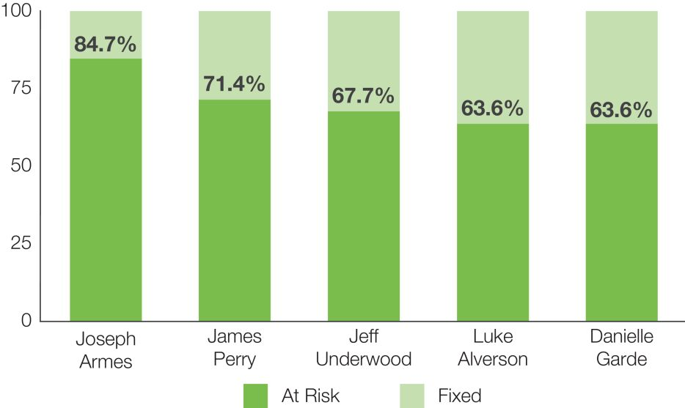

(1) | Calculated by dividing (i) the sum of the annual incentive opportunity and target long-term incentive opportunity by (ii) total target compensation.

Incentive Compensation Should Balance Short-Term and Long-Term Performance
Executive compensation should be linked to building long-term shareholder value while remaining consistent with our business objectives. The Base Salary and Annual Incentive compensation elements emphasize short-term financial and individual performance, as well as the achievement of annually defined business and financial objectives. The Long-Term Equity Incentive compensation element emphasizes long-term financial performance and strategic plan execution by tying a meaningful portion of compensation to the performance of the Company’s common stock.
Compensation Should be Market Competitive and Reflect Individual Performance
Achievement of our compensation objectives requires our compensation program, and the compensation elements within it, to be market competitive. If we are unable to attract and retain top executive talent within the markets in which we compete, we will hinder our ability to create long-term shareholder value. As discussed above, the Compensation Committee utilizes the Compensation Peer Group and relevant market compensation survey data, with the assistance of its independent compensation consultant, to ensure our compensation program is benchmarked and that each NEO’s total target compensation is appropriately tailored for the leadership roles in which they serve.
At the same time, a critical aspect of our culture examines how the Company succeeds, which is reinforced through our ACT. RISE. core values. We seek to attract and retain executive leaders who exemplify our values in how they lead and accomplish business objectives. Compensation programs that are overly focused on market benchmarking, or incentive plans that are purely formulaic, are limited in their ability to account for qualitative performance assessments. This creates program risk and can work against the Company’s and shareholders’ long-term interests. Accordingly, the Compensation Committee retains an element of discretion to ensure an executive’s realized compensation reflects individual, qualitative performance, consistent with our culture and values.

 |  |  |  |  |  |  |  | | 2026 Proxy Statement |  | 43

Table of Contents
Executive Compensation
Compensation Discussion and Analysis

Performance-Based Compensation Metrics Should Be Objective, Clear, Challenging, and Achievable
In simple terms, the objective of any performance- or incentive-based program is to produce a desired result. Achievement of a desired result cannot be determined if the desired result is not objectively defined. Additionally, performance targets must be clear and uncomplicated so that a path to achievement can be developed and understood. As such, the Compensation Committee establishes our incentive plans with objective, clearly defined performance targets that are focused on performance metrics that our Board believes are most critical to the Company’s success.
Aligning our incentive compensation programs with shareholder interests requires that NEOs be paid commensurate with performance, and performance targets must be challenging to create shareholder value. At the same time, performance targets must be realistically achievable to create the proper incentive and reward structure, or else a disincentive risk can emerge. The Compensation Committee balances these interests by setting performance targets at levels requiring significant effort and achievement by our NEOs, relative to Company circumstances and market
conditions, for a target-level payout to occur, within a structure that provides a meaningful incentive to drive overperformance.
Performance-Based Metrics Should be Externally Benchmarked
Measuring how the Company performs against internally developed targets is an important aspect of incentive compensation, as it sets expectations and motivates performance. However, internal performance metrics alone do not create a full picture of Company performance. As such, the performance-based elements of our executive compensation program should also evaluate the Company’s performance relative to external benchmarks.
Since inception, the performance shares granted under our LTIP have used an external benchmark for measuring Company performance, and since 2017, that benchmark has been the Russell 2000 Index, of which the Company is a member. This shows, on a relative basis, how well we deliver results that directly create long-term shareholder value. Additionally, AIP performance metric targets are set in reference to how the Company is expected to perform both compared to the prior year and relative to forecasted market growth rates.

Base Salary |  | 
The Compensation Committee reviews and establishes NEO base salaries consistent with the process described above under “The Compensation Decision Making Process.” For each NEO, the Compensation Committee considers our NEOs scope of responsibilities, experience, and individual performance and then balances these factors against competitive salary practices, including internal pay equity. The Compensation Committee does not assign any relative or specific weights to these factors. The base salaries established for fiscal 2026 are presented in the following table.

Named Executive Officer |  | Fiscal 2026  Annual Base Salary  ($) |  | Fiscal 2025  Annual Base Salary  ($)
Joseph B. Armes |  | 925,000 |  | 850,000
James E. Perry |  | 520,000 |  | 495,000
Jeff A. Underwood |  | 440,000 |  | 385,000
Luke E. Alverson |  | 440,000 |  | 423,000
Danielle R. Garde |  | 440,000 |  | 423,000
The Compensation Committee’s fiscal 2026 compensation evaluation adjusted NEO base salaries as it determined appropriate, making adjustments based on market proximity and the executive team’s strong performance, consistent with our compensation objectives.
Mr. Armes’ base salary and other compensation components in fiscal 2026 are discussed below in further detail under “Chief Executive Officer Compensation in Fiscal 2026.”

 | 44 |  |  |  |  | | 2026 Proxy Statement

Table of Contents
Executive Compensation
Compensation Discussion and Analysis

Annual Incentive Program |  | 
Our AIP exists to provide employees with a short-term, performance-based cash incentive that promotes the achievement of our annual operating budget and the financial metrics that we believe most strongly correlate to long-term shareholder value creation. This incentive most directly supports our “Align Long-Term Executive and Shareholder Interests” and “Reward Current Performance” compensation objectives.
AIP Target Opportunities
The Compensation Committee establishes an AIP target opportunity for each NEO consistent with the process described above under “The Compensation Decision Making Process.” The Compensation Committee also approves the AIP’s financial performance metrics at that same time.
Our NEO’s AIP target opportunities are expressed as a percentage of base salary. AIP target opportunities established for fiscal 2026 are presented in the following table.

Named Executive Officer |  | Fiscal 2026 AIP  Target ($) |  |  |  |  | Fiscal 2026 AIP  Target % of  Base Salary |  |  |  |  | Fiscal 2025 AIP  Target % of  Base Salary
Joseph B. Armes |  |  |  | 1,202,500 |  |  |  |  | 130 | % |  |  |  | 130 | %
James E. Perry |  |  |  | 390,000 |  |  |  |  | 75 | % |  |  |  | 75 | %
Jeff A. Underwood |  |  |  | 286,000 |  |  |  |  | 65 | % |  |  |  | 55 | %
Luke E. Alverson |  |  |  | 242,000 |  |  |  |  | 55 | % |  |  |  | 55 | %
Danielle R. Garde |  |  |  | 242,000 |  |  |  |  | 55 | % |  |  |  | 55 | %
The Compensation Committee did not make any changes to AIP target percentages for fiscal 2026, with the exception of Mr. Underwood based on proximity to market benchmarks. The Compensation Committee determined that, in conjunction with the market-driven base salary increases for fiscal 2026 discussed above, the AIP targets and resulting total target cash compensation for each NEO were within acceptable proximity to market benchmarks and provided incentives consistent with our objectives.
AIP Performance Metrics
The Compensation Committee, working with management and the Compensation Committee’s independent compensation consultant, evaluates and approves the Company’s AIP performance metrics for each fiscal year when AIP target opportunities are established. The Compensation Committee weights performance metrics for each NEO—including business unit leaders—in proportions that ensure performance metrics are heavily weighted toward the Company’s consolidated performance. We believe it is important that all NEOs are primarily focused on setting the strategic direction of the Company (rather than only at the business unit level) and achieving overall Company results.
The Compensation Committee also believes that AIP payouts should reflect individual, non-financial performance metrics. This serves to mitigate the risks that objective factors can have on incentive pay when overused. Importantly, non-formulaic metrics provide the Compensation Committee with discretion to adjust compensation upward or downward based on how an executive accomplished objectives and goals, thereby rewarding behaviors that are consistent with our business objectives and ACT. RISE. core values.

 |  |  |  |  |  |  |  | | 2026 Proxy Statement |  | 45

Table of Contents
Executive Compensation
Compensation Discussion and Analysis

The Company’s fiscal 2026 AIP performance metrics are set forth below and were unchanged from fiscal 2025. The Compensation Committee selected these performance metrics, with input from management and WTW, because they support the key strategies that we believe drive sustainable and profitable Company growth and create shareholder value.

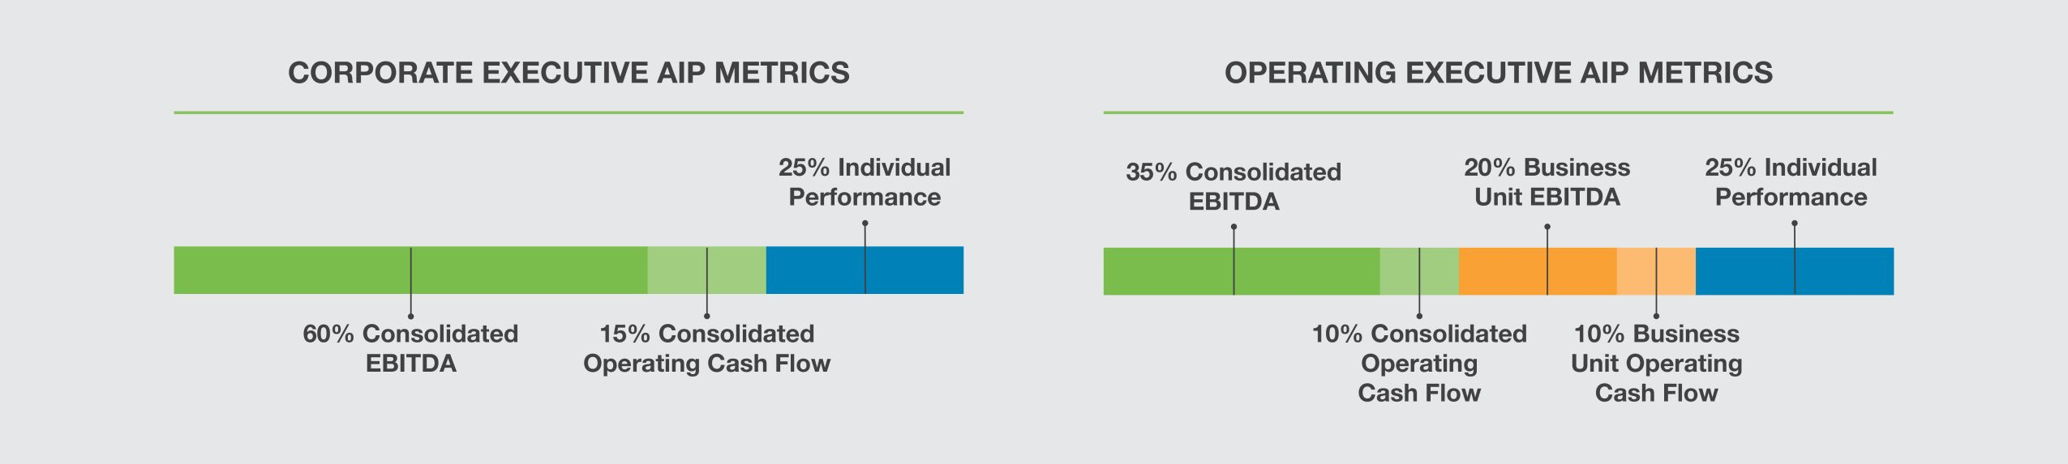

Consolidated  EBITDA |  | Consolidated Operating  Cash Flow |  | Business Unit  EBITDA |  | Business Unit Operating  Cash Flow |  | Individual  Performance
Why we use it: Measures and supports both our revenue and profitability growth objectives, aligning our interests with the interests of our shareholders |  | Why we use it:  Measures and supports our strategic objectives of managing working capital efficiently and delivering strong cash flow from operations to fund growth and returns to shareholders |  | Why we use it: Measures and supports both our revenue and profitability growth objectives at the segment/operating company level, which are in direct control of the executive |  | Why we use it:  Measures and supports our strategic objectives of managing working capital efficiently and delivering strong cash flow from operations to fund growth and returns to shareholders |  | Why we use it: Emphasizes individual performance and qualitative achievement of goals to promote and reward behaviors consistent with our business objectives and core values
How we measure it:  U.S. GAAP net income, plus interest, taxes, depreciation, and amortization |  | How we measure it:  U.S. GAAP (net cash provided by operating activity) |  | How we measure it:  U.S. GAAP net income, plus interest, taxes, depreciation, and amortization |  | How we measure it:  U.S. GAAP (net cash provided by operating activity) |  | How we measure it:  Board and CEO assessment of individual performance against predetermined goals and objectives
Payout range:  0%—200% |  | Payout range:  0%—200% |  | Payout range:  0%—200% |  | Payout range:  0%—200% |  | Payout range:  0%—200%

 | 46 |  |  |  |  | | 2026 Proxy Statement

Table of Contents
Executive Compensation
Compensation Discussion and Analysis

AIP Performance Calculation and Payout
When the Compensation Committee approves AIP performance metrics for the year, it also establishes a payout matrix for the AIP, which determines the percentage of AIP target that is paid for performance achieved. Achievement of financial-based performance metrics is objective and calculated as appropriate. Payout percentages for each NEO’s qualitative individual performance metric are determined by the Compensation Committee based on individual performance assessments, as discussed previously.
Fiscal 2026 AIP Payout Matrix and Performance Measurement
Payout Matrix. The fiscal 2026 payout matrix established for all AIP metrics was 0% to 200% of the target award opportunity, which was unchanged from fiscal 2025. The actual AIP payout percentage is calculated by comparing actual financial metric performance against the established targets. Payouts for each of the financial metrics are calculated on a straight-line basis between the applicable performance levels (“threshold,” “target,” and “maximum”).
Target Setting. In fiscal 2026, the Compensation Committee approved the setting of semi-annual targets for both our EBITDA and OCF financial metrics. The Compensation Committee believed this approach, which the Company used during the fiscal 2022-fiscal 2024 timeframe, was appropriate based on acute uncertainty in overall business conditions present at the start of the fiscal year. First fiscal half (“1H”) performance metric targets were established in early May 2025 (in the first quarter of fiscal 2026), and second fiscal half (“2H”) performance metric targets were established in mid-November 2025 (in the third quarter of fiscal 2026).
Financial Performance Adjustments. For all financial metrics, the Compensation Committee may exercise its judgment, within parameters it establishes at the beginning of the year, about whether to exclude the effect of certain developments in measuring performance. These developments may include unanticipated changes in accounting principles or extraordinary, unusual, or unplanned events, such as the effects of restructurings, impairments, reorganizations, acquisitions, dispositions, or other strategic initiatives.
Any adjustments approved by the Compensation Committee in measuring financial metric performance are fully disclosed below. Concerning acquisitions in particular, the Compensation Committee has consistently applied a policy to exclude the impact of acquisitions consummated during a performance period on AIP financial metrics, ensuring AIP payouts never directly benefit from acquired, unbudgeted EBITDA and cash flow impacts.
Performance Measurement and Payout. The following graphics show the fiscal 2026 AIP’s performance metrics, targets, payout matrixes, performance results, and percentage payouts.

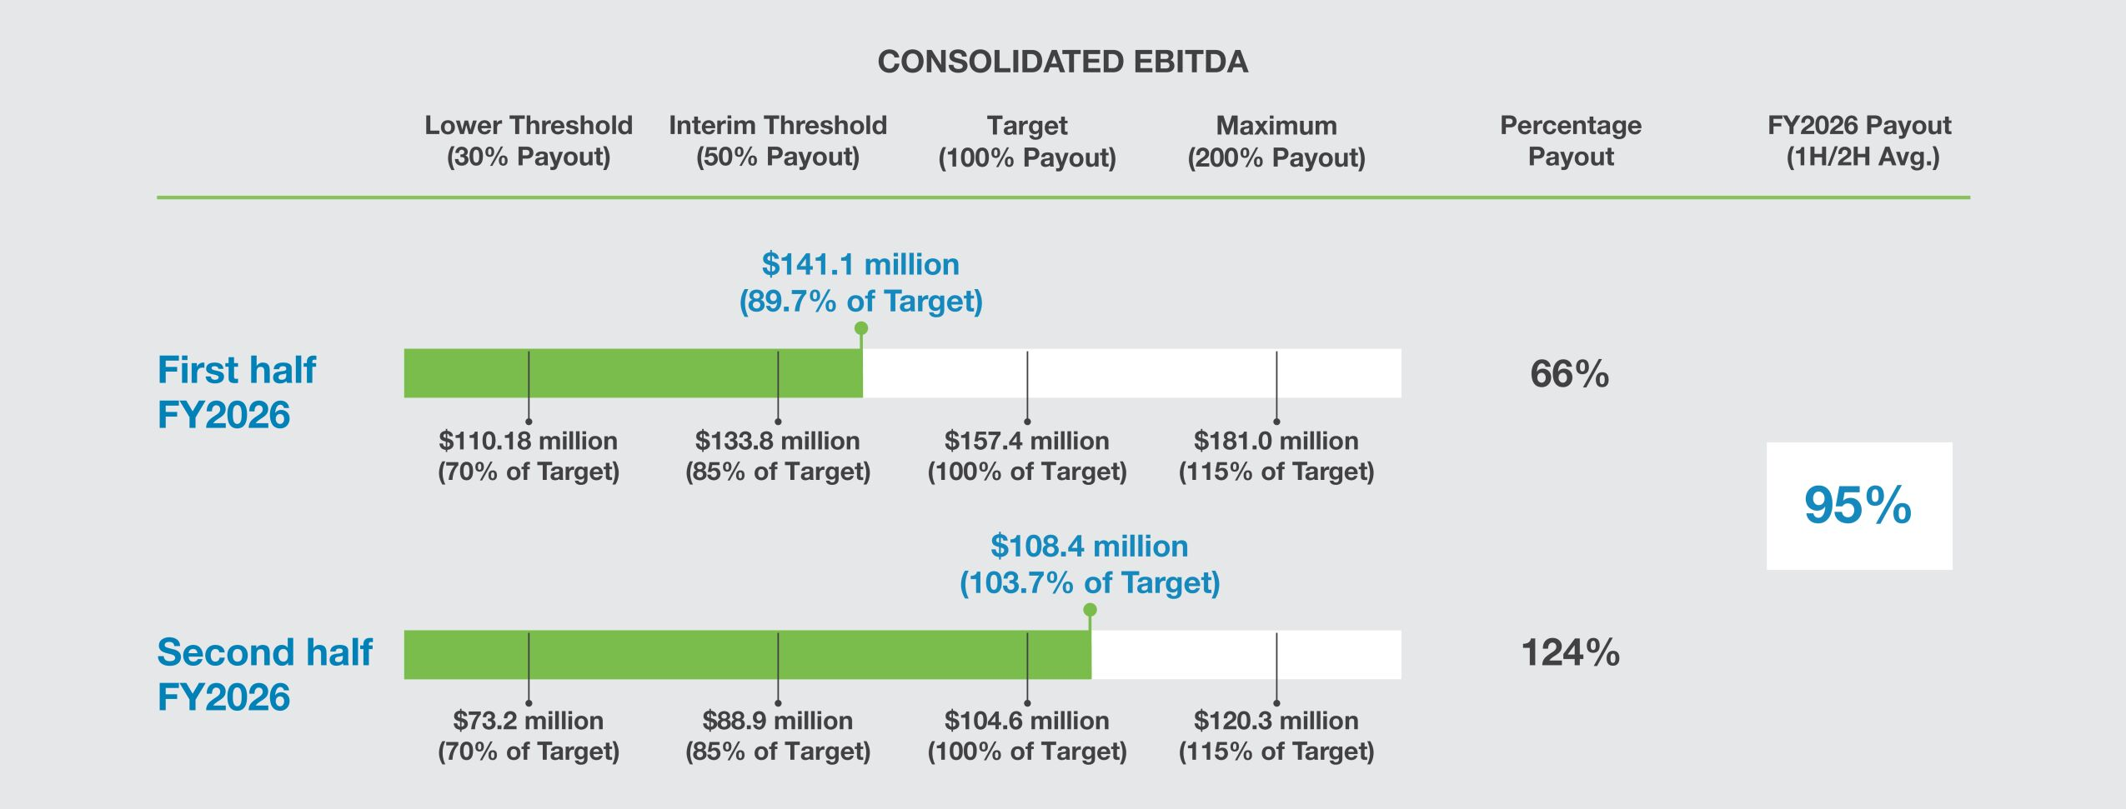

 |  |  |  |  |  |  |  | | 2026 Proxy Statement |  | 47

Table of Contents
Executive Compensation
Compensation Discussion and Analysis

In fiscal 2026, the Company delivered $249.5 million of EBITDA as measured under our AIP, a record performance and 13.5% increase over fiscal 2025. The EBITDA target for fiscal 2026 1H was a 26.7% increase over fiscal 2025 1H actual results, and the EBITDA target for fiscal 2026 2H was a 10.0% increase over fiscal 2025 2H actual results. Consistent with our objectives and historical approach to acquisitions, the fiscal 2026 measured performance excluded all EBITDA impacts from acquisitions consummated after targets are set for a measurement period, as well as all associated one-time transactional expenses. For fiscal 2026, the net EBITDA adjustments reduced the AIP’s measured EBITDA by $20.1 million compared to reported EBITDA.

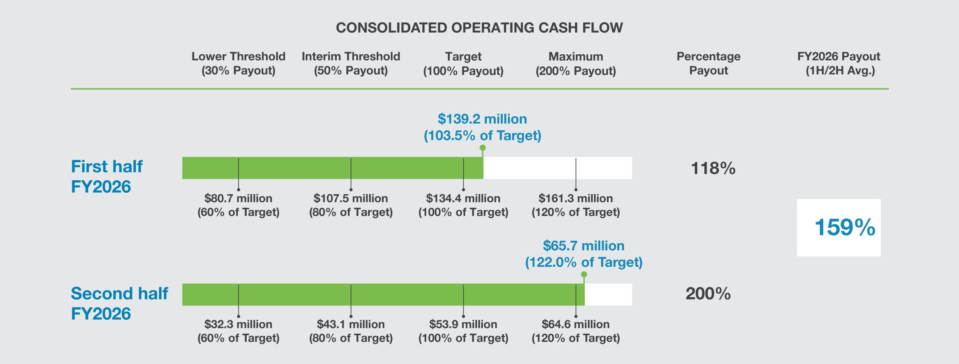
In fiscal 2026, the Company delivered $204.9 million of OCF as measured under our AIP, a record performance and 22.5% increase over fiscal 2025. The OCF target for fiscal 2026 1H was a 4.6% increase over fiscal 2025 1H actual results, and the OCF target for fiscal 2026 2H was a 2.4% decrease from fiscal 2025 2H actual results. The fiscal 2026 measured performance excluded all operating cash impacts from acquisitions consummated after targets are set for a measurement period, as well as all cash used (net of tax benefit) to fund financing costs and one-time transactional expenses related to such acquisitions. For fiscal 2026, the net OCF adjustments increased the AIP’s measured OCF by $55.2 million compared to reported operating cash flow, which was primarily driven by the exclusion of the MARS Parts acquisition from fiscal 2026 2H results.

 | 48 |  |  |  |  | | 2026 Proxy Statement

Table of Contents
Executive Compensation
Compensation Discussion and Analysis

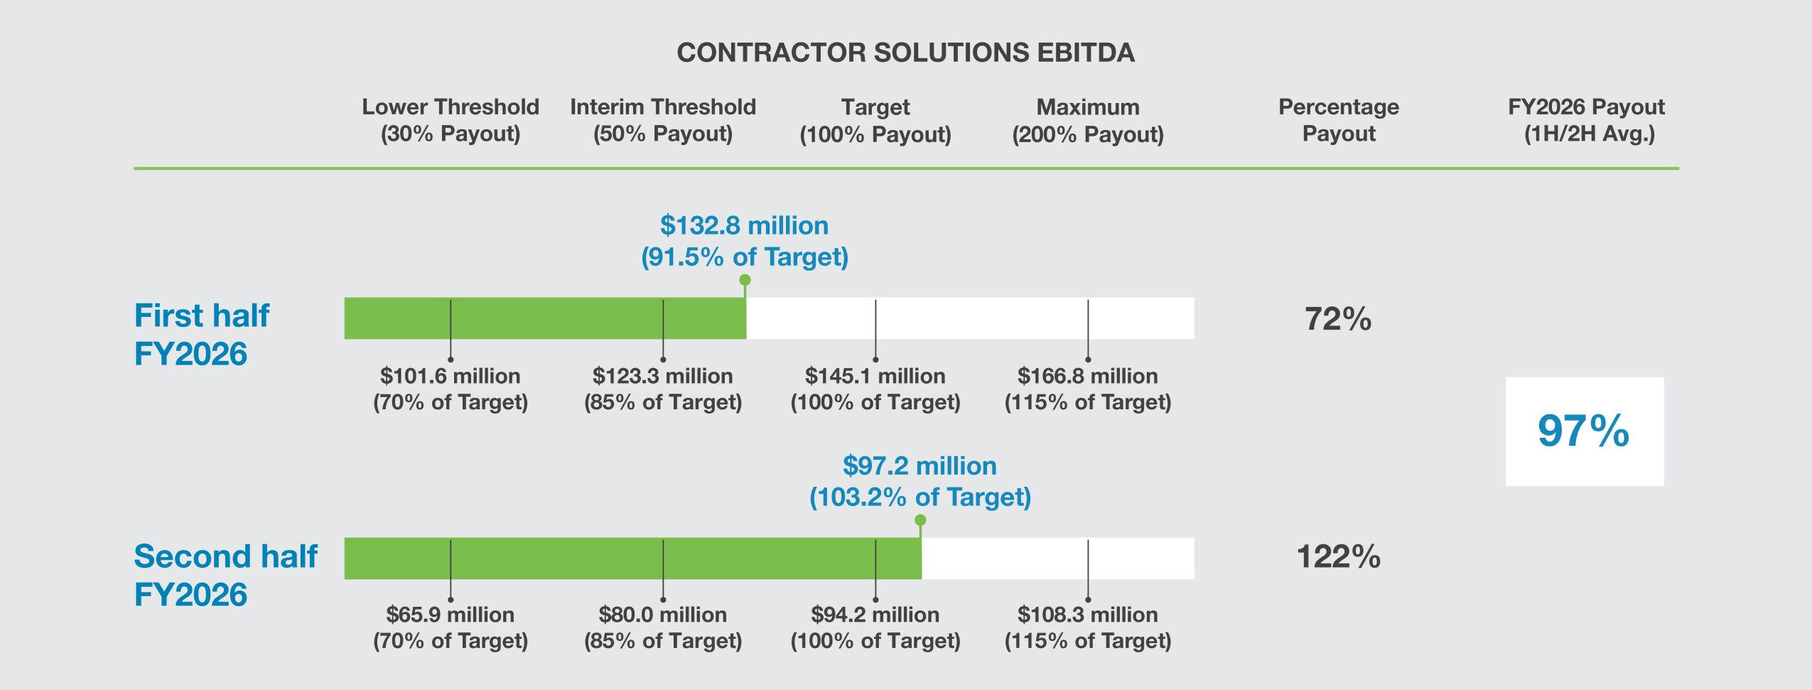
In fiscal 2026, the Company’s Contractor Solutions segment delivered $230.0 million of measured EBITDA, a record performance and 17.2% increase over the AIP’s fiscal 2025 results. These results are used in calculating Mr. Underwood’s business unit EBITDA metric payout percentage. Contractor Solutions’ EBITDA target for fiscal 2026 1H was a 35.7% increase over fiscal 2025 1H actual results, and the EBITDA target for fiscal 2026 2H was a 0.7% increase over fiscal 2025 2H actual results. As with the consolidated results, this measured performance excluded all EBITDA impacts from businesses acquired during a measurement period, as well as all one-time transactional expenses associated with the acquisitions. For fiscal 2026, the net business unit EBITDA adjustments reduced the AIP’s measured business unit EBITDA by $18.8 million compared to reported business unit EBITDA.

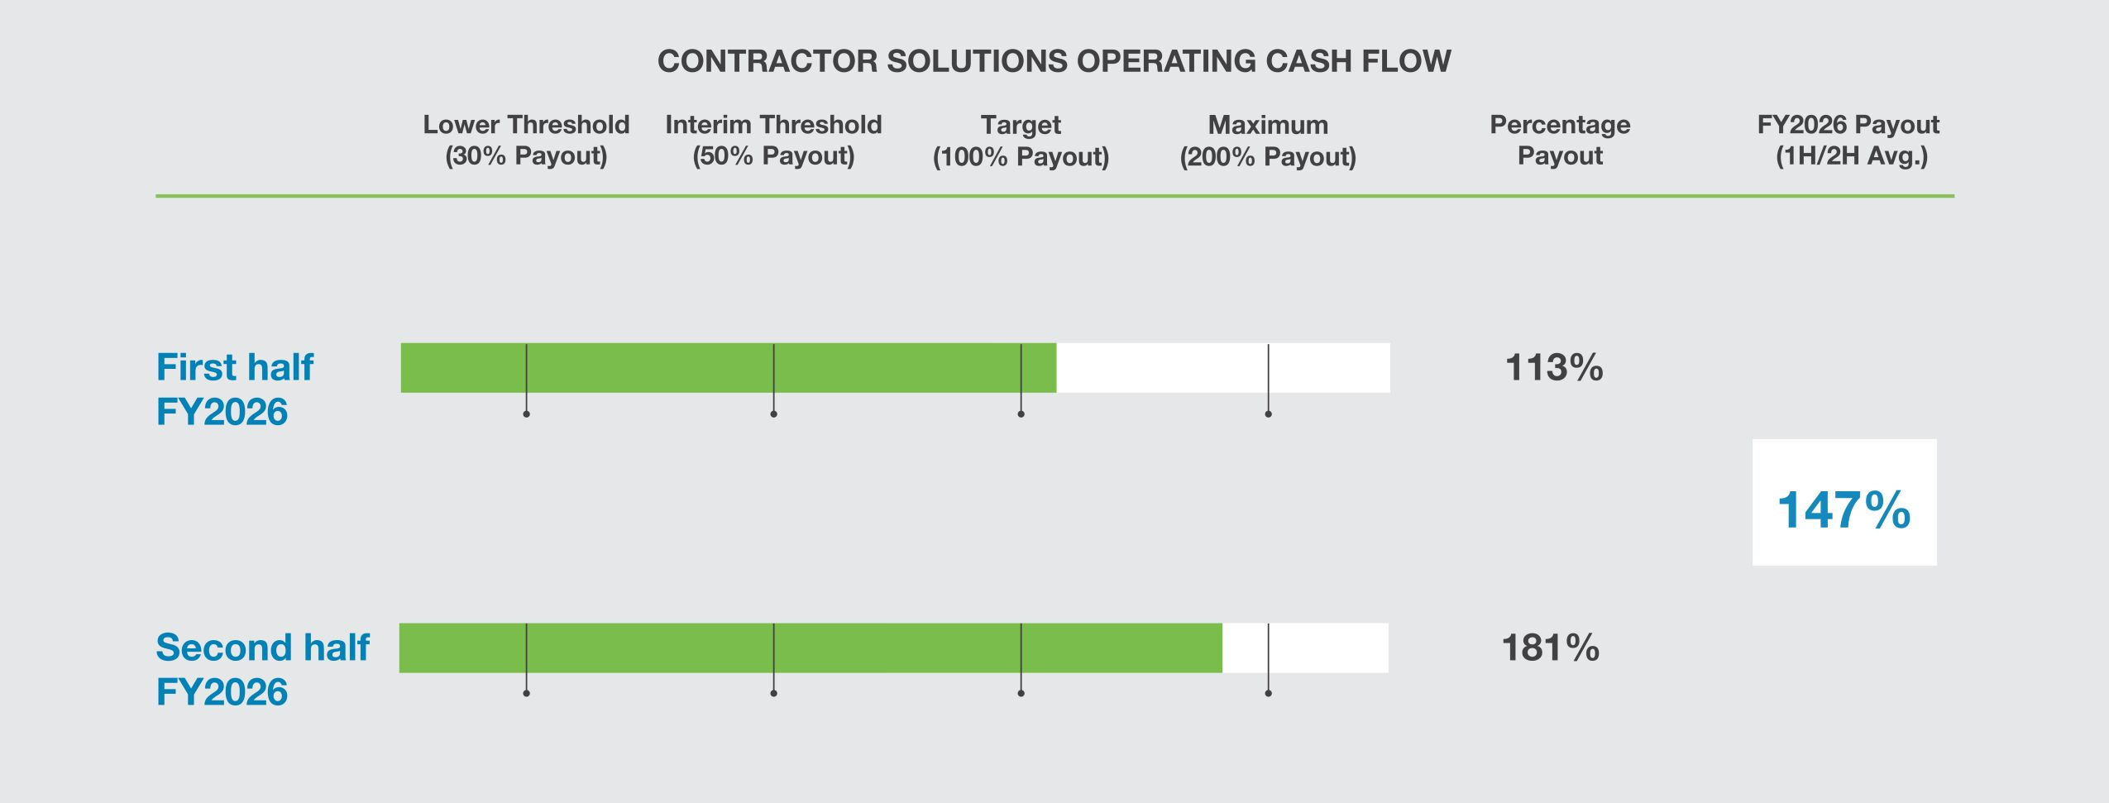

 |  |  |  |  |  |  |  | | 2026 Proxy Statement |  | 49

Table of Contents
Executive Compensation
Compensation Discussion and Analysis

While AIP results for any given year will vary, the Compensation Committee believes that appropriate performance target setting, when combined with strong Company and individual NEO performance, should result in AIP financial metric payouts that average close to target levels over a five-year period. For additional context, the following table summarizes the Company’s actual consolidated financial metric payout percentages under the AIP over the last five years.

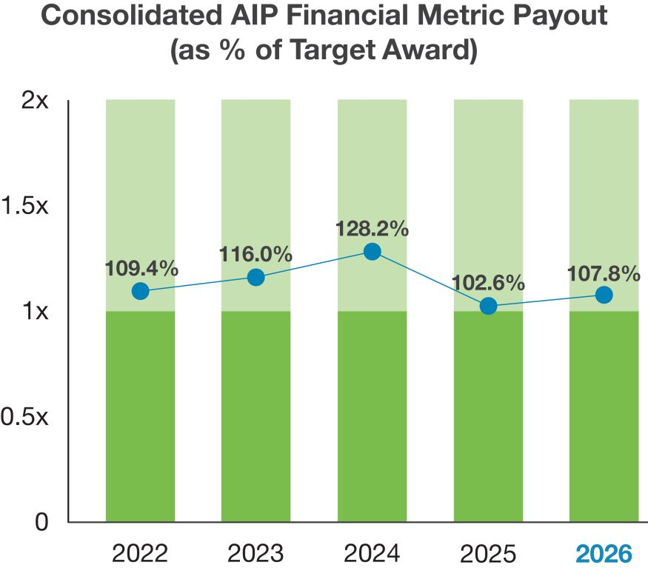
These results are used in calculating Mr. Underwood’s business unit OCF metric payout percentage. The Company has chosen not to disclose the lower threshold, interim threshold, target, maximum, and measured performance data for Contractor Solutions’ OCF metric, as this metric corresponds to financial data that is not publicly disclosed and is used primarily to assess compensation. The Company believes that disclosing such information would cause competitive harm to the Company without adding meaningfully to the understanding of its business.
The Compensation Committee believes that all performance targets for all financial metrics used in our AIP are set at definitive, challenging, and objective levels that require significant effort and achievement by our NEOs for a target payout to occur. Despite the inherent challenges of establishing performance targets in fiscal 2026 due to continued uncertainty in overall business conditions, particularly in light of challenged end markets driven by multiple factors, including rapidly changing foreign policy, the imposition of new and increased tariffs, and increased macroeconomic volatility, the Compensation Committee believes the AIP target-setting approach used in fiscal 2026 ensured these intentions were met.

Individual Performance
In determining individual performance payouts for our NEOs, the Compensation Committee considered pre-established individual performance goals and objectives for each NEO, which addressed the following topics:

 | • | Achievement of the Company’s and business units’ performance against key financial metrics, as applicable;

 | • | Execution of identified key growth initiatives and development of strategic growth capabilities, including successful execution of acquisitions and integration of acquired businesses;

 | • | Improvement in human capital management metrics, including talent development and employee retention;

 | • | Achievement of operational excellence and sustainability initiatives;

 | • | Successful management and mitigation of enterprise risks; and

 | • | Improvement in performance against key environmental, health, and safety metrics.

Additionally, the Compensation Committee considered the leadership acumen demonstrated by each NEO in addressing the unique challenges of fiscal 2026, and how each NEO performed and delivered results in a manner consistent with our ACT. RISE. core values: Accountability, Citizenship, Teamwork, Respect, Integrity, Stewardship, and Excellence.
The payout percentages for the 25%-weighted individual performance metric for each NEO are set forth in the final AIP payments table below. The total AIP award earned by each NEO for fiscal 2026 is reported in the “Summary Compensation Table” under the “Non-Equity Incentive Plan Compensation” column.

 | 50 |  |  |  |  | | 2026 Proxy Statement

Table of Contents
Executive Compensation
Compensation Discussion and Analysis

 |  | Target  AIP Award |  |  |  | Consolidated  EBITDA |  |  |  | Consolidated  Operating  Cash Flow |  |  |  | Business Unit  EBITDA |  |  |  | Business Unit  Operating  Cash Flow |  |  |  | Individual  Performance |  |  |  | FY2026  AIP Award
Joseph B. Armes |  | $ | 1,202,500 |  |  |  | $684,704  (94.9% Payout) |  |  |  | $286,616  (158.9% Payout) |  |  |  | — |  |  |  | — |  |  |  | $315,656  (105% Payout) |  |  |  | $1,286,976  (107.0% Payout)
James E. Perry |  | $ | 390,000 |  |  |  | $222,066  (94.9% Payout) |  |  |  | $92,957  (158.9% Payout) |  |  |  | — |  |  |  | — |  |  |  | $102,375  (105% Payout) |  |  |  | $417,398  (107.0% Payout)
Jeff A. Underwood |  | $ | 286,000 |  |  |  | $94,995  (94.9% Payout) |  |  |  | $45,445  (158.9% Payout) |  |  |  | $55,255  (96.6% Payout) |  |  |  | $42,042  (147.0% Payout) |  |  |  | $82,225  (115% Payout) |  |  |  | $319,963  (111.9% Payout)
Luke E. Alverson |  | $ | 242,000 |  |  |  | $137,795  (94.9% Payout) |  |  |  | $57,681  (158.9% Payout) |  |  |  | — |  |  |  | — |  |  |  | $63,535  (105% Payout) |  |  |  | $259,001  (107.0% Payout)
Danielle R. Garde |  | $ | 242,000 |  |  |  | $137,795  (94.9% Payout) |  |  |  | $57,681  (158.9% Payout) |  |  |  | — |  |  |  | — |  |  |  | $63,525  (105% Payout) |  |  |  | $259,001]  (107.0% Payout)

Long-Term Equity Incentives |  | 
Our LTIP exists to provide senior leaders a long-term, performance-based incentive that promotes building long-term shareholder value. These incentives most directly support our “Align Long-Term Executive and Shareholder Interests” and “Drive Future Performance” compensation objectives. LTIP awards take the form of Company equity, as the Compensation Committee believes that this is the best available vehicle to encourage performance with a view toward building long-term shareholder value.
LTIP Award Structure
Our LTIP consists of two components: performance shares and restricted stock, as shown below.

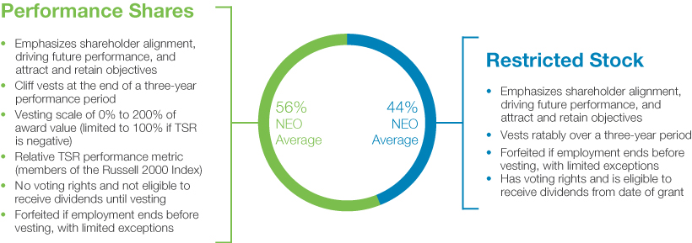
In fiscal 2026, all NEOs received their long-term incentive awards in these forms. The Compensation Committee believes these equity award forms and the target weighting appropriately balances ensuring executives have meaningful, long-term equity ownership, promoting stock price-based and financial-based achievements, and aligning the interests of the NEOs with the Company’s risk profile and the interests of our shareholders.

 |  |  |  |  |  |  |  | | 2026 Proxy Statement |  | 51

Table of Contents
Executive Compensation
Compensation Discussion and Analysis

LTIP Target Opportunities
Target Opportunities. The Compensation Committee establishes a target opportunity for each NEO under the Company’s LTIP consistent with the process described above under “The Compensation Decision Making Process.” Our NEOs LTIP target opportunities are expressed as a percentage of base salary. The LTIP target opportunities established for fiscal 2026 are set forth in the table below.

Named Executive Officer |  | 2026 LTIP  Target ($) |  |  |  |  | 2026 LTIP  Target as %  of Base Salary |  |  |  |  | LTIP Award  Format |  |  |  |  | 2025 LTIP  Target as %  of Base Salary
Joseph B. Armes |  |  |  | 3,931,250 |  |  |  |  | 425 | % |  |  |  | 60% PS /40% RS |  |  |  |  | 375 | %
James E. Perry |  |  |  | 910,000 |  |  |  |  | 175 | % |  |  |  | 50% PS /50% RS |  |  |  |  | 175 | %
Jeff A. Underwood |  |  |  | 638,000 |  |  |  |  | 145 | % |  |  |  | 50% PS /50% RS |  |  |  |  | 115 | %
Luke E. Alverson |  |  |  | 528,000 |  |  |  |  | 120 | % |  |  |  | 50% PS /50% RS |  |  |  |  | 115 | %
Danielle R. Garde |  |  |  | 528,000 |  |  |  |  | 120 | % |  |  |  | 50% PS /50% RS |  |  |  |  | 115 | %

In reviewing the NEO’s LTIP target opportunities for fiscal 2026, the Compensation Committee largely maintained existing LTIP target percentages, with the exception of Mr. Armes and Mr. Underwood, whose targets were adjusted based on proximity to market benchmarks and consistent with demonstrated performance. As adjusted, the Compensation Committee determined that LTIP targets for NEOs were within acceptable proximity to market benchmarks and provided
performance-based compensation and “at risk” pay consistent with our objectives. Additionally, the Compensation Committee desired to maintain an increased level of performance-based compensation for Mr. Armes, informed by our compensation philosophy and market practices. As such, Mr. Armes’ target performance share award allocation was maintained at 60%, and his target restricted stock award allocation was maintained at 40%, of total LTIP.

 | 52 |  |  |  |  | | 2026 Proxy Statement

Table of Contents

Executive Compensation
C
o
m
pens
ation Discussion and Analysis

Burn Rates and Dilution
. The Compensation Committee also evaluates the impact of LTIP target opportunities and actual awards on “burn rates,” which measures the annual dilutive effect on our common stock resulting from shares awarded under our LTIP or otherwise. Generally, the Compensation Committee targets a Company-wide unadjusted “burn rate” of 1.0% or less for all annual grants of equity awards to all participants. Our equity granting practices have stayed well below this target every year since the Company’s inception, and the fiscal 2026 LTIP target opportunities established by the Compensation Committee ensured this practice continued.
Equity Grant Timing and Valuation.
The Compensation Committee grants equity awards to NEOs at two points during the year: performance shares are granted in the first quarter of our fiscal year, and restricted stock is granted on or about October 1 (the middle of our fiscal year). The Compensation Committee does not grant equity awards to NEOs or other LTIP participants in anticipation of the release of material nonpublic information. Additionally, the Company does not time the release of material nonpublic information based on the grant date of equity awards.
The material terms and conditions of these equity awards are determined under the provisions of our existing equity compensation plan, which is available on the Company’s website at
www.csw.com
under “Investors —Financial Reports and Filings.”
The grant date fair values of the performance share and restricted stock awards granted to the NEOs during fiscal 2026, calculated in accordance with U.S. GAAP pursuant to Financial Accounting Standards Board (“FASB”) Accounting Standards Codification (“ASC”) 718, “Compensation—Stock Compensation,” are shown in the “Summary Compensation Table” under the “Stock Awards” column and the accompanying footnotes. The actual award values of the equity awards at grant differ from the “grant date fair value” disclosed in the Summary Compensation Table due to the required accounting methodology, as discussed in footnote 2. Additional information on the awards granted in fiscal 2026 is shown in the “2026 Grants of Plan-Based Awards” table.
Restricted Stock Awards

Award Design
. Restricted stock awards in fiscal 2026 maintained all of the design characteristics of the prior year and were otherwise unchanged. The awards vest ratably over a three-year period, delivering a meaningful long-term incentive that balances risk and potential reward. These awards help executives build ownership in the Company, aligning their interests with shareholders, and serve as an effective retention tool, encouraging our executive officers to remain with the Company and perform at high levels. Restricted stock awards are variable compensation, and the Compensation Committee considers them to be “at risk”—no compensation is realized when awards are made, the awards are subject to forfeiture based on employment status, and their future value to the executive is directly determined by the Company’s stock price.
Valuation and Other Terms
. For the fiscal 2026 restricted stock awards, the reported value shown in the “Summary Compensation Table” was computed based on the “grant date fair value,” or the price of our common stock on the date of grant multiplied by the number of shares granted. The number of shares granted was computed by dividing target grant values by the volume weighted average trading price of our common stock in the last 20 trading days of August 2025, a methodology we have used since 2016.
Subject to limited exceptions, restricted stock awards are only earned if the individual continues to be employed by the Company through the vesting date. Unvested restricted stock has voting rights and earns dividends, if any, on the same basis as the Company’s outstanding unrestricted common stock.
 |  |  |  |  |  |  |  | |  2026 Proxy Statement |  | 53

Table of Contents
Executive Compensation
Compensation Discussion and Analysis

Performance Share Awards
Award Design and Performance Metric.
Performance share awards in fiscal 2026 maintained all of the design characteristics of the prior year and were otherwise unchanged. The awards cliff vest at the end of a three-year performance period, and they have one performance metric—TSR relative to the members of the Russell 2000 Index. The Compensation Committee believes using TSR as the sole performance metric supports the Company’s strategic objective of emphasizing growth in excess of market levels and unquestionably aligns our executives’ interests with those of our shareholders. The Compensation Committee believes the use of the Russell 2000 Index for TSR benchmarking is highly relevant, as the Company is a member of the index and competes with other index members for investor capital. Additionally, comparison to a broad index, rather than individually selected companies, better suits the highly diversified nature of the Company’s business and, as a fully objective standard, mitigates risk in the program.
Vesting Matrix.
The Compensation Committee establishes a vesting matrix for performance shares when they are granted. This vesting matrix calculates the number of performance shares that vest relative to the number of shares originally granted. Like the AIP, this vesting matrix has an established upper limit and a minimum below which no shares will vest. For fiscal 2026, the vesting matrix established was 0% to 200% of the award value, unchanged from fiscal 2025. The vesting percentage is calculated using the Company’s TSR percentile ranking among the Russell 2000 Index members, and then multiplying the number of performance shares granted by the applicable interpolated vesting percentage, as set forth below:

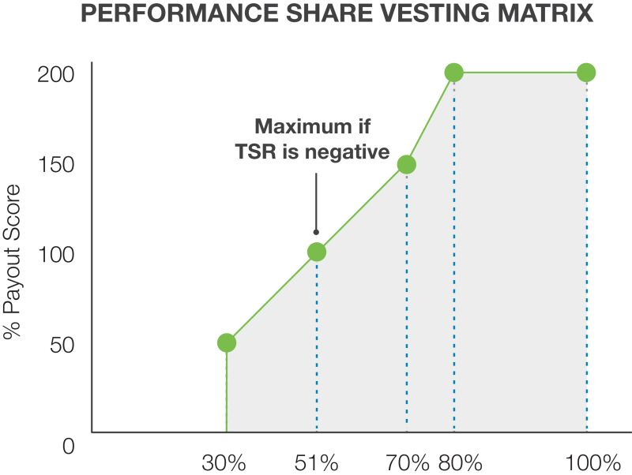
Relative TSR Percentile Ranking
As noted, the established vesting matrix features a limit on the number of shares that will vest if the Company’s TSR is negative for the performance period. If that occurs, the maximum amount of performance shares that can vest is 100%, even if the Company’s TSR performs above the 51
st
percentile of the Russell 2000 Index.
Valuation and Other Terms
. For the fiscal 2026
per
formance share awards, the reported value shown in the “Summary Compensation Table” was computed based on the probable outcome of the performance conditions based on a Monte Carlo simulation and the grant date estimate of compensation cost to be recognized over the performance period, which was 144.9% of target, or $428.80 per share. This “grant date fair value” (i.e., 144.9% of the target amount) is reported in the “Summary Compensation Table” for the NEOs’ performance share awards. This reported amount is higher than the actual granted award value (i.e., 100% of the target amount) due to the accounting methodology for calculating this amount, as discussed in footnote 2 to the table.
The number of performance shares granted was computed by dividing target grant values by the volume weighted average trading price of our common stock in the last 20 trading days of March 2025, a methodology we have used since 2016. Performance shares are subject to forfeiture if the executive’s employment is terminated by the Company for cause or by the executive without good reason before the end of the three-year performance period. Until vesting, holders of performance shares do not have voting rights. They also do not receive dividends but are entitled to receive accrued dividend equivalents that vest, if at all, at the same percentage as the underlying award.
 | 54 |  |  |  |  | |  2026 Proxy Statement

Table of Contents
Executive Compensation
Compensation Discussion and Analysis

Additional Executive Compensation Information

Anti-Hedging and Anti-Pledging
Under the Company’s
Insider Trading Policy
, which is available on our website at
www.csw.com
under “Investors —Corporate Governance,” directors, executives and other employees are prohibited from pledging stock, holding Company securities in a margin account, and engaging in transactions (such as trading in options, short sales, and sales “against the box”) designed to hedge against the value of the Company’s common stock.
Stock Ownership Guidelines
Our executive compensation program provides guidelines for executive ownership of Company common stock, expressed as a multiple of annual base salary. The Compensation Committee believes these guidelines encourage the alignment of executive and shareholder interests and promote the Company’s objective of building long-term shareholder value by requiring executives to build and mai
nta
in a meaningful stake in the Company.
The stock ownership guidelines are designed to encourage stock ownership at levels high enough to indicate management’s commitment to the Company and share value appreciation, while satisfying an individual executive’s prudent needs for investment diversification. The stock ownership guidelines are set by the Compensation Committee using competitive benchmarking data, and the guidelines are reviewed each year and updated as necessary. There were no changes to the stock ownership guidelines during fiscal 2026.
The Company’s current stock ownership guidelines for the NEOs and the number of shares needed to satisfy the guidelines are shown below.

Named Executive Officer |  | Ownership Guideline |  |  |  |  | Ownership Guideline  at 3/31/2026  (# of Shares)  (1) |  |  |  |  | Current Ownership  (# of Shares and  Multiple of Salary)  (1)
Joseph B. Armes |  |  |  | 6 x Annual Base Salary |  |  |  |  | 21,318 |  |  |  |  | 89,213 |  |  |  |  | 25.1x
James E. Perry |  |  |  | 3 x Annual Base Salary |  |  |  |  | 5,992 |  |  |  |  | 28,276 |  |  |  |  | 14.2x
Jeff A. Underwood |  |  |  | 3 x Annual Base Salary |  |  |  |  | 5,070 |  |  |  |  | 8,063 |  |  |  |  | 4.8x
Luke E. Alverson |  |  |  | 3 x Annual Base Salary |  |  |  |  | 5,070 |  |  |  |  | 15,332 |  |  |  |  | 9.1x
Danielle R. Garde |  |  |  | 3 x Annual Base Salary |  |  |  |  | 5,070 |  |  |  |  | 5,782 |  |  |  |  | 3.4x

(1) | Based on a price per share of $260.58, the closing price of the Company’s stock on March 31, 2026.
Executives are expected to meet the stock ownership guidelines within five years from the date the guidelines are first applicable. Recognizing the time required to achieve the ownership guidelines, our guidelines contain an interim retention requirement. Specifically, executives who do not yet meet the applicable ownership requirement must retain at least 75% of the vested common stock they receive from equity awards granted from the time the ownership guidelines become applicable, net of any shares used or sold to pay applicable tax withholding. For fiscal 2026, all NEOs satisfied their ownership guideline or retention requirement.
The Compensation Committee periodically reviews the stock ownership guidelines and no less than annually monitors the executives’ progress toward meeting their target ownership levels. Shares held directly by an executive count toward satisfying the requirements, as do unvested restricted stock awards, but unvested equity awards with performance-based vesting conditions do not.

 |  |  |  |  |  |  |  | |  2026 Proxy Statement |  | 55

Table of Contents
Executive Compensation
Compensation Discussion and Analysis

Recoupment of Incentive Compensation Policy
The Company maintains a NYSE-compliant Dodd-Frank Recoupment of Incentive Compensation Policy (the “Recoupment Policy”), which reinforces our commitment to our business objectives and core values. Under the Recoupment Policy, the Compensation Committee can “claw back” from an executive certain incentive compensation paid in the past three years if the Company is required to restate its financial statements. If a restatement occurs, the Compensation Committee will require any current or relevant former executive to reimburse the Company when the amount of compensation received was greater than the amount the Compensation Committee believes was actually earned based on the restated financial results. The Recoupment Policy does not require any finding of fault or malfeasance on the part of an executive to support the Company’s demand for recoupment.
Legacy Pension Plans
In connection with our spin-off from Capital Southwest Corporation in September 2015 (the “Spin-Off”), the Company assumed administrative responsibility and liability for certain legacy pension plans and the associated benefits payable to participating employees. On January 1, 2015, the legacy pension plans were closed to new participants. At the Spin-Off, the Company froze the legacy pension plans, and future benefits to plan participants ceased to accrue as of that date. Mr. Armes is the only NEO who accrued benefits under the legacy plans as part of his prior employment with Capital Southwest Corporation. In September 2019, the Company terminated the legacy pension plans.
The legacy pension plans included a qualified defined benefit, non-contributory retirement plan, as well as a restoration plan that provided benefits to the plan participants in the qualified plan to fulfill the intent of the qualified plan without regard to limitations under the Internal Revenue Code of 1986, as amended (the “Code”). The retirement benefits payable under the legacy pension plans depended on the participant’s years of service and their final average monthly compensation determined by averaging the five consecutive years of highest compensation prior to retirement. The amount of legacy pension plan benefits attributable to Mr. Armes as of March 31, 2026, and prior to the plan termination is shown in the “2026 Pension Benefits” table below.
Other Benefits
As previously discussed, the Compensation Committee strives to make our executive compensation program primarily performance-based and, as such, does not provide perquisites for our executive officers other than benefits generally provided to all employees, such as profit sharing through the Company’s 401(k) plan and ESOP. Our executive compensation program from time to time may provide limited other benefits that the Compensation Committee determines to be competitive with the level of benefits offered by the companies with which we compete for executive talent. Any such benefits would serve to meet our stated objective of attracting and retaining executive talent. In addition, some benefits may, in the Compensation Committee’s view, be provided for the Company’s benefit, notwithstanding any personal benefit an executive may derive. No such other benefits were provided in fiscal 2026.
Chief Executive Officer Compensation in Fiscal 2026
The Compensation Committee set our CEO’s compensation in a manner consistent with our compensation philosophy and the general compensation objectives and principles discussed above. In the interest of providing shareholders with a better understanding of Mr. Armes’ compensation for fiscal 2026, we are providing the following discussion and analysis.
Employment Agreement
On October 1, 2015, the Company entered into an employment agreement with Mr. Armes. The employment agreement provides that Mr. Armes will serve as CEO of the Company and that the Board will nominate Mr. Armes for election to the Board during the term of the agreement. The employment agreement had an initial term of two years, but the term automatically extends for additional one-year periods unless Mr. Armes’ employment is terminated as provided in the employment agreement. Mr. Armes is the only NEO with whom the Company has entered into an employment agreement.

 | 56 |  |  |  |  | | 2026 Proxy Statement

Table of Contents
Executive Compensation
Compensation Discussion and Analysis

Base Salary and Incentive Opportunities
Base Salary
During fiscal 2026 Mr. Armes’ base salary was increased by 8.8% to $925,000. As discussed previously, this increase was made to address proximity to competitive market benchmarks, consistent with our stated executive compensation objectives and principles and supported by Mr. Armes’ performance.
AIP Target and Fiscal 2026 Award
During fiscal 2026, Mr. Armes’ target AIP opportunity was maintained at 130% of base salary. After performance results for the fiscal year were confirmed, the Compensation Committee approved a total AIP payout of $1,286,976, or 107.0% of target, broken down as follows:

Metric |  | Amount ($) |  | Weight |  |  |  | Payout
Consolidated EBITDA |  | 684,704 |  |  | 60% |  |  |  | 94.9%
Consolidated Operating Cash Flow |  | 286,616 |  |  | 15% |  |  |  | 158.9%
Individual Performance |  | 315,656 |  |  | 25% |  |  |  | 105.0%
LTIP Target and Fiscal 2026 LTIP Awards
Annual LTIP Awards. During fiscal 2026, Mr. Armes’ target LTIP opportunity was increased to 425% of base salary, addressing proximity to competitive market benchmarks and consistent with our stated executive compensation objectives and principles and supported by Mr. Armes’ performance. As discussed above, the Compensation Committee maintained Mr. Armes’ LTIP award mix at 60% performance shares and 40% restricted stock. These factors increased Mr. Armes’ performance-based compensation as a percentage of total target compensation to 58.8%, and increased his “at risk” target pay to 84.7%.
Accordingly, Mr. Armes received an award of 8,004 performance shares in May 2025 ($2,358,750 target award value), and an award of 5,971 shares of restricted stock in October 2025 ($1,572,500 target award value). Mr. Armes did not receive any special equity awards outside of the LTIP in fiscal 2026.
Benefits Upon Termination
Under Mr. Armes’ employment agreement, if his employment is terminated due to death or disability, Mr. Armes will receive (1) his base salary and any unpaid benefits (including death benefits) through the date of termination; (2) the AIP cash payment related to the previous year, if the date of termination is after the end of a fiscal year but before the Company pays AIP cash incentives; and (3) a prorated AIP cash payment related to the then-current fiscal year, if the date of termination is before the end of a fiscal year. Additionally, all of Mr. Armes’ unvested equity-based awards will immediately vest in full, except for performance-based awards, which will vest when and to the extent that the performance conditions have been satisfied. Any options he holds will remain exercisable for one year following the date of termination.
If Mr. Armes’ employment is terminated by the Company without “cause” or by Mr. Armes for “good reason,” Mr. Armes will receive (1) his base salary and any unpaid benefits through the date of termination; (2) a lump sum payment equal to two times the sum of (a) his then-current base salary or any higher base salary that was in effect during the 12 months prior to the date of termination, and (b) the greater of his annual AIP payment for the prior fiscal year or his target AIP incentive for the current year; (3) the AIP cash payment related to the previous year, if the date of termination is after the end of a fiscal year but before the Company pays AIP cash incentives; (4) a prorated AIP cash payment related to the then-current fiscal year, if the date of termination is before the end of a fiscal year; and (5) continued medical and dental insurance for him and his dependents for 24 months following the date of termination. Additionally, and with certain exceptions related to Mr. Armes’ Special Equity Grant, all of Mr. Armes’ unvested equity-based awards will immediately vest in full, except for performance-based awards, which will vest when and only to the extent that the performance conditions have been satisfied.

 |  |  |  |  |  |  |  | | 2026 Proxy Statement |  | 57

Table of Contents
Executive Compensation
Compensation Discussion and Analysis

If Mr. Armes’ employment is terminated by the Company for “cause” or by Mr. Armes without “good reason,” Mr. Armes will receive only his base salary and any unpaid benefits through the date of termination.
Additionally, Mr. Armes participates in the Company’s Executive Change in Control and Severance Benefit Plan (the “CIC and Severance Plan”). To the extent the provisions of the CIC and Severance Plan are more beneficial to Mr. Armes than the terms set forth in his employment agreement, such provisions would apply in the applicable termination scenario.
The employment agreement also provides that Mr. Armes will not engage in activities that are competitive with the Company’s business or solicit any key employees of the Company to leave or accept employment with another company for 24 months following the date of termination.
Executive Change in Control and Severance Benefit Plan
The Company maintains the CIC and Severance Plan. This plan is publicly filed, and its features are described more fully under “Potential Payments upon Termination or Change-In-Control—CSW Industrials, Inc. Executive Change in Control and Severance Benefit Plan” below. The Compensation Committee believes that this plan benefits shareholders in providing consistency and transparency in severance benefits if an executive officer’s employment is terminated, and also supports alignment between executive interests and shareholder interests should a transformative transaction arise that is in shareholders’ best interests.
Review and Assessment of Compensation Under Termination Scenarios
The Compensation Committee regularly reviews each NEO’s total compensation under several scenarios including a change-in-control of the Company, termination of employment by the Company, and resignation or retirement by the executive. Tally sheets setting forth all the listed scenarios are prepared by management and reviewed by the Compensation Committee with input from WTW. Based on its most recent review of the tally sheets, the Compensation Committee determined that the potential payments that would be provided to the NEOs were consistent with our executive compensation objectives and principles.
Executive Compensation Program Changes for Fiscal 2027
For the benefit of our shareholders, we summarize below certain changes and other matters that the Compensation Committee has approved regarding our fiscal 2027 executive compensation program. These and any other fiscal 2027 compensation program changes will be discussed in further detail in our proxy statement for the 2027 annual meeting of shareholders.
Annual Incentive Plan Changes
Metric Target Setting and Weighting. In fiscal 2026 and as stated above, the Compensation Committee returned to a semi-annual target-setting process for our AIP metrics. For fiscal 2027, the Compensation Committee, with the support of WTW and management, will continue setting financial metric targets semi-annually under our AIP. As we have demonstrated in prior years, the semi-annual AIP target-setting process provides an artful solution to target setting difficulties that exist in the face of unique market conditions and their associated challenges. These factors continue to be present in fiscal 2027 and are enhanced by our ongoing efforts to integrate our over $1 billion of acquisitions completed in fiscal 2026, as well as the disruptions caused by global events, U.S. and international trade policies, and ongoing macroeconomic uncertainty.
When we have used semi-annual target setting practices under our AIP in the past, we used a simple average of first half and second half performance payouts to determine the full fiscal year payouts for each financial metric. However, in fiscal 2027, full fiscal year AIP payouts will be determined by weighting first half EBITDA and OCF performance payouts at 60% of full year payout, and weighting second half EBITDA and OCF performance payouts at 40% of full year payout. As we have discussed publicly, the acquisitions we completed in fiscal 2026 are expected to increase the effects of market seasonality on our financial results, which is expected to further increase the amount of our full year EBITDA and OCF performance that is delivered in the first half of the year compared to the second half. Given this, the Compensation Committee and management believe this modified weighting of first and second half performance payouts in calculating full year payouts will more closely align the AIP’s full year outcome with the Company’s actual delivery of EBITDA and OCF throughout the fiscal year.

 | 58 |  |  |  |  | | 2026 Proxy Statement

Table of Contents
Executive Compensation
Summary Compensation Table

Summary Compensation Table
The following table sets forth compensation information for our NEOs—the individuals who served during fiscal 2026 as principal executive officer and principal financial officer of the Company, and the three other most highly compensated executive officers of the Company serving at the end of fiscal 2026.

Name and  Principal Position |  | Year(1) |  | Salary  ($) |  |  |  | Stock  Awards  ($)(2) |  |  |  | Non-Equity  Incentive Plan  Compensation  ($)(3) |  |  |  | Change in  Pension  Value and  Non-qualified  Deferred  Compensation  Earnings  ($)(4) |  | All Other  Compensation  ($)(5) |  | Total  ($)
Joseph B. Armes  Chairman, CEO and President |  | 2026 |  |  | 925,000 |  |  |  | 4,938,001 | (6) |  |  | 1,286,976 |  |  | 4,420 |  | 119,218 |  | 7,273,615
Joseph B. Armes  Chairman, CEO and President |  | 2025 |  |  | 850,000 |  |  |  | 4,221,414 |  |  |  | 1,147,784 |  |  | 5,148 |  | 106,133 |  | 6,330,479
Joseph B. Armes  Chairman, CEO and President |  | 2024 |  |  | 800,000 |  |  |  | 3,733,051 |  |  |  | 1,324,960 |  |  | 3,022 |  | 102,212 |  | 5,963,245
James E. Perry  Executive VP, CFO |  | 2026 |  |  | 520,000 |  |  |  | 1,097,869 | (7) |  |  | 417,398 |  |  | — |  | 77,146 |  | 2,112,413
James E. Perry  Executive VP, CFO |  | 2025 |  |  | 495,000 |  |  |  | 1,125,065 |  |  |  | 391,512 |  |  | — |  | 74,521 |  | 2,086,098
James E. Perry  Executive VP, CFO |  | 2024 |  |  | 475,000 |  |  |  | 1,005,765 |  |  |  | 453,862 |  |  | — |  | 75,881 |  | 2,010,508
Jeff A. Underwood  Executive VP & GM, Contractor Solutions |  | 2026 |  |  | 440,000 |  |  |  | 770,057 | (8) |  |  | 319,963 |  |  | — |  | 72,620 |  | 1,602,640
Jeff A. Underwood  Executive VP & GM, Contractor Solutions |  | 2025 |  |  | 385,000 |  |  |  | 667,015 |  |  |  | 244,792 |  |  | — |  | 76,561 |  | 1,373,368
Luke E. Alverson  Senior VP, General Counsel and Secretary |  | 2026 |  |  | 440,000 |  |  |  | 637,161 | (9) |  |  | 259,001 |  |  | — |  | 79,669 |  | 1,415,831
Luke E. Alverson  Senior VP, General Counsel and Secretary |  | 2025 |  |  | 423,000 |  |  |  | 659,147 |  |  |  | 244,548 |  |  | — |  | 76,820 |  | 1,403,515
Luke E. Alverson  Senior VP, General Counsel and Secretary |  | 2024 |  |  | 412,000 |  |  |  | 573,257 |  |  |  | 280,191 |  |  | — |  | 77,010 |  | 1,342,458
Danielle R. Garde  Senior VP, Chief People Officer |  | 2026 |  |  | 440,000 |  |  |  | 637,161 | (10) |  |  | 259,001 |  |  | — |  | 80,532 |  | 1,416,694
Danielle R. Garde  Senior VP, Chief People Officer |  | 2024 |  |  | 390,000 |  |  |  | 542,860 |  |  |  | 265,230 |  |  | — |  | 75,859 |  | 1,273,949

(1) | The Company’s fiscal year begins April 1 and ends March 31.

(2) | Represents the grant date fair value of long-term equity incentive awards under the Company’s LTIP computed in accordance with FASB ASC 718 “Compensation—Stock Compensation,” including the impact of forfeitures. The incentive awards are granted in the form of restricted stock, which generally vest ratably over a three-year period, and performance shares. The performance criteria for the performance share awards is based on the Company’s TSR over a three-year period compared to the TSR of the Company’s applicable benchmark group for the same period, as described in further detail under “Executive Compensation Program—Long-Term Equity Incentives—Performance Share Awards” above. The reported value of the performance unit awards is computed based on the probable outcome of the performance conditions based on a Monte Carlo simulation and the grant date estimate of compensation cost to be recognized over the performance period, which was 144.9% of target, or $428.80 per share. Payout for the performance share awards can range from 0% to a maximum of 200%. Assumptions used in the valuations are discussed in Note 5 to the Company’s audited consolidated financial statements for the year ended March 31, 2026, in the Annual Report.

(3) | The amounts in this column include an annual cash incentive bonus for fiscal 2026 under the Company’s AIP that was earned in fiscal 2026 but paid in fiscal 2027.

(4) | Reflects the annualized change in pension value under the restoration plan. There are no above-market or preferential earnings on compensation deferred under the restoration plan.

(5) | The components of this column for fiscal 2026 are set forth in the table below, calculated at the aggregate incremental cost to the Company (all in U.S. dollars):

Name |  | Retirement Plan  Contributions  ($)(A) |  | ESOP  Contributions  ($)(B) |  | Insurance  Premiums  ($)(C) |  | Dividends  Paid  ($)(D) |  | Total  ($)
Joseph B. Armes |  | 36,242 |  | 21,000 |  | 15,689 |  | 46,287 |  | 119,218
James E. Perry |  | 31,578 |  | 21,000 |  | 20,483 |  | 4,085 |  | 77,146
Jeff A. Underwood |  | 25,723 |  | 21,000 |  | 23,633 |  | 2,264 |  | 72,620
Luke E. Alverson |  | 31,000 |  | 21,000 |  | 25,442 |  | 2,227 |  | 79,669
Danielle R. Garde |  | 31,710 |  | 21,000 |  | 25,442 |  | 2,380 |  | 80,532

 | (A) | Includes matching and discretionary Company contributions to the NEOs under the Company’s 401(k) plan, which is generally available to all the Company’s U.S. employees.

 | (B) | Includes Company contributions to the Company’s ESOP for fiscal 2026, which is generally available to all the Company’s U.S. employees. These amounts were accrued in fiscal 2026 but contributed in fiscal 2027.

 | (C) | Includes annual premiums for group term life insurance, the Company’s portion of annual premiums for medical, dental and vision benefits and the Company’s portion of disability premiums.

 | (D) | Includes dividends paid on outstanding, unvested restricted stock awards, which are entitled to voting and dividend rights at grant.

 |  |  |  |  |  |  |  | | 2026 Proxy Statement |  | 59

Table of Contents
Executive Compensation
Summary Compensation Table

(6) | Includes annual grants of 5,971 shares of restricted stock ($1,505,886) and 8,004 shares of performance shares ($3,432,115) made under the Company’s LTIP. Restricted stock award values were calculated using a price per share of $252.20, the closing market price of the Company’s common stock as reported by the NYSE on October 1, 2025, the date of grant. Performance unit award values were calculated using a fair value of $428.80 per share as determined by the Monte Carlo simulation. The maximum potential value of the performance shares at grant date, assuming the highest level of performance conditions, was $4,905,492.

(7) | Includes annual grants of 1,728 shares of restricted stock ($435,802) and 1,544 shares of performance shares ($662,067) made under the Company’s LTIP. Restricted stock award values were calculated using a price per share of $252.20, the closing market price of the Company’s common stock as reported by the NYSE on October 1, 2025, the date of grant. Performance unit award values were calculated using a fair value of $428.80 per share as determined by the Monte Carlo simulation. The maximum potential value of the performance shares at grant date, assuming the highest level of performance conditions, was $946,287.

(8) | Includes annual grants of 1,212 shares of restricted stock ($305,666) and 1,083 shares of performance shares ($464,390) made under the Company’s LTIP. Restricted stock award values were calculated using a price per share of $252.20, the closing market price of the Company’s common stock as reported by the NYSE on October 1, 2025, the date of grant. Performance unit award values were calculated using a fair value of $428.80 per share as determined by the Monte Carlo simulation. The maximum potential value of the performance shares at grant date, assuming the highest level of performance conditions, was $663,749.

(9) | Includes annual grants of 1,003 shares of restricted stock ($252,957) and 896 shares of performance shares ($384,205) made under the Company’s LTIP. Restricted stock award values were calculated using a price per share of $252.20, the closing market price of the Company’s common stock as reported by the NYSE on October 1, 2025, the date of grant. Performance unit award values were calculated using a fair value of $428.80 per share as determined by the Monte Carlo simulation. The maximum potential value of the performance shares at grant date, assuming the highest level of performance conditions, was $549,140.

(10) | Includes annual grants of 1,003 shares of restricted stock ($252,957) and 896 shares of performance shares ($384,205) made under the Company’s LTIP. Restricted stock award values were calculated using a price per share of $252.20, the closing market price of the Company’s common stock as reported by the NYSE on October 1, 2025, the date of grant. Performance unit award values were calculated using a fair value of $428.80 per share as determined by the Monte Carlo simulation. The maximum potential value of the performance shares at grant date, assuming the highest level of performance conditions, was $549,140.
2026 Grants of Plan-Based Awards
The following table sets forth certain information with respect to plan-based awards granted to the NEOs for the year ended March 31, 2026.

 |  |  |  |  |  | Estimated Future Payouts  Under Non-Equity  Incentive Plan Awards |  |  |  |  |  | Estimated Future Payouts  Under Equity  Incentive Plan Awards(1) |  |  |  |  |  | All Other  Stock  Awards:  Shares  of Stock  or Units  (#) |  | Grant Date  Fair Value  of  Stock and  Option  Awards  ($)(2)
Name |  | Grant Date |  |  |  | Threshold  ($) |  | Target  ($) |  | Maximum  ($) |  | Threshold  (#) |  | Target  (#) |  | Maximum  (#)
Joseph B. Armes |  |  | 5/7/2025 | (3) |  | 360,750 |  | 1,202,500 |  | 2,405,000
Joseph B. Armes |  |  | 5/7/2025 |  |  |  |  |  |  |  |  | 4,002 |  | 8,004 |  | 16,008 |  |  |  |  | 3,432,115 | (4)
Joseph B. Armes |  |  | 10/1/2025 |  |  |  |  |  |  |  |  |  |  |  |  |  |  | 5,971(5) |  |  | 1,505,886
James E. Perry |  |  | 5/7/2025 | (3) |  | 117,000 |  | 390,000 |  | 780,000
James E. Perry |  |  | 5/7/2025 |  |  |  |  |  |  |  |  | 772 |  | 1,544 |  | 3,088 |  |  |  |  | 662,067 | (4)
James E. Perry |  |  | 10/1/2025 |  |  |  |  |  |  |  |  |  |  |  |  |  |  | 1,728(5) |  |  | 435,802
Jeff A. Underwood |  |  | 5/7/2025 | (3) |  | 85,800 |  | 286,000 |  | 572,000
Jeff A. Underwood |  |  | 5/7/2025 |  |  |  |  |  |  |  |  | 542 |  | 1,083 |  | 2,166 |  |  |  |  | 464,390 | (4)
Jeff A. Underwood |  |  | 10/1/2025 |  |  |  |  |  |  |  |  |  |  |  |  |  |  | 1,212(5) |  |  | 305,666
Luke E. Alverson |  |  | 5/7/2025 | (3) |  | 72,600 |  | 242,000 |  | 484,000
Luke E. Alverson |  |  | 5/7/2025 |  |  |  |  |  |  |  |  | 448 |  | 896 |  | 1,792 |  |  |  |  | 384,205 | (4)
Luke E. Alverson |  |  | 10/1/2025 |  |  |  |  |  |  |  |  |  |  |  |  |  |  | 1,003(5) |  |  | 252,957
Danielle R. Garde |  |  | 5/7/2025 | (3) |  | 72,600 |  | 242,000 |  | 484,000
Danielle R. Garde |  |  | 5/7/2025 |  |  |  |  |  |  |  |  | 448 |  | 896 |  | 1,792 |  |  |  |  | 384,205 | (4)
Danielle R. Garde |  |  | 10/1/2025 |  |  |  |  |  |  |  |  |  |  |  |  |  |  | 1,003(5) |  |  | 252,957

(1) | The number of shares listed represents long-term equity incentive awards in the form of performance shares granted under the Company’s LTIP. The performance criteria for these awards is based on the Company’s TSR from April 1, 2025 through March 31, 2028 compared to the TSR performance of the members of the Russell 2000 Index for the same period, as described in further detail under “Executive Compensation Program—Long-Term Equity Incentives—Performance Share Awards” above.

(2) | These amounts represent the fair value, as determined under FASB ASC Topic 718, of the awards based on the grant date fair value estimated by the Company for financial reporting purposes.

 | 60 |  |  |  |  | | 2026 Proxy Statement

Table of Contents
Executive Compensation
2026 Grants of Plan-Based Awards

(3) | Under the AIP, the primary performance measures are internally defined metrics based on operating income, cash flow from operations, and achievement of individual performance objectives. See “Executive Compensation Program—Annual Incentive Program” above. Actual amounts payable under the AIP, if any, can range from 30% (Threshold) to 200% (Maximum) of the target amounts for the NEOs based upon the extent to which performance under the foregoing criteria meets, exceeds or is below the target.

(4) | Represents the fair value on the date of grant, as described in footnote (2), of the performance shares awarded, which values were calculated using a fair value of $428.80 per share determined by using the Monte Carlo simulation. The actual value may be more or less depending on the Company’s TSR performance during the applicable three-year performance period.

(5) | The amounts shown reflect the numbers of shares of restricted stock granted to each NEO pursuant to the Company’s 2024 Equity and Incentive Compensation Plan. The shares vest ratably over a three-year period on each anniversary of the date of grant.
Outstanding Equity Awards at Year-End 2026
The following table sets forth certain information with respect to outstanding equity awards held by each of the NEOs as of March 31, 2026, the last day of fiscal 2026. As of that date, no NEO had any outstanding stock option awards.

 |  | Stock Awards
Name |  | Number of  Shares or  Units of  Stock that  Have Not  Vested  (#) |  | Market Value  of Shares or  Units of  Stock that  Have Not  Vested  ($) (1) |  | Equity  Incentive  Plan  Awards:  Unearned  Shares,  Units or  Other  Rights  that Have  Not  Vested  (#) |  | Equity  Incentive  Plan  Awards:  Market or  Payout  Value of  Unearned  Shares,  Units or  Other  Rights that  Have Not  Vested  ($)(1)
Joseph B. Armes |  | 11,051(2) |  | 2,879,670 |  | 18,783(3) |  |  | 9,561,343
 |  | 31,496(4) |  | 8,207,228 |  | 12,569(5) |  |  | 6,245,864
 |  | 20,130(6) |  | 5,245,475 |  | 8,297(7) |  |  | 4,324,065
 |  |  |  |  |  | 8,029(8) |  |  | 4,184,394
James E. Perry |  | 3,407(9) |  | 887,796 |  | 3,079(5) |  |  | 1,530,035
 |  |  |  |  |  | 1,884(7) |  |  | 981,865
 |  |  |  |  |  | 1,550(8) |  |  | 807,798
Jeff A. Underwood |  | 2,215(10) |  | 577,185 |  | 1,116(5) |  |  | 554,569
 |  |  |  |  |  | 964(7) |  |  | 502,398
 |  |  |  |  |  | 1,088(8) |  |  | 567,022
Luke E. Alverson |  | 1,975(11) |  | 514,646 |  | 1,756(5) |  |  | 872,602
 |  |  |  |  |  | 1,104(7) |  |  | 575,361
 |  |  |  |  |  | 899(8) |  |  | 468,523
Danielle R. Garde |  | 1,952(12) |  | 508,652 |  | 1,664(5) |  |  | 826,885
 |  |  |  |  |  | 1,017(7) |  |  | 530,020
 |  |  |  |  |  | 899(8) |  |  | 468,523

(1) | Calculated using a price per share of $260.58, the closing market price of the Company’s common stock as reported by the NYSE on March 31, 2026, the last trading day before the end of the Company’s last completed fiscal year.

(2) | Mr. Armes’ shares of restricted stock (all of which are part of the annual LTIP and not part of the fiscal 2022 CEO retention and succession arrangement) vest as follows: 5,708 shares on October 1, 2026; 3,353 shares on October 1, 2027; and 1,990 shares on October 1, 2028.

(3) | These shares represent long-term equity incentive awards in the form of performance shares under the Company’s LTIP granted as part of the fiscal 2022 CEO retention and succession arrangement, including accrued dividend equivalent units. The performance measure for these shares was based on the Company’s TSR over the period from April 1, 2021 through each of March 31, 2026 and 2027, compared to the TSRs of the members of the Russell 2000 Index for the same periods. Payouts range from 0% to a maximum of 200% of the shares granted. The reported value associated with the shares reflects a vesting of the March 31, 2026 tranche of performance shares at 200% effective April 1, 2026, and assumes vesting at 200% for the remaining award.

(4) | These shares represent shares of restricted stock under the Company’s LTIP granted as part of the fiscal 2022 CEO retention and succession arrangement. These shares cliff vested on April 26, 2026.

(5) | These shares represent long-term equity incentive awards in the form of performance shares under the Company’s annual LTIP, including accrued dividend equivalent units. The performance measure set for this plan was based on the Company’s TSR over the period from April 1, 2023 through March 31, 2026 compared to the TSRs of the members of the Russell 2000 Index for the same period. Payouts ranged from 0% to a maximum of 200% of the shares granted. The number of shares reported vested at 190.7% of shares granted effective March 31, 2026, and the associated value reported reflects this vesting percentage.

 |  |  |  |  |  |  |  | | 2026 Proxy Statement |  | 61

Table of Contents
Executive Compensation
Outstanding Equity Awards at Year-End 2026

(6) | These shares represent restricted stock units under the Company’s LTIP granted as part of the fiscal 2022 CEO retention and succession arrangement, including accrued dividend equivalent rights. 40% of the shares will vest after a successor CEO is successfully recruited and hired, and 60% of the shares will vest upon the successful first employment anniversary of the successor CEO. The amount shown assumes full satisfaction of the associated performance conditions.

(7) | These shares represent long-term equity incentive awards in the form of performance shares under the Company’s annual LTIP, including accrued dividend equivalent units. The performance measure for this plan is based on the Company’s TSR over the period from April 1, 2024 through March 31, 2027 compared to the TSRs of the members of the Russell 2000 Index for the same period. Payouts can range from 0% to a maximum of 200% of the shares granted. The reported value associated with the shares assumes vesting at 200%.

(8) | These shares represent long-term equity incentive awards in the form of performance shares under the Company’s annual LTIP, including accrued dividend equivalent units. The performance measure for this plan is based on the Company’s TSR over the period from April 1, 2025 through March 31, 2028 compared to the TSRs of the members of the Russell 2000 Index for the same period. Payouts can range from 0% to a maximum of 200% of the shares granted. The reported value associated with the shares assumes vesting at 200%.

(9) | Mr. Perry’s shares of restricted stock vest as follows: 1,792 shares on October 1, 2026; 1,039 shares on October 1, 2027; and 576 shares on October 1, 2028.

(10) | Mr. Underwood’s shares of restricted stock vest as follows: 1,086 shares on October 1, 2026; 785 shares on October 1, 2027; and 404 shares on October 1, 2028.

(11) | Mr. Alverson’s shares of restricted stock vest as follows: 1,036 shares on October 1, 2026; 605 shares on October 1, 2027; and 334 shares on October 1, 2028.

(12) | Ms. Garde’s shares of restricted stock vest as follows: 1,013 shares on October 1, 2026; 605 shares on October 1, 2027; and 334 shares on October 1, 2028.
2026 Option Exercises and Stock Vested
The following table sets forth certain information with respect to restricted stock vesting during the fiscal year ended March 31, 2026, with respect to the NEOs. The Company does not grant stock options or stock appreciation rights.

 |  | Stock Awards
Name |  | Number of Shares  Acquired on Vesting  (#)(1) |  |  |  |  | Value Realized  on Vesting  ($)(2)
Joseph B. Armes |  |  |  | 40,683 |  |  |  |  | 11,750,326
James E. Perry |  |  |  | 8,465 |  |  |  |  | 2,396,521
Jeff A. Underwood |  |  |  | 2,909 |  |  |  |  | 808,831
Luke E. Alverson |  |  |  | 4,298 |  |  |  |  | 1,217,358
Danielle R. Garde |  |  |  | 1,223 |  |  |  |  | 308,440

(1) | The number of shares reported includes shares that were surrendered during the fiscal year ended March 31, 2026, to satisfy taxes upon the vesting of restricted stock awards.

(2) | Reflects the gross number of shares acquired on vesting multiplied by the closing market price of the Company’s common stock on the vesting date. Includes the value of shares surrendered to satisfy taxes upon the vesting of restricted stock awards.
2026 Pension Benefits
The following table sets forth certain information as of March 31, 2026, with respect to pension benefits attributable to our NEOs. Please refer to “Executive Compensation Program—Legacy Pension Plans” above for a narrative description of our pension plans.

Name |  | Plan Name(1) |  |  |  |  | Years of  Credited Service  (#) |  |  |  |  | Present Value of  Accumulated Benefit  ($) |  |  |  |  | Payments During Last  Fiscal Year  ($)
Joseph B. Armes |  |  |  | Restoration Plan |  |  |  |  | 2.25 |  |  |  |  | 106,975 |  |  |  |  | —
James E. Perry |  |  |  | — |  |  |  |  | — |  |  |  |  | — |  |  |  |  | —
Jeff A. Underwood |  |  |  | — |  |  |  |  | — |  |  |  |  | — |  |  |  |  | —
Luke E. Alverson |  |  |  | — |  |  |  |  | — |  |  |  |  | — |  |  |  |  | —
Danielle R. Garde |  |  |  | — |  |  |  |  | — |  |  |  |  | — |  |  |  |  | —

(1) | The pension plans listed represent legacy plans assumed from CSWC in connection with the Spin-Off. The plans listed were frozen on October 1, 2015, and no benefits have accrued to any plan participant following that date. The plans listed were subsequently terminated in September 2019. Mr. Armes’ 2.25 years of credited service under the Restoration Plan is attributable to his employment with CSWC prior to the Spin-Off. The present value of accumulated benefit shown is an actuarial present value derived from the plans’ provisions, which is influenced by credited service and based on the mortality and discount rate assumptions used for financial reporting purposes (but excluding pre-retirement mortality). Assumptions used in the valuations are discussed in Note 16 to the Company’s audited consolidated financial statements for the year ended March 31, 2026 in the Annual Report.

 | 62 |  |  |  |  | | 2026 Proxy Statement

Table of Contents
Executive Compensation
Potential Payments upon Termination or Change-In-Control

Potential Payments upon Termination or Change-In-Control
The information below describes compensation that would have been paid under existing plans and contractual arrangements to the NEOs in the event of a termination of the executive’s employment with the Company or change in control of the Company, assuming these events occurred on March 31, 2026. Amounts shown therefore include amounts earned through such time and are estimates of the amounts that would have been paid out to the executives based upon their respective compensation and service levels as of such date and the closing price of the Company’s common stock on March 31, 2026, of $260.58. The actual amounts to be paid can only be determined at the time of a change in control or the executive’s termination of employment with the Company. Upon any termination of employment, each of the NEOs would also be entitled to the vested amounts, if any, shown in the “2026 Pension Benefits” table above.
CSW Industrials Executive Change in Control and Severance Benefit Plan
All the NEOs participated in the Company’s CIC and Severance Plan as of March 31, 2026. The CIC and Severance Plan provides benefits for termination of employment under three scenarios: by the Company without cause or by the executive for good reason; following a qualifying change in control; and upon death or disability. In any scenario, benefits are only paid after the executive (or the executive’s estate) executes a release in favor of the Company.
The CIC and Severance Plan provides benefits based on two participant levels, referred to as Level One and Level Two. Currently, Mr. Armes is the only Level One participant, and all other NEOs are Level Two participants.
Termination Without Cause by the Company or For Good Reason by the Executive
Upon an executive’s termination by the Company without cause or by the executive for good reason, the executive is entitled to the following severance benefits:

 | • | A pro-rata bonus for the year in which termination occurs, calculated using the greater of the actual AIP award earned in the preceding fiscal year or the target AIP award for the current fiscal year;

 | • | A lump sum payment equal to (a) in the case of a Level One participant, two times, and (b) in the case of a Level Two participant, one times, 12 months of base salary;

 | • | Continuation of health and welfare benefits for the earlier of the executive’s acceptance of full-time employment with another entity and (a) in the case of a Level One participant, 24 months following termination, and (b) in the case of a Level Two participant, 12 months following termination, in any case at a cost equal to the cost for an active employee for similar coverage; and

 | • | Immediate vesting in full of all unvested equity awards that have a vesting date within (a) in the case of a Level One participant, two years, and (b) in the case of a Level Two participant, one year, of the date of termination, in accordance with the terms of the applicable award agreements.
As used in the CIC and Severance Plan, “cause” generally means: (a) the commission of an act of personal dishonesty intended to result in substantial personal enrichment to the detriment of the Company; (b) the conviction or plea of nolo contendere to a misdemeanor involving moral turpitude or a felony; (c) the failure to perform work responsibilities; (d) violation of any of the Company’s material policies or procedures; or (e) any material breach of any material agreement with the Company, and in the cases of (c), (d) and (e), where such failure, violation or breach has continued for more than 30 days following written notice to the executive.
As used in the CIC and Severance Plan, “good reason” generally means, without the express written consent of the executive: (a) a material reduction in base compensation; (b) a material diminution in authority, duties, or responsibilities; (c) a permanent relocation more than 50 miles from where services were normally performed; (d) a material reduction in the authority, duties, or responsibilities of the person to whom the executive reports; or (e) any other action or inaction that constitutes a material breach by the Company of its obligations under the CIC and Severance Plan or any other material agreement to which the Company and the executive are parties.

 |  |  |  |  |  |  |  | | 2026 Proxy Statement |  | 63

Table of Contents
Executive Compensation
Potential Payments upon Termination or Change-In-Control

Termination Following a Change in Control
Upon the occurrence of a Change in Control (as defined in the Company’s 2024 Equity and Incentive Compensation Plan) and without a requirement that the executive’s employment be terminated, all then-outstanding unvested equity awards (including restricted stock and performance share awards) will fully vest, in accordance with the terms of the applicable award agreements.
If an executive’s employment is terminated without cause by the Company or for good reason by the executive, in either case within two years following a Change in Control, then the executive is entitled to the following severance benefits:

 | • | A pro-rata bonus for the year in which termination occurs, calculated using the greater of the actual AIP award earned in the preceding fiscal year or the target AIP award for the current fiscal year;

 | • | A lump sum payment equal to (a) in the case of a Level One participant, three times, and (b) in the case of a Level Two participant, two times, the sum of (i) 12 months of base salary plus (ii) the executive’s target AIP award for the current fiscal year;

 | • | Continuation of health and welfare benefits for the earlier of 24 months following termination or the executive’s acceptance of full-time employment with another entity, at a cost equal to the cost for an active employee for similar coverage.
In addition to the above, an executive would be entitled to any unpaid base salary through the date of termination, any AIP earned for a completed fiscal year but not yet paid, any unreimbursed business or other expenses through the date of termination, and any employee benefits to which the executive is entitled pursuant to the terms of the plans governing the benefits.
Additionally, the CIC and Severance Plan does not contemplate tax “gross up” payments. Instead, under a “best of net” provision in the CIC and Severance Plan, if any payments or benefits to which an executive is entitled are likely subject to the tax imposed by Section 4999 of the Code, the payment will be reduced such that Section 4999 does not apply or be paid in full, whichever produces the better net after-tax position, as determined by the Board in good faith.
Termination Due to Death or Disability
Upon an executive’s death or disability, the executive (or the executive’s estate) would be entitled to receive: (a) a pro-rata bonus for the year in which termination occurs, calculated using the greater of the actual AIP award earned in the preceding fiscal year or the target AIP award for the current fiscal year; and (b) continued medical and dental insurance coverage for 12 months following termination, at a cost equal to the cost for an active employee for similar coverage. Additionally, all then-outstanding unvested equity awards will fully vest, in accordance with the terms of the applicable award agreements.

 | 64 |  |  |  |  | | 2026 Proxy Statement

Table of Contents
Executive Compensation
Potential Payments upon Termination or Change-In-Control

Quantification of Potential Payments
The following table sets forth the estimated value of the potential payments to each of the NEOs, assuming the executive’s employment had terminated on March 31, 2026. For the events of termination involving a change-in-control, we assumed that the change-in-control also occurred on that date. In addition to the payments set forth in the following table, Mr. Armes may receive certain payments upon his termination or a change-in-control pursuant to the legacy pension plans. Previously vested benefits under those plans for Mr. Armes are disclosed in the “2026 Pension Benefits” table above.

 |  |  |  | Payout ($)
Triggering Event |  | Compensation Component |  | Joseph B.  Armes(1) |  |  |  | James E.  Perry |  |  |  | Jeff A.  Underwood |  |  |  | Luke E.  Alverson |  |  |  | Danielle  R. Garde
Death |  | Life insurance benefit (third party payment) |  |  | 50,000 |  |  |  | 50,000 |  |  |  | 50,000 |  |  |  | 50,000 |  |  |  | 50,000
Death |  | Pro-rata annual incentive award (greater of target or last year actual) |  |  | 1,202,500 |  |  |  | 391,512 |  |  |  | 286,000 |  |  |  | 244,548 |  |  |  | 244,548
Death |  | Health & welfare benefit |  |  | 14,009 |  |  |  | 18,804 |  |  |  | 21,958 |  |  |  | 23,763 |  |  |  | 23,763
Death |  | Immediate vesting of equity awards(2) |  |  | 18,265,355 |  |  |  | 2,584,954 |  |  |  | 1,402,702 |  |  |  | 1,494,166 |  |  |  | 1,441,529
Death |  | TOTAL |  |  | 19,531,864 |  |  |  | 3,045,270 |  |  |  | 1,760,660 |  |  |  | 1,812,477 |  |  |  | 1,759,840
Disability |  | Pro-rata annual incentive award (greater of target or last year actual) |  |  | 1,202,500 |  |  |  | 391,512 |  |  |  | 286,000 |  |  |  | 244,548 |  |  |  | 244,548
Disability |  | Health & welfare benefit |  |  | 14,009 |  |  |  | 18,804 |  |  |  | 21,958 |  |  |  | 23,763 |  |  |  | 23,763
Disability |  | Immediate vesting of equity awards(2) |  |  | 18,265,355 |  |  |  | 2,584,954 |  |  |  | 1,402,702 |  |  |  | 1,494,166 |  |  |  | 1,441,529
Disability |  | TOTAL |  |  | 19,481,864 |  |  |  | 2,995,270 |  |  |  | 1,710,660 |  |  |  | 1,762,477 |  |  |  | 1,709,840
Termination Without  Cause by the Company  or For Good Reason by the Executive |  | Termination payment |  |  | 4,255,000 |  |  |  | 520,000 |  |  |  | 440,000 |  |  |  | 440,000 |  |  |  | 440,000
 |  | Pro-rata annual incentive award (greater of target or last year actual) |  |  | 1,202,500 |  |  |  | 391,512 |  |  |  | 286,000 |  |  |  | 244,548 |  |  |  | 244,548
 |  | Immediate vesting of certain equity awards(2)(3) |  |  | 23,510,831 |  |  |  | 1,269,285 |  |  |  | 573,797 |  |  |  | 727,539 |  |  |  | 697,573
 |  | Health & welfare benefit |  |  | 28,018 |  |  |  | 18,804 |  |  |  | 21,958 |  |  |  | 23,763 |  |  |  | 23,763
 |  | TOTAL |  |  | 28,996,349 |  |  |  | 2,199,601 |  |  |  | 1,321,755 |  |  |  | 1,435,850 |  |  |  | 1,405,884
Change-in-Control—  Employment Continues |  | Immediate vesting of equity awards(2) |  |  | 23,510,831 |  |  |  | 2,584,954 |  |  |  | 1,402,702 |  |  |  | 1,494,166 |  |  |  | 1,441,529
Change-in-Control—  Employment Continues |  | TOTAL |  |  | 23,510,831 |  |  |  | 2,584,954 |  |  |  | 1,402,702 |  |  |  | 1,494,166 |  |  |  | 1,441,529
Change-in-Control—  Termination Without  Cause by the Company |  | Termination payment |  |  | 6,382,500 |  |  |  | 1,823,024 |  |  |  | 1,452,000 |  |  |  | 1,369,096 |  |  |  | 1,369,096
 |  | Pro-rata annual incentive award (greater of target or last year actual) |  |  | 1,202,500 |  |  |  | 391,512 |  |  |  | 286,000 |  |  |  | 244,548 |  |  |  | 244,548
 |  | Immediate vesting of equity awards(2) |  |  | 23,510,831 |  |  |  | 2,584,954 |  |  |  | 1,402,702 |  |  |  | 1,494,166 |  |  |  | 1,441,529
 |  | Health & welfare benefit |  |  | 28,018 |  |  |  | 37,608 |  |  |  | 43,916 |  |  |  | 47,526 |  |  |  | 47,526
 |  | TOTAL |  |  | 31,123,849 |  |  |  | 4,837,098 |  |  |  | 3,184,618 |  |  |  | 3,155,336 |  |  |  | 3,102,699

(1) | Amounts shown for Mr. Armes are determined in accordance with the terms of his employment agreement, discussed under “Chief Executive Officer Compensation in Fiscal 2026,” as well as the CIC and Severance Plan. Where benefits between the employment agreement and the CIC and Severance Plan overlap, the highest potential amount is shown.

(2) | These amounts are calculated assuming that the market price per share of the Company’s common stock on the date of the event was equal to the closing price of the Company’s common stock on March 31, 2026 ($260.58), the last trading day of fiscal 2026. Additionally, it assumes that, for performance shares that have not vested, the performance conditions are satisfied at target (100%) vesting at the time of termination.

(3) | Pursuant to Mr. Armes’ employment agreement, all unvested equity awards vest immediately in this termination scenario. For the other NEOs under the CIC & Severance Plan, the shares vesting within one year following termination automatically vest.

 |  |  |  |  |  |  |  | | 2026 Proxy Statement |  | 65

Table of Contents
Executive Compensation
CEO Pay Ratio

CEO Pay Ratio
Determination Date and Measurement Period
We used the fiscal year ended March 31, 2026 as the compensation measurement period to determine the median of the annual total compensation of all of our employees and those of our consolidated subsidiaries other than Mr. Armes (“Median Annual Compensation”). We identified our employee who received the Median Annual Compensation (the “Median Employee”) as of March 31, 2026 (the “Determination Date”).
Median Employee Identification and Compensation Calculation
As of the Determination Date, we had approximately 2,700 employees, including approximately 1,200 located in Vietnam. This employee pool includes all full-time, part-time, seasonal, and temporary employees of the Company and its subsidiaries. This number does not include any independent contractors or “leased” workers. For purposes of identifying the Median Employee this year, we excluded 15 employees from the pool, representing all of our employees in Australia (7) and the UK (8), using the permitted “de minimis” exception.
We calculated the Median Annual Compensation by totaling all applicable elements of compensation for our employees consistent with the methodology used for our NEOs set forth in the “Summary Compensation Table.” This includes taxable wages per payroll records and as reported to authorities, which reflect, among other things, salary, wages, bonuses, and stock compensation, if any. Compensation paid in foreign currencies was converted to U.S. dollars based on the exchange rate in effect at the end of fiscal 2026. We did not make any cost-of-living adjustments in calculating the Median Annual Compensation or in identifying the Median Employee.
A portion of our permanent employee workforce (full-time and part-time) worked for less than the full year because, among other things, they commenced employment after the beginning of the year or took an unpaid leave of absence. In determining our Median Employee, we annualized the total compensation for those individuals (but not for individuals in temporary or seasonal positions).
Based on the above methodology, our Median Employee was identified as an hourly manufacturing team member located in the U.S., and their Median Annual Compensation for fiscal 2026 was $37,371. For additional context, the Median Annual Compensation among our North American employees for fiscal 2026 was $68,649.
CEO Compensation
For fiscal 2026, the annual total compensation of Mr. Armes, our CEO, was $7,273,615, calculated using the total of all applicable compensation elements reported in the “Summary Compensation Table” (“CEO Compensation”).
Pay Ratio
For fiscal 2026, the ratio of CEO Compensation to the Median Annual Compensation was 194.6 to 1.
This CEO Compensation to the Median Annual Compensation ratio is a reasonable good faith estimate calculated in a manner consistent with SEC regulations using the data and assumptions summarized above. The assumptions we used are specific to our Company and our employee population. Because the SEC’s regulations for identifying the Median Employee, calculating annual total compensation, and determining the pay ratio allow companies to use different methodologies, exemptions, estimates, and assumptions, the Company’s pay ratio disclosure may not be comparable to that reported by other companies.
Additionally, our pay ratio is not an element that the Compensation Committee considers in setting CEO compensation, nor is CEO Compensation a material element that management considers in making compensation decisions for non-officer employees.

 | 66 |  |  |  |  | | 2026 Proxy Statement

Table of Contents
Executive Compensation
Pay Versus Performance Disclosure

Pay Versus Performance Disclosure

The following table sets forth required disclosures regarding our principal executive officer (“PEO”) and
Non-PEO
NEOs and Company performance for the fiscal years listed below.
These required disclosures include a figure labeled “Compensation Actually Paid” (“CAP”), which is calculated pursuant to SEC disclosure requirements. While CAP includes some compensation elements that are actually paid by the Company and received by the NEOs (namely, base salary and AIP payments), CAP includes amounts that the Company did not actually pay to the NEOs in the fiscal years below and that the NEOs did not receive from the Company. As such, CAP is not equivalent to realized pay.
The Compensation Committee did not consider these disclosures in evaluating compensation decisions in any year shown. For a fulsome discussion of how the Compensation Committee does seek to align executive pay with Company performance when making compensation decisions, please refer to “The Compensation Decision Making Process” and “Executive Compensation Program” in the CD&A.

Year |  | Summary  Compensation  Table Total for  PEO  (1)  ($) |  |  |  |  | Compensation  Actually Paid  to PEO  (1)(2)  ($) |  |  |  |  | Average  Summary  Compensation  Table Total for  Non-PEO  NEOs  (1)  ($) |  |  |  |  | Average  Compensation  Actually Paid  to  Non-PEO  NEOs  (1)(2)  ($) |  |  |  |  | Value of Initial  Fixed $100  Investment  based on  (3)  : |  |  |  |  |  |  |  |  |  | Net Income  ($ Thousands) |  |  |  |  | EBITDA  (4)  ($ Thousands)
 |  |  |  |  |  |  |  |  |  |  |  |  |  |  |  |  |  |  |  |  |  | TSR  ($) |  |  |  |  | Peer  Group  TSR  ($)
2022 |  |  |  | 17,043,097 |  |  |  |  | 12,476,830 |  |  |  |  | 1,506,616 |  |  |  |  | 945,584 |  |  |  |  | 87.09 |  |  |  |  | 97.82 |  |  |  |  | 67,319 |  |  |  |  | 133,323
2023 |  |  |  | 4,276,487 |  |  |  |  | 9,426,129 |  |  |  |  | 1,426,777 |  |  |  |  | 2,102,263 |  |  |  |  | 102.90 |  |  |  |  | 101.30 |  |  |  |  | 96,574 |  |  |  |  | 174,067
2024 |  |  |  | 5,963,245 |  |  |  |  | 24,801,517 |  |  |  |  | 1,661,475 |  |  |  |  | 3,501,738 |  |  |  |  | 173.80 |  |  |  |  | 134.46 |  |  |  |  | 102,539 |  |  |  |  | 200,013
2025 |  |  |  | 6,330,479 |  |  |  |  | 17,689,641 |  |  |  |  | 1,715,506 |  |  |  |  | 2,644,990 |  |  |  |  | 215.90 |  |  |  |  | 126.28 |  |  |  |  | 136,652 |  |  |  |  | 227,860
2026 |  |  |  | 7,273,615 |  |  |  |  | 1,042,676 |  |  |  |  | 1,636,895 |  |  |  |  | 1,096,335 |  |  |  |  | 193.60 |  |  |  |  | 166.08 |  |  |  |  | 112,045 |  |  |  |  | 269,638

(1) | The individuals comprising the PEO and  Non-PEO  NEOs for each year presented are listed below:

 |  | 2026 |  | 2025 |  | 2024 |  | 2023 |  | 2022
PEO:  NON-PEO  NEOS: |  | Joseph  B. Armes  James E. Perry  Jeff A. Underwood  Luke E. Alverson  Danielle R. Garde |  | Joseph  B. Armes  James E. Perry  Donal  J. Sullivan  Luke E. Alverson  Jeff A. Underwood |  | Joseph  B. Armes  James E. Perry  Donal  J. Sullivan  Luke E. Alverson  Danielle R. Garde |  | Joseph  B. Armes  James E. Perry  Donal  J. Sullivan  Luke E. Alverson  Danielle R. Garde |  | Joseph  B. Armes  James E. Perry  Donal  J. Sullivan  Luke E. Alverson

(2) | The amounts shown for CAP have been calculated in accordance with Item 402(v) of Regulation  S-K.  To calculate CAP for the PEO and  Non-PEO  NEOs, the following adjustments were made to the Summary Compensation Table (“SCT”) Total in accordance with SEC methodology:

 |  | 2026 |  |  |  |  |  |  |  | 2025 |  |  |  |  |  |  |  | 2024 |  |  |  |  |  |  |  | 2023 |  |  |  |  |  |  |  | 2022
Year |  | PEO  ($) |  |  |  | Non-PEO  NEO  Average  ($) |  |  |  | PEO  ($) |  |  |  | Non-PEO  NEO  Average  ($) |  |  |  | PEO  ($) |  |  |  | Non-PEO  NEO  Average  ($) |  |  |  | PEO  ($) |  |  |  | Non-PEO  NEO  Average  ($) |  |  |  | PEO  ($) |  |  |  | Non-PEO  NEO  Average  ($)
SCT Total |  |  | 7,273,615 |  |  |  | 1,636,895 |  |  |  | 6,330,479 |  |  |  | 1,715,506 |  |  |  | 5,963,245 |  |  |  | 1,661,475 |  |  |  | 4,276,487 |  |  |  | 1,426,777 |  |  |  | 17,043,097 |  |  |  | 1,506,616
Less: Change in Actuarial Value of Pension Plan Value |  |  | (4,042 | ) |  |  | — |  |  |  | (5,148 | ) |  |  | — |  |  |  | (3,022 | ) |  |  | — |  |  |  | 13,961 |  |  |  | — |  |  |  | 6,486 |  |  |  | —
Less: GDFV of Equity Awards Reported in SCT Total Compensation |  |  | (4,938,001 | ) |  |  | (785,562 | ) |  |  | (4,221,414 | ) |  |  | (882,670 | ) |  |  | (3,733,051 | ) |  |  | (781,912 | ) |  |  | (2,251,035 | ) |  |  | (661,237 | ) |  |  | (15,314,974 | ) |  |  | (726,354 | )
Plus: Year End Fair Value of Equity Awards Granted in Covered Year |  |  | 3,959,044 |  |  |  | 653,897 |  |  |  | 5,145,837 |  |  |  | 1,012,317 |  |  |  | 6,923,908 |  |  |  | 1,412,904 |  |  |  | 2,982,181 |  |  |  | 866,910 |  |  |  | 12,266,848 |  |  |  | 593,743
Change in Fair Value of Equity Awards that Vested in Covered Year |  |  | (177,091 | ) |  |  | (48,520 | ) |  |  | 946,913 |  |  |  | 268,780 |  |  |  | 322,469 |  |  |  | 85,356 |  |  |  | (65,768 | ) |  |  | (5,276 | ) |  |  | (22,956 | ) |  |  | (5,535 | )
Change in Fair Value of Outstanding Unvested Equity Awards from Prior Years |  |  | (5,070,849 | ) |  |  | (491,056 | ) |  |  | 9,492,974 |  |  |  | 351,722 |  |  |  | 15,327,968 |  |  |  | 995,941 |  |  |  | 4,470,303 |  |  |  | 475,088 |  |  |  | (1,498,186 | ) |  |  | (422,887 | )
Calculated CAP |  |  | 1,042,676 |  |  |  | 1,096,335 |  |  |  | 17,689,641 |  |  |  | 2,644,990 |  |  |  | 24,801,517 |  |  |  | 3,501,738 |  |  |  | 9,426,129 |  |  |  | 2,102,263 |  |  |  | 12,476,830 |  |  |  | 945,584

The above equity award values are calculated in accordance with FASB ASC Topic 718.

 |  |  |  |  |  |  |  | |  2026 Proxy Statement |  | 67

Table of Contents
Executive Compensation
Pay Versus Performance Disclosure

(3) | The Peer Group TSR set forth in this table utilizes the S&P SmallCap 600 Industrial Index, which we also utilize in the stock performance graph required by Item 201(e) of Regulation  S-K  included in our Annual Report. The comparison assumes $100 was invested for the period starting April 1, 2021, through March 31 of the listed year in each of the Company and in the index, respectively.

(4) | We determined EBITDA to be the most important financial performance measure used to link Company performance to the calculated CAPs of our PEO and  Non-PEO  NEOs in fiscal 2026. This performance measure may not have been the most important financial performance measure for fiscal years 2022, 2023, 2024 and 2025, and we may determine a different financial performance measure to be the most important financial performance measure in future years. EBITDA is defined for purposes of the AIP as set forth above in the “Compensation Discussion and Analysis” section. See Exhibit A for GAAP reconciliation information.
Description of Relationship Between PEO and
Non-PEO
NEO Compensation Actually Paid and Company Performance

The following chart sets forth the relationship between the calculated CAP of our PEO, the average CAP of our other NEOs, and the Company’s EBITDA over the five most recently completed fiscal years.

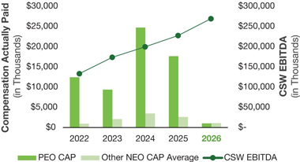
The following chart sets forth the relationship between the CAP calculation of our PEO, the average CAP of our other NEOs, and the Company’s cumulative TSR over the five most recently completed fiscal years.

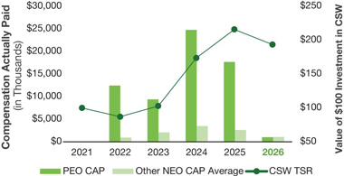
The following chart compares the Company’s TSR over the last five completed fiscal years to that of the Peer Group over the same period.

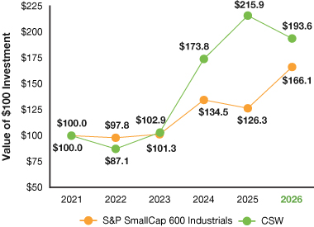
The following chart sets forth the relationship between the calculated CAP of our PEO, the average CAP of our other NEOs, and the Company’s Net Income over the five most recently completed fiscal years.

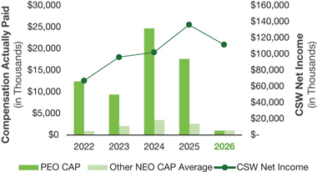
The following table presents the financial performance measures that the Company considers to have been the most important in linking the CAP of our PEO and other NEOs for fiscal 2026 to Company performance. The CAP calculation is heavily influenced by the year-over-year change in values of unvested equity awards, and equity awards constitute the majority of our NEO’s compensation. As such, TSR performance has an outsized effect on CAP figures when compared to SCT totals.

TSR
EBITDA
Cash Flow from Operations

 | 68 |  |  |  |  | |  2026 Proxy Statement

Table of Contents

Equity Compensation Plan Information
The following table provides certain information related to our 2024 Equity and Incentive Compensation Plan as of March 31, 2026 under which our equity securities are authorized for issuance.

Plan Category |  | Number  of Securities  to Be Issued  Upon Exercise  of Outstanding  Options,  Warrants and  Rights |  | Weighted-  Average  Exercise  Price of  Outstanding  Options,  Warrants  and Rights |  | Number of  Securities  Remaining  Available  for Future  Issuance  Under Equity  Compensation  Plans  (Excluding  Securities  Reflected  in the First  Column)
Equity compensation plans approved by securities holders |  | — |  | — |  | 784,584
Equity compensation plans not approved by securities holders |  | — |  | — |  | —
TOTAL |  | — |  | — |  | 784,584
Our 2024 Equity and Incentive Compensation Plan (the “2024 Plan”) was approved by our shareholders on August 15, 2024, at the 2024 annual meeting of shareholders (the “2024 Plan Effective Date”). As a result, and as previously disclosed, the remaining share capacity of our prior 2015 Equity and Incentive Compensation Plan (the “2015 Plan”) was forfeited and not rolled into the 2024 Plan’s share reserve, and no new awards were made under the 2015 Plan following the 2024 Plan Effective Date. As of June 30, 2026, there were 765,552 shares of common stock that remained available for future issuance under our 2024 Plan. Additionally, 75,318 and 57,539 shares of common stock were subject to outstanding awards under the 2024 Plan and the 2015 Plan, respectively, in each case calculated based on the target number of shares subject to outstanding equity awards. For additional context, there are no option rights or stock appreciation rights outstanding under the 2024 Plan or the 2015 Plan, and as such all shares subject to outstanding awards represent full value awards.
Section 16(a) Beneficial Ownership Reporting Compliance
Section 16(a) of the Exchange Act requires the Company’s directors, executive officers and any person beneficially owning more than 10% of the Company’s common stock to file reports of ownership and any changes in ownership with the SEC. Based solely on the Company’s review of reports furnished to the Company and representations provided to the Company by persons required to file reports under Section 16 of the Exchange Act, the Company’s directors, executive officers and greater than 10% beneficial owners properly and timely complied with their Section 16(a) filing requirements during the fiscal year ended March 31, 2026.

 |  |  |  |  |  |  |  | | 2026 Proxy Statement |  | 69

Table of Contents

Proposal 3:
Ratification of Grant Thornton LLP’s Appointment to Serve as our Independent Registered Public Accounting Firm for Fiscal 2027
The Audit Committee has approved Grant Thornton LLP (“GT”) to serve as our independent registered public accounting firm for the fiscal year ending March 31, 2027.
We are asking our shareholders to ratify the appointment of GT as our independent registered public accounting firm. The Company’s independent registered public accounting firm is engaged, retained and supervised by the Audit Committee. However, the Board considers a proposal for shareholders to ratify this appointment to be an opportunity for shareholders to provide input to the Audit Committee and the Board on a key corporate governance issue.
Required Vote and Recommendation
The proposal to ratify the appointment of GT to serve as the Company’s independent registered public accounting firm for fiscal 2027 requires the affirmative vote of a majority of the votes cast in person or represented by proxy. The individuals named as proxies on the enclosed proxy card will vote your proxy “FOR” ratifying the appointment of GT unless you instruct otherwise on the proxy or unless you withhold authority to vote. For more information, see “General Voting and Meeting Information — Voting — Counting of Votes.”

THE BOARD RECOMMENDS A VOTE FOR THE RATIFICATION OF GRANT THORNTON LLP’S APPOINTMENT TO SERVE AS OUR INDEPENDENT REGISTERED PUBLIC ACCOUNTING FIRM FOR FISCAL 2027.

 | 70 |  |  |  |  | | 2026 Proxy Statement

Table of Contents

Report of The Audit Committee
During fiscal 2026, the Audit Committee of the Board of Directors consisted of four independent directors: Anne B. Motsenbocker (Chair), Darron K. Ash, Terry L. Johnston, and J. Kent Sweezey. The Audit Committee operates under a written charter adopted by the Board. The Audit Committee met five times in fiscal 2026.
Management has primary responsibility for the Company’s internal controls and the financial reporting process. The independent auditors are responsible for performing an independent audit of the Company’s consolidated financial statements in accordance with generally accepted auditing standards and issuing a report on this audit. The Audit Committee’s responsibility is to monitor and oversee this process, including engaging the independent auditors, pre-approving their annual audit plan, and reviewing their annual audit report.
In this context, the Audit Committee has reviewed and held detailed discussions with management, including the executive leadership team and internal audit staff, on the Company’s consolidated financial statements and matters relating to the Company’s internal control over financial reporting. Management represented to the Audit Committee that the Company’s consolidated financial statements were prepared in accordance with accounting principles generally accepted in the United States and that these statements fairly present the financial condition and results of operations of the Company for the period described. The Audit Committee has relied upon this representation without any independent verification, except for the work of GT, the Company’s independent registered public accounting firm. The Audit Committee also discussed these statements with GT, both with and without management present, and has relied upon their reported opinion on these financial statements.
The Audit Committee further discussed with GT matters required to be discussed by the applicable requirements of the Public Company Accounting Oversight Board (“PCAOB”) and the SEC. In addition, the Audit Committee received from GT the written disclosures and letter required by applicable requirements of the PCAOB regarding GT’s communications with the Audit Committee concerning its independence and has discussed with GT its independence from the Company and its management.
Based on these reviews and discussions, including the Audit Committee’s specific review with management of the Company’s Annual Report on Form 10-K for the fiscal year ended March 31, 2026 (“Annual Report”) and based upon the representations of management and the report of the independent auditors to the Audit Committee, the Audit Committee recommended to the Board that the audited consolidated financial statements be included in the Annual Report filed with the SEC.
Anne B. Motsenbocker, Chair
Darron K. Ash
Terry L. Johnston
J. Kent Sweezey

 |  |  |  |  |  |  |  | | 2026 Proxy Statement |  | 71

Table of Contents

Other Audit Information
Relationship with Independent Registered Public Accounting Firm
The Audit Committee appointed GT to serve as the Company’s independent registered public accounting firm for the fiscal year ending March 31, 2026. In this role, GT audits the Company’s financial statements. Representatives from GT will attend the Annual Meeting and will be available to respond to appropriate questions from shareholders. They will have the opportunity to make a statement if they wish.
Audit and Non-Audit Fees and Services
The following table summarizes the aggregate fees (excluding value-added taxes) for professional services incurred by the Company for the audits of its fiscal 2026 financial statements and other fees billed to the Company by GT in fiscal 2026. In general, the Company retains GT for services that are related to or an extension of the Company’s annual audit.

 |  | 2026 |  |  |  | 2025
Audit Fees(1) |  | $ | 2,398,890 |  |  | $ | 2,207,393
Audit Related Fees(2) |  |  | 360,217 |  |  |  | 255,200
Total Audit and Audit-Related Fees |  |  | 2,759,107 |  |  |  | 2,462,593
Tax Fees |  |  | — |  |  |  | —
All Other Fees |  |  | — |  |  |  | —
TOTAL FEES |  | $ | 2,759,107 |  |  | $ | 2,462,593

(1) | Represents fees for the audit of our annual financial statements, internal controls and review of our quarterly financial statements, consents, and comfort letter.

(2) | Represents professional services provided in connection with the audit of annual financial statements for the Shell & Whitmore Reliability Solutions joint venture and stub-period audit in connection with the acquisition of Dusk Acquisition Corp (MARS Parts).
The Audit Committee pre-approved all the audit and non-audit fees described above for the year ended March 31, 2026, in accordance with its approval policy discussed below.
Audit Committee Approval Policy
The Audit Committee approves all proposed services and related fees to be rendered by the Company’s independent registered public accounting firm before the firm is engaged. Services to be provided by the Company’s independent registered public accounting firm generally include audit services, audit-related services, and certain tax services. All fees for the annual audit or audit-related services to be performed by the Company’s independent registered public accounting firm are itemized for the purposes of approval. The Audit Committee approves the scope and timing of the external audit plan for the Company and focuses on any matters that may affect the scope of the audit or the independence of the Company’s independent registered public accounting firm. In that regard, the Audit Committee receives certain representations from the Company’s independent registered public accounting firm regarding their independence and the permissibility under the applicable laws and regulations of any services provided to the Company outside the scope of those otherwise allowed.
The Audit Committee may delegate its approval authority to the Chairman of the Audit Committee to the extent allowed by law. In the case of any delegation, the Chairman must disclose all approval determinations to the full Audit Committee as soon as possible after such determinations have been made.

 | 72 |  |  |  |  | | 2026 Proxy Statement

Table of Contents

Beneficial Ownership of Common Stock
Directors and Executive Officers
The following table sets forth information regarding the beneficial ownership of our common stock as of the close of business on July 8, 2026 by (i) each of our directors and nominees for director, (ii) each named executive officer, and (iii) all current directors and executive officers as a group.
We determined beneficial ownership as reported in accordance with Rule 13d-3 under the Securities Exchange Act of 1934, as amended (the “Exchange Act”). Unless otherwise indicated, beneficial ownership includes both sole voting and sole dispositive power. Even though SEC rules require reporting all the shares listed in the table, the directors and executive officers may not claim beneficial ownership of all of these shares. For example, a director or executive officer might not claim beneficial ownership of shares owned by a relative. Unless otherwise indicated, the table does not include any shares that may be held by pension and profit-sharing plans of the corporations or endowment funds of educational and charitable institutions for which various directors and officers serve as directors or trustees.

Amount and
Nature of Common
Stock Beneficially
Owned
Beneficial Owner |  | Number of  Shares  Beneficially  Owned(1) |  |  |  | Percent  of  Class
Non-Employee Directors
Darron K. Ash |  |  | 495 |  |  |  | *
Michael R. Gambrell |  |  | 22,113 |  |  |  | *
Bobby Griffin |  |  | 2,943 |  |  |  | *
Terry L. Johnston |  |  | 9,987 |  |  |  | *
Linda A. Livingstone |  |  | 12,283 |  |  |  | *
Anne B. Motsenbocker |  |  | 2,245 |  |  |  | *
J. Kent Sweezey |  |  | 10,098 |  |  |  | *
Named Executive Officers
Joseph B. Armes |  |  | 72,409 |  |  |  | *
James E. Perry |  |  | 28,354 |  |  |  | *
Jeff A. Underwood |  |  | 8,215 |  |  |  | *
Luke E. Alverson |  |  | 14,410 |  |  |  | *
Danielle R. Garde |  |  | 5,929 |  |  |  | *
Group
All directors and current executive officers (12 persons) as a group |  |  | 189,481 |  |  |  | 1.2%

* | Less than one percent based on a total of 16,296,266 shares of common stock outstanding on July 8, 2026.

(1) | No shares of our common stock were owned by relatives of our directors, NEOs, or directors and executive officers as a group.

 |  |  |  |  |  |  |  | | 2026 Proxy Statement |  | 73

Table of Contents
Beneficial Ownership of Common Stock
Certain Other Beneficial Owners

Certain Other Beneficial Owners
The following table sets forth information regarding each person or group of persons known by the Company to beneficially own more than 5% of the Company’s common stock as of the Record Date. Except as otherwise indicated, the information is based solely upon information contained in Schedule 13G and Schedule 13G/A filings made with the SEC.
As of June 30, 2026, Fidelity, as trustee of the Company’s ESOP, held approximately 430,000 shares of the Company’s common stock, representing approximately 2.5% of the Company’s outstanding common stock as of the Record Date.

Name and Address of Beneficial Owner |  | Amount and nature of  beneficial ownership(1) |  |  |  |  | Percent of class
BlackRock, Inc.  50 Hudson Yards, New York, New York 10001 |  |  |  | 2,340,423 | (2) |  |  |  | 13.9 | %
Vanguard Portfolio Management  100 Vanguard Boulevard, Malvern, Pennsylvania 19355 |  |  |  | 911,560 | (3) |  |  |  | 5.53 | %
Wasatch Advisors LP  505 Wakara Way, 3rd Floor, Salt Lake City, Utah 84108 |  |  |  | 873,658 | (4) |  |  |  | 5.30 | %
Vanguard Capital Management  100 Vanguard Boulevard, Malvern, Pennsylvania 19355 |  |  |  | 857,112 | (5) |  |  |  | 5.20 | %

(1) | Beneficial ownership has been determined in accordance with SEC rules.

(2) | Based solely upon information contained in the most recently filed Schedule 13G/A of BlackRock, Inc. filed with the SEC on October 17, 2025, reflecting beneficial ownership as of September 30 2025. According to this Schedule 13G/A , BlackRock Inc. had sole voting power for 2,312,215 of these shares, no shared voting power, sole dispositive power for 2,340,423 of these shares, and no shared dispositive power.

(3) | Based solely upon information contained in the most recently filed Schedule 13G of Vanguard Portfolio Management, filed with the SEC on April 29, 2026, reflecting beneficial ownership as of March 31, 2026. According to this Schedule 13G,Vanguard Portfolio Management had sole voting power for 13,904 of these shares, no shared voting power, sole dispositive power for 911,560 of these shares, and no shared dispositive power.

(4) | Based solely upon information contained in the most recently filed Schedule 13G of Wasatch Advisors LP, filed with the SEC on April 23, 2026, reflecting beneficial ownership as of March 31, 2026. According to this Schedule 13G, Wasatch Advisors LP had sole voting power for 585,712.50 of these shares, no shared voting power, sole dispositive power for 873,658.50 of these shares, and no shared dispositive power.

(5) | Based solely upon information contained in the most recently filed Schedule 13G of Vanguard Capital Management, filed with the SEC on April 29, 2026, reflecting beneficial ownership as of March 31, 2026. According to this Schedule 13G,Vanguard Capital Management had sole voting power for 124,559 of these shares, no shared voting power, sole dispositive power for 857,112 of these shares, and no shared dispositive power.

 | 74 |  |  |  |  | | 2026 Proxy Statement

Table of Contents

General Voting and Meeting Information
Solicitation
We are providing these proxy materials in connection with the solicitation by the Board of proxies to be voted at the 2026 Annual Meeting of Shareholders and at any adjournments or postponements thereof. The Annual Meeting will be held virtually on Thursday, August 27, 2026, at 12:30 p.m. Central Time, at: www.virtualshareholdermeeting.com/CSW2026.
IMPORTANT NOTICE REGARDING THE AVAILABILITY OF PROXY MATERIALS FOR THE SHAREHOLDER MEETING TO BE HELD ON AUGUST 27, 2026
Pursuant to SEC rules, we are furnishing proxy materials, including this Proxy Statement and the Company’s Annual Report, to certain of our shareholders by providing access to these documents on the Internet instead of mailing printed copies. “Street name” shareholders, as defined below under “Voting—How to Vote,” will not receive printed copies of the proxy materials unless they request them. Instead, a Notice of Internet Availability of Proxy Materials (“Notice of Internet Availability”) was mailed to most of our “street name” shareholders, which explains how to access and review the proxy materials and how you may submit your proxy electronically. If you would like to receive a paper or electronic copy of our proxy materials, please follow the instructions included in the Notice of Internet Availability. Shareholders who requested paper copies of proxy materials or previously elected to receive proxy materials by email did not receive the Notice of Internet Availability and are receiving the proxy materials in the format requested.
This Proxy Statement and the Company’s Annual Report, are also available electronically at www.proxyvote.com.
To access and review the materials electronically:

1. | Have your Notice of Internet Availability, proxy card or voting instructions available.

2. | Go to www.proxyvote.com and input your 16-digit control number.

3. | Click the “2026 Proxy Statement” in the right column.
We encourage you to review all the important information contained in the proxy materials before voting. If you would like to attend the virtual Annual Meeting, instructions on how to attend and participate via the Internet, including how to demonstrate proof of stock ownership, are posted at www.virtualshareholdermeeting.com/CSW2026.
The proxy materials are being sent to shareholders on or about July 16, 2026.
Voting
Who May Vote and Number of Votes
If you are a shareholder of record at the close of business on July 8, 2026 (the “Record Date”), you may vote on the matters proposed in this Proxy Statement. For each matter raised at the Annual Meeting, you have one vote for each share you owned on the Record Date. At the close of business on the Record Date, 16,296,266 shares of common stock were issued and outstanding (excluding treasury shares) that may be voted at the Annual Meeting. A list of shareholders entitled to vote at the Annual Meeting will be available for inspection by any shareholder at our offices in Dallas, Texas during ordinary business hours for a period of 10 days prior to the Annual Meeting.

 |  |  |  |  |  |  |  | | 2026 Proxy Statement |  | 75

Table of Contents
General Voting and Meeting Information
Voting

If your shares are held through a broker, your vote instructs the broker how you want your shares to be voted. If you vote on each proposal, your shares will be voted in accordance with your instructions. Brokers may vote shares they hold in “street name” on behalf of beneficial owners who have not voted with respect to certain “routine” matters. The proposal to ratify the appointment of Grant Thornton LLP (Proposal 3) is considered a routine matter, so brokers may vote shares on this matter in their discretion if no voting instructions are received. However, the proposals for the election of directors (Proposal 1) and the advisory vote on executive compensation (Proposal 2) are NOT considered routine matters, so your broker will not have discretion to vote your shares if you do not provide voting instructions. This is referred to as a “broker non-vote.”
Quorum for the Meeting
A majority of the outstanding shares of common stock entitled to vote at the Annual Meeting and represented in person or by proxy constitutes a quorum. We must have a quorum to conduct business at the Annual Meeting. You will be part of the quorum if you vote your shares in advance of the Annual Meeting. If you abstain from voting on a particular proposal, your shares will still be counted as present at the meeting for purposes of determining a quorum. Broker non-votes are also counted as present for purposes of determining a quorum.
Counting of Votes
The following table shows the proposals to be presented for a vote, the applicable voting requirements, and the Board’s recommendations.

Proposal |  | Vote Required to Pass |  | Voting Options |  | Board’s  Recommendation |  | Effect of Abstentions  and Broker Non-Votes
1. Elect seven directors to hold office until the 2027 annual meeting of shareholders |  | The affirmative vote of a majority of the votes cast in person or by proxy |  | FOR all director nominees; WITHHOLD as to all director nominees;  FOR all director nominees except for those specified, from whom you WITHHOLD your vote |  | FOR |  | No effect
2. Approve, on a non-binding, advisory basis, the compensation of our Named Executive Officers |  | The affirmative vote of a majority of the votes cast in person or by proxy |  | FOR, AGAINST or ABSTAIN |  | FOR |  | No effect
3. Ratify the appointment of Grant Thornton LLP as our independent registered public accounting firm for the fiscal year ending March 31, 2027 |  | The affirmative vote of a majority of the votes cast in person or by proxy |  | FOR, AGAINST or ABSTAIN |  | FOR |  | Abstentions will not have any effect. There should not be any broker non-votes, but if any, they will have no effect on the outcome.
The Company knows of no other matters to be submitted to the shareholders at the Annual Meeting. If any other matters are properly raised at the Annual Meeting, the individuals named on the enclosed proxy card intend to vote the shares represented thereby on such matters in accordance with their best judgment.

 | 76 |  |  |  |  | | 2026 Proxy Statement

Table of Contents
General Voting and Meeting Information
Voting

How to Vote
If your shares are registered in the name of a brokerage firm, bank, or other nominee (i.e., in “street name”). You will receive instructions from your nominee, which you must follow in order to have your shares voted. “Street name” shareholders who wish to vote at the Annual Meeting will need to obtain a proxy from the broker, bank or other nominee that holds their shares, which will include a 16-digit control number that enables you to vote your shares.
If your shares are registered directly in your name. You can vote your shares in one of four ways: by proxy via the Internet; by proxy over the telephone; by proxy using a proxy card; or online during the virtual Annual Meeting. Even if you do not plan to attend the Annual Meeting, we urge you to vote by proxy to ensure your vote is counted. For all voting methods, you will need your 16-digit control number.

 | • | Vote by Internet. You have the option to vote using the Internet at www.proxyvote.com. The on-screen instructions will direct you how to vote your shares. Internet voting is available 24 hours a day, seven days a week, until 11:59 p.m., Eastern Time, on August 26, 2026. IF YOU VOTE BY INTERNET, YOU DO NOT NEED TO RETURN A PROXY CARD.

 | • | Vote by Telephone. You have the option to vote by telephone by calling 1.800.690.6903 toll-free from the United States and Canada and following the series of voice instructions that will direct you how to vote your shares. Telephone voting is available 24 hours a day, seven days a week, until 11:59 p.m., Eastern Time, on August 26, 2026. IF YOU VOTE BY TELEPHONE, YOU DO NOT NEED TO RETURN A PROXY CARD.

 | • | Vote by Mail. You may mark the proxy card, sign and date it, and return it in the envelope provided as soon as possible before the Annual Meeting. Your signed proxy card must be received before the Annual Meeting for your vote to be counted at the Annual Meeting.

 | • | Vote during the Annual Meeting. You may vote by online ballot during the virtual Annual Meeting by following the instructions posted at www.virtualshareholdermeeting.com/CSW2026.
Participants in the Company’s ESOP. Under the terms of the ESOP, Fidelity, the ESOP trustee, votes all shares held by the ESOP, but each participant in the ESOP may direct the trustee how to vote the shares allocated to his or her account. If the trustee does not receive voting instructions from you by 11:59 p.m., Eastern Time, on August 24, 2026, your ESOP shares will be voted as directed by the CSW Industrials, Inc. ESOP Committee. If your shares are held in the ESOP, you may not vote in person at the Annual Meeting.
Changing Your Vote
If you are a registered shareholder, you may revoke your proxy at any time before it has been exercised at the Annual Meeting by:

 | • | timely mailing in a revised proxy dated later than the prior submitted proxy;

 | • | timely notifying the Corporate Secretary in writing that you are revoking your proxy;

 | • | timely casting a new vote by telephone or the Internet; or

 | • | voting by online ballot at the virtual Annual Meeting.
If you are a beneficial shareholder, please contact your bank, broker, or nominee for instructions on how to change your vote.
Vote Tabulations
Tabulation of voted proxies will be handled by Broadridge, an independent firm. Broadridge is the inspector of elections for the Annual Meeting.

 |  |  |  |  |  |  |  | | 2026 Proxy Statement |  | 77

Table of Contents

Other Information About this Solicitation
Cost of Proxy Solicitation
The solicitation of proxies is made by our Board and will be conducted primarily by mail. The Company will reimburse brokerage firms and other custodians, nominees, and fiduciaries for reasonable out-of-pocket expenses that they incur to send proxy materials to shareholders and solicit their votes. In addition to this mailing, proxies may be solicited, without extra compensation, by our officers and employees, by mail, telephone, facsimile, electronic mail, and other methods of communication. The Company bears the full cost of soliciting proxies. The Company has also retained D.F. King for certain advisory services and to aid in the solicitation of proxies, and will ask brokerage houses and other nominees, fiduciaries, and custodians to forward soliciting materials to beneficial owners of the Company’s common stock. For these services, the Company will pay D.F. King a fee of $13,000 plus reimbursement for reasonable out-of-pocket expenses.
Shareholders Sharing an Address
To reduce the expenses of delivering duplicate proxy materials, we deliver one annual report and proxy statement to multiple shareholders sharing the same mailing address unless otherwise requested. This is referred to as “householding.” We will promptly send a separate annual report and proxy statement to a shareholder at a shared address upon request at no cost. Shareholders with a shared address may also request that we send a single copy of these materials in the future if we are currently sending multiple copies to the same address. Requests related to delivery of proxy materials may be made by calling our Investor Relations department at 214.489.7113 or by writing to CSW Industrials, Inc., Attention: Investor Relations, 5420 Lyndon B. Johnson Freeway, Suite 500, Dallas, Texas 75240. Shareholders who hold shares in “street name” may contact their brokerage firm, bank, or other nominee to request information about householding.
Shareholder Proposals and Nominations
SEC rules provide that certain shareholder proposals may be eligible for inclusion in our 2027 proxy statement. These shareholder proposals must comply with the requirements of Rule 14a-8, including a requirement we receive such proposals no later than March 19, 2027. We strongly encourage any shareholder interested in submitting a proposal to contact the Corporate Secretary at the address below in advance of this deadline to discuss the proposal. The N&CG Committee reviews all shareholder proposals and makes recommendations to the Board for responsive action.
Alternatively, under the Company’s Bylaws, if a shareholder does not want to submit a proposal for inclusion in our proxy statement but wants to introduce it at our 2027 annual meeting of shareholders, or intends to nominate a person for election to the Board directly (rather than by recommending such person as a candidate to our N&CG Committee), the shareholder must submit the proposal or nomination in writing at the address below between April 29, 2027, and May 29, 2027. However, if the 2027 annual meeting of shareholders is held more than 30 days before or more than 30 days after the anniversary of the 2026 Annual Meeting, the shareholder must submit any such proposal no later than the 90th calendar day prior to the 2027 annual meeting of shareholders or 10 days following the date on which the date of the 2027 annual meeting of shareholders is publicly announced. Any such submission must be made by a registered shareholder on the shareholder’s own behalf or on behalf of a beneficial owner of our common stock and must include detailed information specified in our Bylaws concerning the proposal or nominee, as the case may be, and detailed information as to the shareholder’s interests in Company securities. We will not entertain any proposals or nominations at the 2027 annual meeting of shareholders that do not meet these requirements.

 | 78 |  |  |  |  | | 2026 Proxy Statement

Table of Contents
Other Information About this Solicitation
Shareholder Proposals and Nominations

To comply with the universal proxy rules, shareholders who intend to solicit proxies in support of director nominees for the 2027 annual meeting of shareholders must provide notice that sets forth the information required by Rule 14a-19 under the Exchange Act, and, pursuant to the Company’s Bylaws, such notice must be provided within the same time frame as any Rule 14a-8 proposal. If the shareholder does not comply with the requirements of the SEC, we may exercise discretionary voting authority under proxies that we solicit to vote in accordance with our best judgment on any such shareholder proposal or nomination. The Company’s Bylaws are posted on our website at www.csw.com under “Investors — Corporate Governance.” To make a submission or to request a copy of the Company’s Bylaws at no charge, shareholders should contact our Corporate Secretary at the following address:
CSW Industrials, Inc.
5420 Lyndon B. Johnson Freeway, Suite 500
Dallas, Texas 75240
Attention: Corporate Secretary

 |  |  |  |  |  |  |  | | 2026 Proxy Statement |  | 79

Table of Contents

Exhibit A
GAAP to Non-GAAP Reconciliations
RECONCILIATION OF NET INCOME TO ADJUSTED EBITDA
(Unaudited)

 |  | Fiscal Year Ended March 31,
(Amounts in thousands) |  | 2026 |  |  |  | 2025 |  |  |  | 2024
GAAP Net Income attributable to CSW |  | $ | 112,045 |  |  | $ | 136,652 |  |  | $ | 101,648
Plus: Income attributable to redeemable noncontrolling interest |  |  | 802 |  |  |  | 832 |  |  |  | 891
GAAP Net Income |  |  | 112,846 |  |  |  | 137,484 |  |  |  | 102,539
Adjusting items:
Interest Expense |  |  | 22,245 |  |  |  | 269 |  |  |  | 12,723
Income Tax Expense |  |  | 32,706 |  |  |  | 42,633 |  |  |  | 37,942
Depreciation & Amortization |  |  | 67,071 |  |  |  | 42,223 |  |  |  | 38,289
Greco Impairment Expense |  |  | 15,627 |  |  |  | — |  |  |  | —
EBITDA |  |  | 250,496 |  |  |  | 222,608 |  |  |  | 191,492
Adjusting Items:
Acquisition-Related Integration Expenses |  |  | 7,664 |  |  |  | — |  |  |  | —
Nonrecurring Inventory Write Down |  |  | 3,135 |  |  |  | — |  |  |  | —
Nonrecurring Restructuring Expenses |  |  | 542 |  |  |  | — |  |  |  | —
Reversal of Tax Indemnification Receivable |  |  | 1,406 |  |  |  | 858 |  |  |  | 8,519
Acquisition-Related Transaction Expenses |  |  | 4,265 |  |  |  | 2,294 |  |  |  | —
Greco Canada exit related expenses |  |  | 2,130 |  |  |  | — |  |  |  | —
Fair value change in contingent consideration liability |  |  | — |  |  |  | 2,100 |  |  |  | —
Adjusted EBITDA |  | $ | 269,638 |  |  | $ | 227,860 |  |  | $ | 200,011
RECONCILIATION OF NET INCOME AND EPS TO ADJUSTED NET INCOME AND EPS

(Amounts in thousands, except per share amounts) |  | Fiscal Year Ended  March 31, 2026
GAAP Net Income attributable to CSW |  |  | $ | 112,045
Adjusting items, net of tax:
Amortization of acquisition-related intangible assets and inventory step-up |  |  |  | 51,173
Amortization tax effect |  |  |  | (12,727 | )
Acquisition-related integration expenses, net of tax effect |  |  |  | 5,773
Nonrecurring inventory write down, net of tax effect |  |  |  | 2,361
Acquisition-related transaction expenses, net of tax effect |  |  |  | 3,829
Greco Canada exit related expenses, net of tax effect |  |  |  | 1,575
Nonrecurring restructuring expenses, net of tax effect |  |  |  | 408
Greco impairment expenses, net of tax effect |  |  |  | 13,617
Uncertain tax position accrual release |  |  |  | (4,544 | )
Adjusted Net income attributable to CSW |  |  | $ | 173,510
GAAP Net Income attributable to CSW per diluted common share |  |  | $ | 6.70
Adjusting Items, per diluted common share:
Amortization of acquisition-related intangible assets and inventory step-up |  |  |  | 3.06
Amortization tax effect |  |  |  | (0.76 | )
Acquisition-related integration expenses, net of tax effect |  |  |  | 0.35
Nonrecurring inventory write down, net of tax effect |  |  |  | 0.14
Acquisition-related transaction expenses, net of tax effect |  |  |  | 0.23
Greco Canada exit related expenses, net of tax effect |  |  |  | 0.09
Nonrecurring restructuring expenses, net of tax effect |  |  |  | 0.02
Greco impairment expenses, net of tax effect |  |  |  | 0.81
Uncertain tax position accrual release |  |  |  | (0.27 | )
Adjusted Net Income attributable to CSW per diluted common share |  |  | $ | 10.38

 |  |  |  |  |  |  |  | | 2026 Proxy Statement |  | A-1

Table of Contents
  CSW INDUSTRIALS, INC.  5420 LYNDON B. JOHNSON FREEWAY  SUITE 500  DALLAS, TX 75240 |  |   VOTE BY INTERNET  Before The Meeting - Go to www.proxyvote.com or scan the QR Barcode above  Use the Internet to transmit your voting instructions and for electronic delivery of information. Vote by 11:59 P.M. ET on August 26, 2026 for shares held directly and by 11:59 P.M. ET on August 24, 2026 for shares held in a Plan. Have your proxy card in hand when you access the website and follow the instructions to obtain your records and to create an electronic voting instruction form.  During The Meeting - Go to www.virtualshareholdermeeting.com/CSW2026  You may attend the meeting via the Internet and vote during the meeting. Have the information that is printed in the box marked by the arrow available and follow the instructions.  VOTE BY PHONE - 1-800-690-6903  Use any touch-tone telephone to transmit your voting instructions. Vote by 11:59 P.M. ET on August 26, 2026 for shares held directly and by 11:59 P.M. ET on August 24, 2026 for shares held in a Plan. Have your proxy card in hand when you call and then follow the instructions.  VOTE BY MAIL  Mark, sign and date your proxy card and return it in the postage-paid envelope we have provided or return it to Vote Processing, c/o Broadridge, 51 Mercedes Way, Edgewood, NY 11717.
TO VOTE, MARK BLOCKS BELOW IN BLUE OR BLACK INK AS FOLLOWS:
T01143-P54877 KEEP THIS PORTION FOR YOUR RECORDS
— — — — — — — — — — — — — — — — — — — — — — — — — — — — — — — — — — — — — — — — — — — — — — — — — — —
DETACH AND RETURN THIS PORTION ONLY
THIS PROXY CARD IS VALID ONLY WHEN SIGNED AND DATED.

CSW INDUSTRIALS, INC.  The Board of Directors recommends you vote FOR  the following:  1. Election of Directors. |  |  |  |  |  | For All  ☐ |  | Withhold  All  ☐ |  | For All Except  ☐ |  | To withhold authority to vote for any individual nominee(s), mark “For All Except” and write the number(s) of the nominee(s) on the line below.
 |  | Nominees:
 |  | 01) Joseph B. Armes  02) Darron K. Ash  03) Michael R. Gambrell  04) Bobby Griffin |  | 05) Terry L. Johnston  06) Linda A. Livingstone  07) Anne B. Motsenbocker
 |  | The Board of Directors recommends you vote FOR proposals 2 and 3: |  |  |  |  |  |  |  |  |  |  |  | For |  | Against |  | Abstain
 |  | 2. Approval, by non-binding vote, of executive compensation. |  |  |  |  |  |  |  |  |  |  |  | ☐ |  | ☐ |  | ☐
 |  | 3. The ratification of Grant Thornton LLP to serve as independent registered public accounting firm for the fiscal year ending March 31, 2027. |  |  |  |  |  |  |  |  |  |  |  | ☐ |  | ☐ |  | ☐
 |  | NOTE: Such other business as may properly come before the meeting or any adjournment thereof.
Please sign exactly as your name(s) appear(s) hereon. When signing as attorney,
executor, administrator, or other fiduciary, please give full title as such. Joint owners
should each sign personally. All holders must sign. If a corporation or partnership,
please sign in full corporate or partnership name by authorized officer.

 |  | Signature [PLEASE SIGN WITHIN BOX] |  | Date |  |  |  | Signature (Joint Owners) |  | Date

Table of Contents

Important Notice Regarding the Availability of Proxy Materials for the Annual Meeting:
The Notice of Meeting, Proxy Statement, and Annual Report on Form 10-K are available at www.proxyvote.com.

— — — — — — — — — — — — — — — — — — — — — — — — — — — — — — — — — — — — — — — — — — — — — — — — — — —
T01144-P54877

CSW INDUSTRIALS, INC.
2026 Annual Meeting of Stockholders
August 27, 2026 12:30 p.m., Central Time
THIS PROXY IS SOLICITED BY THE BOARD OF DIRECTORS
The stockholders hereby appoint(s) Joseph B. Armes, Linda A. Livingstone, and Luke E. Alverson, or any of them, as proxies, each with the power to appoint their substitute, and hereby authorize(s) them to represent and to vote, as designated on the reverse side of this ballot, all of the shares of common stock of CSW INDUSTRIALS, INC. that the stockholder(s) is/are entitled to vote at the Annual Meeting of Stockholders to be held virtually at www.virtualshareholdermeeting.com/CSW2026 at 12:30 p.m., Central Time on August 27, 2026, and any adjournment or postponement thereof.
Participants holding shares in the CSW Industrials, Inc. ESOP: By marking, signing and dating this card or submitting your voting instruction by telephone or internet, you are instructing Fidelity Investments, the ESOP trustee, to vote the shares of CSW Industrials, Inc. common stock allocated to the ESOP account as instructed. All voting instructions from ESOP plan participants must be received no later than 11:59 P.M. Eastern Time on August 24, 2026. If your instructions are not received by such time, the ESOP shares will be voted as directed by the CSW Industrials, Inc. ESOP Committee.
THIS PROXY, WHEN PROPERLY EXECUTED, WILL BE VOTED AS DIRECTED BY THE STOCKHOLDER(S). IF NO SUCH DIRECTION IS MADE, THIS PROXY WILL BE VOTED FOR THE ELECTION OF THE NOMINEES FOR THE BOARD OF DIRECTORS LISTED ON THE REVERSE SIDE, FOR PROPOSAL 2, AND FOR PROPOSAL 3.
Continued and to be signed on reverse side

