UNITED STATES
SECURITIES AND EXCHANGE COMMISSION
Washington, D.C. 20549
SCHEDULE 14A
Proxy Statement Pursuant to Section 14(a) of the Securities
Exchange Act of 1934

 |  | Filed by the Registrant |  |  |  | Filed by a party other than the Registrant

Check the appropriate box:
Preliminary Proxy Statement
CONFIDENTIAL, FOR USE OF THE COMMISSION ONLY (AS PERMITTED BY RULE 14A-6(e)(2))
Definitive Proxy Statement
Definitive Additional Materials
Soliciting Material under §240.14a-12
CSW INDUSTRIALS, INC.


(Name of Registrant as Specified in its Charter)
(Name of Person(s) Filing Proxy Statement, if other than the Registrant)

Payment of Filing Fee (Check the appropriate box):
No fee required.
Fee paid previously with preliminary materials.
Fee computed on table in exhibit required by Item 25(b) per Exchange Act Rules 14a-6(i)(1) and 0-11.

T01147-P54591 |  | 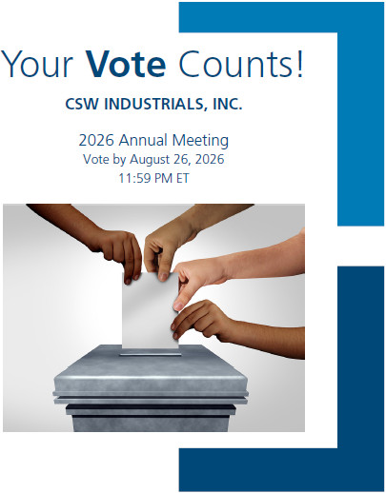
You invested in CSW INDUSTRIALS, INC. and it’s time to vote!
You have the right to vote on proposals being presented at the Annual Meeting. This is an important notice regarding the availability of proxy materials for the stockholder meeting to be held on August 27, 2026.
Get informed before you vote
View the Notice of Meeting, Proxy Statement, and Annual Report on Form 10-K online OR you can receive a free paper or email copy of the material(s) by requesting prior to August 13, 2026. If you would like to request a copy of the material(s) for this and/or future stockholder meetings, you may (1) visit www.ProxyVote.com, (2) call 1-800-579-1639 or (3) send an email to sendmaterial@proxyvote.com. If sending an email, please include your control number (indicated below) in the subject line. Unless requested, you will not otherwise receive a paper or email copy.

 |  | For complete information and to vote, visit www.ProxyVote.com
 |  | Control # |  | 

 |  |  |  |  |  |  |  |  |  | Vote Virtually at the Meeting*  August 27, 2026  12:30 p.m., Central Time
Virtually at:
www.virtualshareholdermeeting.com/CSW2026

*Please check the meeting materials for any special requirements for meeting attendance.

Vote at www.ProxyVote.com

THIS IS NOT A VOTABLE BALLOT  This is an overview of the proposals being presented at the upcoming stockholder meeting. Please follow the instructions on the reverse side to vote these important matters. |  | 

Voting Items |  |  |  | Board  Recommends
1. Election of Directors.
Nominees:
01) Joseph B. Armes |  | 05) Terry L. Johnston |  |  |  | For
02) Darron K. Ash |  | 06) Linda A. Livingstone
03) Michael R. Gambrell |  | 07) Anne B. Motsenbocker
04) Bobby Griffin
2. Approval, by non-binding vote, of executive compensation. |  |  |  |  |  | For
3. The ratification of Grant Thornton LLP to serve as independent registered public accounting firm for the fiscal year ending March 31, 2027. |  |  |  |  |  | For
NOTE: Such other business as may properly come before the meeting or any adjournment thereof.
T01148-P54591

